



Your Office Depot Major Account Manager:
Susan Lerner
Telephone: 201.679.1933
Email: Susan.Lerner@officedepot.com

WELCOME

We are pleased to announce our new office supply agreement with Office Depot effective Wednesday, April 8th, 2015.

After much consideration, Office Depot has demonstrated the ability to uniquely service LifeCell on a local and national level. We have chosen Office Depot to supply us with our everyday office supply, furniture and Copy and Print needs, effective April 8th.

Boasting 99% + next day delivery capabilities, Office Depot also offers over 1,100 full service retail stores across North America (our program ensures negotiated contract pricing is available for our members in Office Depot’s Retail stores). Office Depot’s ordering website is highly ranked among all internet retailers in the country and designed for maximum online ordering experience and efficiency.

Place Orders, Return Orders, Browse Products, Track Orders & Much More!
business.officedepot.com

Office Depot’s award winning website includes the following features:
- Easy to navigate - find and order what you need quickly and efficiently
- Online Returns
- Real time inventory & pricing
- Find accessories/supplies for your office machines ( find all applicable toners and machine consumables by simply typing in your machines brand and model number)
- Create a personal shopping list for your store!
- View order status
- Live chat with customer service

If you have any questions regarding our new Office Depot office supply program, please contact James Bodrogi or Renee Wright.

Account Information:

Office Depot Corporate Account #: 34395661
Field Sales Team Office Depot Account #: 21799889
Web address: business.officedepot.com – Orders may be placed via the web only.

Your Office Depot Field Representative: Susan Lerner, Major Account Manager, Email: Susan.Lerner@officedepot.com; Telephone: 201.679.1933

Ordering Method:

To access your contract pricing:
Login Name: <Your Company Email Address>
Initial Password: Welcome1

Sample Login: tsmith@lifecell.com

IMPORTANT NOTE: When you log in for the first time, you will be prompted to change your password. Passwords must be at least eight to 10 characters in length and are alphanumeric. You will also be asked to respond to a security question. This will help us identify you if your password is lost.

On-line Tutorials:

To review how to navigate through the Office Depot website please click on the Customer Service words located at the top right of the screen. The User Guide and Web Demonstrations can be accessed by scrolling down to General Help on the lower left side of the Customer Service page.

Deliveries:

Deliveries will be made the next business day, unless otherwise noted by Office DEPOT provided your order has been approved and received BY 5:00 P.M. your local time via the internet.

Freight:

Orders will be delivered free of charge. Please consolidate your orders where possible. Ordering in bulk is a simple way to reduce costs, waste, fuel and greenhouse gases. You will save on paper, staff time and logistical costs while also reducing the product packaging waste & carbon dioxide emissions associated with delivery of your office supplies.

Upon Receipt of Your Order:

Verify that all items on the packing slip listed as shipped are in your order. Any shortages or incorrect items should be reported to the Office Depot Customer Service Desk within 10 days of delivery. Items on backorder will be noted on the packing slip. All packing slips must be signed and sent to Accounts Payable for retention as proof of delivery.
BSD Customer Support:

You can connect immediately with a customer service representative, Monday–Friday 8:00 A.M. to 8:00 P.M. (ET), using our Live Chat functionality or by calling us toll-free at 888.263.3423. For technical support, our E-Commerce Support Desk is available via phone at 800.269.6888 or by e-mail at ecsupport@officedepot.com.

Quick Step Internet Ordering Instructions

Placing an Order
- Use browser to access the Internet and type in http://business.officedepot.com
- Type in your Login Name and Password
- Click on
- Please click the items link from the bulletin board to access your core items. We have categorized your core items for convenience. Please shop your core items first.
- If you know the item number(s) for the product(s) you wish to order select:

- Type in Office Depot Item #, quantity, and comment, if desired
- If you do not know the item number(s) for the product(s) you wish to order, you can:
  - Search for product using key words or manufacturer part numbers by entering the information in the space provided in the gray toolbar and then clicking Go 
  - Shop using our online catalog. Simply click on in the upper left hand corner or  in the grey toolbar and you will be directed to category listings of the catalog
- Select to add your desired product to your shopping cart
- Select to continue or from the shopping cart in the top left if you have finished shopping
- If you selected then click on to add more items
- If you selected verify items in your cart and complete any required information
- Please confirm your shipping information is correct , please fill in your (will provide customer specific field information here once finalized)

- You now have three options, 
  - If you are satisfied with your order, select to complete the process
  - If you would like to save the items in your cart and purchase at a later date, select . When placing an order on hold, your inventory will be held for 24 hrs
  - If you would like to save the items in a list but not create the order select
- When you see “Thank you for your order,” and your number, your order has been successfully completed.

Training:

Online training is available in the Customer Service section; select Customer Services.
SEE BELOW.
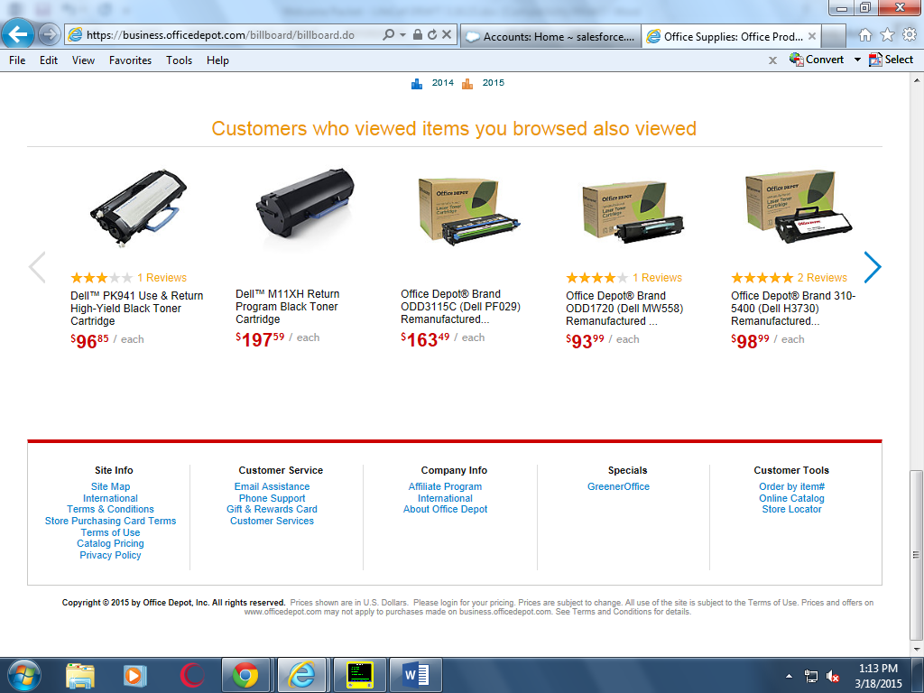

Website demonstrations are also available online for your convenience. SEE BELOW.


