WELCOME TO: STATE OF ALASKA, UNIVERSITY OF ALASKA FAIRBANKS

Welcome to Office Depot|Office Max!
We are your single source for Office Supplies, Toner, and Paper.

Office Depot|Office Max is proud to have the opportunity
to partner with University of Alaska Fairbanks. Our goal is to make purchasing from us as simple as possible. The following pages include information on how to order from Office Depot|Office Max, including details on:
> Product information
> Pricing
> Delivery
> Customer service
> Returns

You also will find helpful tools to reduce the time and money spent on procuring supplies.

We look forward to working together.

Online pricing, ordering and service

To create your login/password, visit: http://odams.officedepot.com/registrations/portal.php?a=74985996

Account number: 74985996

Login Name: Enter the login you created
Password: Enter the password you created

Office Depot|Office Max Customer Support

OfficeMax-Fairbanks
Attn: Delivery Team
24 College Road-Bentley Mall
Fairbanks, AK 99701
Email: ods06466@officedepot.com
907-456-6662

Office Depot-Anchorage
Attn: Delivery Team
201 E. 6th Avenue
Anchorage, AK 99501
Email: ods00557csr@officedepot.com
907-277-7470

OfficeMax-Juneau
Attn: Delivery Team
8745 Glacier Hwy #103
Juneau, AK 99801
Email: ods06858@officedepot.com
907-523-2900

Customer Service Hours:
Monday thru Friday, 7AM to 5PM, local time

Orders and returns may be processed on web 24/7

Contact website support at 800-269-6888

OFFICE DEPOT|OFFICE MAX ACCOUNT MANAGER:

Steven Henson
Email: steven.henson@officedepot.com
Office: 800-597-3181 Ext. 1707
Cell: 907-885-7446

Merchandise returns policy

Getting started
Confirmation of your order
For every order placed, you will receive an email confirmation that details your transaction and product status of the items you ordered.

Online customer service
Request an online chat or a phone call with just a click. Customer service will return your call within
10-60 seconds when you request a call through the live online assistant.

Delivery
Place your order by 4 p.m. and get it the next business day. Orders placed on Saturday and Sunday are delivered the following business day.

Order Office Depot|Office Max-branded items in catalog where available
These items are value priced and include an assortment of environmentally preferable products, such as Office Depot-brand sticky notes.

Select Best Value Items to maximize savings
In order to assist you with selecting the most cost effective items, all contract items are tagged with a Best Value Icon.
You can easily locate Best Value items by accessing the preloaded shopping lists by clicking on the My Shopping List link on the top of the Office Depot website.

Additionally, search results will display Best Value before displaying non-contract items.

Returns are accepted on stock catalog items in new condition with original packing slip and within 30 days of the original invoice date. No returns on custom-made, made-to-order or assembled furniture, unless defective. No returns on special orders, food & beverage items, other ingested or absorbed items, hazardous materials, non-catalog items and technology items (including hardware, software and peripherals), unless the technology manufacturer allows returns. Office Depot will consider returns of special orders and non-catalog items on a case-by-case basis.

We will replace all defective and damaged products at no charge to you within 30 days of invoicing the original order. Thereafter, you’ll need to follow the manufacturers’ product warranty policies.

For all returns, follow these guidelines:
- Call Office Depot Customer Service Team at 888-777-4044 or request an Authorization to Return (ATR) number
by accessing Order History under My Account on business.officedepot.com and selecting Begin Return from the bottom of your order detail page. To expedite your service when contacting us, have handy a copy of
the packing list that came with your order.
- Write ATR number on packing slip and attach
it to the merchandise you’re returning. If you process a return online you will be able to print a shipping label to affix to the outside of the shipping box. Do not mark manufacturer’s original packaging, and make sure resalable products are in original manufacturer’s packaging.
- On packing list, note reason for return
(damaged, ordered incorrectly, incorrect item sent, quantity error, etc.).
- Place the merchandise, with the ATR number noted clearly on the label, at the same place
you received your order.

Frequently asked questions
- How do I start ordering from the Office Depot website?
After you create your log on:
The online ordering system is simple to use.
> Go to business.officedepot.com.
> Type your Login Name
> Type your Password
> Click Log In.
> Once you are logged in you may begin shopping.

2. I forgot my password to the Office Depot website. How can I log in?
Click the Forgot Your login name/password? link below the log-in section.

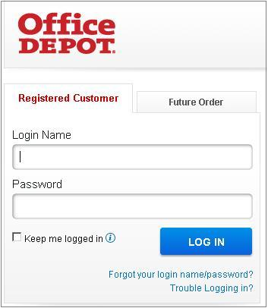
3. I forgot my username and password for the Office Depot website.
Whom do I call?
Call website customer support at 800-269-6888

4. Where do I get an item number for ordering?
The item number will be listed in our online catalog or within the shopping lists. The manufacturer number is always listed on the box and/or item. You can type either number into one of your searches, and either number will cross-reference to the Office Depot Workplace product number.

5. How do I find the products I am looking
for online?
We created Online Shared Shopping Lists to assist you with ordering core office supplies that offer you the best value. These categorized lists enable you to effectively capitalize on the cost-saving benefits of this program.

If you can’t find what you’re looking for in the shopping lists, you can usually find the item you need by typing the manufacturer’s part number or product in the search field at the top of the site.

You also can use the category searches. It works in a drilldown fashion, so try to be as specific as possible to limit your search results.

6. What is a Best Value item?
All CUSTOMER contract items are tagged with a Best Value Icon.

7. What is a shopping list?
A shopping list contains items that are ordered frequently. The items can be entered by category, item number or item description. Shared shopping lists are created by your purchasing professionals and can be viewed by all preparers. Personal shopping lists are created by you, for you only. They cannot be viewed by any other preparers.

8. What is the difference between a shopping list and catalog?
Shopping lists usually contain items that are ordered frequently. The catalog includes the assortment of items that Office Depot sells.

9. I don’t find an item I need in the online catalog. Can I still order the item?
Yes. However, the Office Depot product offering has been optimized to deliver quick turnaround and competitive pricing. Please consider before sourcing alternate products. For any item not found in the catalog or any item that is restricted, contact one of the Customer Service numbers on page 1.

10. How do I get an Office Depot catalog?
You can access our online catalog Online Catalog link under the My Account menu. To receive a hard copy of an Office Depot catalog, order 559619 with your next order. The catalog features an incredible offering of office products. The 850+ page catalog boasts more than 10,000 SKUs. In addition to everyday office supplies, the catalog includes interiors & furniture, facility resources, technology, and private label, MWBE and recycled products. Pricing is live at time of order. To get the best value with your contract pricing, select items marked with the Best Value icon or call customer service for your pricing.

11. How can I find recycled items?
A recycled icon appears next to recycled items
in the online catalog.
You can also find recycled items by selecting and applying the recycled icon to the left of your Search results.

12. Can I create my own personal shopping lists?
You can create your own personal shopping list(s) as you shop. Simply click the Add to List button at the same time you are ordering your supplies, so that you can easily find these items the next time you order. You can also create a personal shopping list from the My Shopping List link above the keyword search box. You can create as many personal lists as you would like, but you are limited to 200 items per list.

13. When should I place an order to receive it
the next business day?
Office Depot recommends having the order created and approved by 4 p.m. in order to ensure next business day delivery.

14. How will I know if Office Depot received my order?
We will send an order acknowledgement to confirm your order. Always check your order acknowledgement for accuracy and product availability. If you have questions about your order after it has been placed, go to the Order Tracking page or contact Office Depot Customer Support Team at 888-777-4044.

15. Whom do I contact if I have a question?
For questions about order placement, products, order tracking and returns, call the Customer Service location below that is closest to you. Please reference your new Office Depot account number or your order number when contacting customer service.
OfficeMax-Fairbanks
Attn: Delivery Team
24 College Road-Bentley Mall
Fairbanks, AK 99701
Email: ods06466@officedepot.com
907-456-6662

Office Depot-Anchorage
Attn: Delivery Team
201 E. 6th Avenue
Anchorage, AK 99501
Email: ods00557csr@officedepot.com
907-277-7470

OfficeMax-Juneau
Attn: Delivery Team
8745 Glacier Hwy #103
Juneau, AK 99801
Email: ods06858@officedepot.com
907-523-2900

Office Depot|Office Max Account Manager:
Steven Henson
Email: Steve.henson@officedepot.com
Office: 800-597-3181 Ext. 1707
Cell: 907-885-7446



Website Features

My Account  To view Account Profile, On line Reporting, Dashboard features | Orders  View order tracking, Orders waiting for approval, Future Order, Recent orders | Quick Entry:  `Add a single item to order or shopping cart with fewer clicks | My Lists  Shopping Lists, manage lists and quick view default shopping lists |  Shopping Cart: value, details and current shipping address
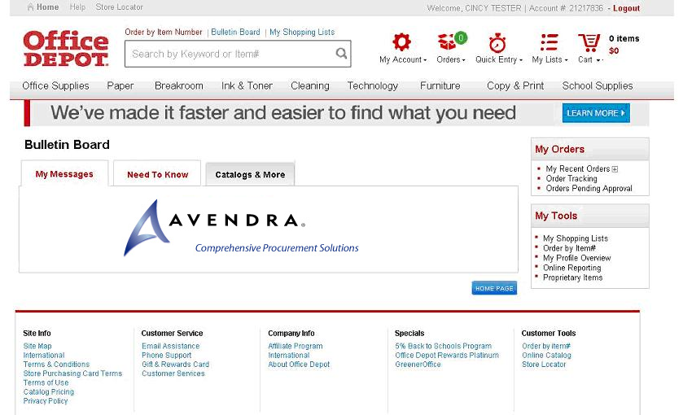
Help
Live Chat, customer service links, User Guide and online Demos

Search:
Type in product description: Office Depot or manufacturer product codes. Predictive search reduces keystrokes

View recent orders, Orders pending approval and track order status up to 360 days. Place Returns [See page 6 for details]

Order by Item #
Key in up to 20 product #s for simultaneous entry into shopping cart.
Help
Live Chat, customer service links, User Guide and online Demos

Custom Bulletin Board to keep you informed.

Building your order

  - Logon on to https://business.officedepot.com using the unique user id and password that you created
Step 2 Combine any of the following tools to build you order:  - Catalog: Click a category from the Product Navigation Bar and select the category or sub-category to view products.  - Search: type item Keyword or Item Number and click Search. A summary of matching categories and the top ranking items will appear. Choose a category or brand, or go directly to an item. Results can be resorted by: Best Value (Contract), Price and relevance. To filter search results by characteristics such as brand, size, color etc, click the desired characteristic listed on the left-side tool bar. | - Order by Item #: ** Enter the Office Depot, manufacturer, or custom product code numbers, then quantity , click Add to Cart ** Click the “Show Images” check box to view product images  - Quick Entry: Add a single item to order by entering Office Depot part # manufacturer# , or custom product code numbers, quantity then  - My Lists. Select Default or any Add preselected  - lists. To add an item to your shopping cart: enter the quantity desired, make sure the select box is checked, and then click Add to Cart. Hint: If the shopping list quantities are “0”, click “Select all” and populate quantity only on the desired items.
- ** Shopping Cart to review your selections, view Office Depot recommended savings opportunities, share your cart with another user, save items for later, or add to custom shopping lists.
- Checkout - Review selected items and shipping address and accounting field requirements; modify as needed. If the order is released to Office Depot by 5:00 it will be processed for next available day delivery

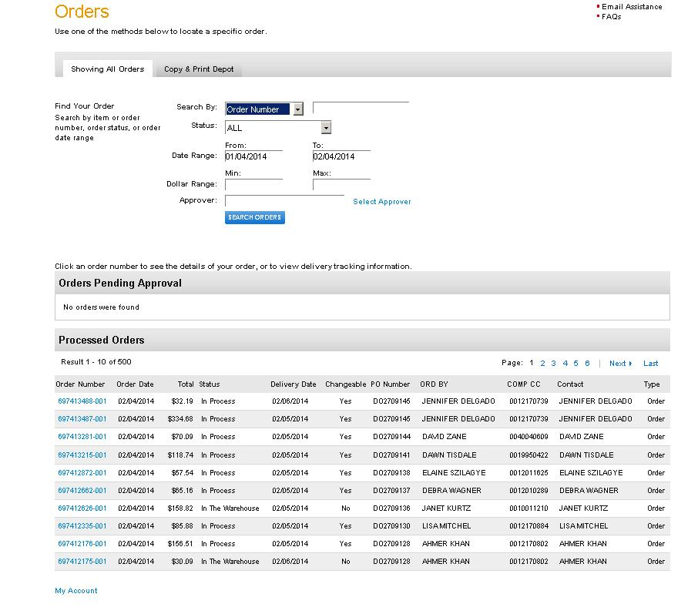
Search For orders by:
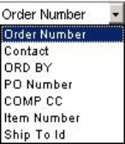
Search for orders by the following Status:
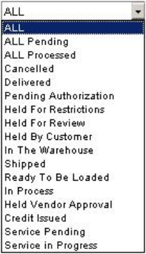

View recent orders, Orders pending approval and track order status up to 360 days. Place Returns [See page 6 for details]
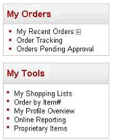
A
B
C

Date Range: Initial display is orders placed within the last 30 days. The search may be expanded to 12 Months.

Click on the Order # to view detail

Order Tracking
- To view orders, check order status, copy and reorder items, release orders hold orders, or request product return.
- Up to 12 month of order history is available
Searching for Orders  Orders are displayed descending chronologically (most recent orders at the top) If order is not visible on initial display, Use the following to search for orders.  . | Use the Search by  Order # Contact information Accounting field or by Item #  Order Status  Date Range, up to 12 months of orders can be searched. Initial display shows most recent orders within the last 30 days.
- Click or the blue order # to display order detail.

Order Detail

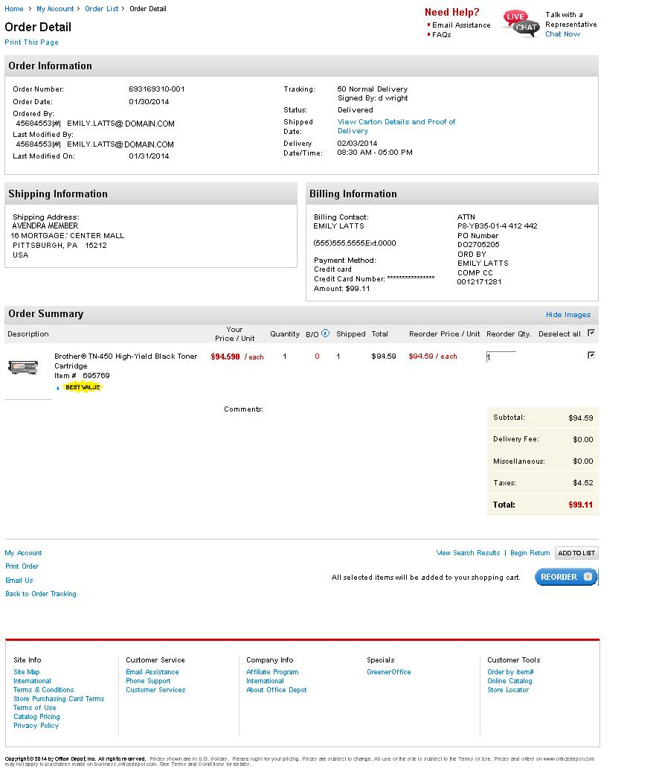
Copy an order to create a new one. The REORDER option may be used regardless of the order status.
Billing information including Delivery Contact details
If Products are eligible for return the order will display Begin Return option.
Order creator information
Shipping Address details
Links to Order tracking

