
Introducing Your Office Depot Coffee Program!
Brewer Cost $1.00
Installation Site Survey Checklist
Completing this checklist is mandatory for all equipment installations to insure our customer receives the highest quality installation service available.
Scan completed form and send to: elizabeth.henderson@officedepot.com
Questions Call:773-430-0602 Elizabeth Henderson

Type of Keurig Equipment Requested:
Keurig K150 (5-25 employees) Not Plumbed Quantity________
Keurig K150P (25+ employees) Plumbed (into water source) or Not Quantity________
Keurig K3000 (30+ employees) Plumbed (into water source) Only Quantity________
Type of Pour Over Equipment Requested:
Newco ACE TS Air Pot Brewer Plumbed (into water source) Only Quantity________
Newco ACE-LP Traditional Brewer 2 Warmers Plumbed Only Quantity________
Office Depot Account # 38560847-00005
Name of Building, Dept Name __________________________________
Address, Floor # __________________________________________
Contact Name_____________________ Phone # _________________________
Email Address ___________________________________
Where is the specific location of the installation within the building breakroom (s)? For example, First floor, Lobby, Executive Office, etc.______________________________
Are we replacing an existing coffee brewer? If yes does it require disconnection? _______________________
Approximately how far away (in feet) is the nearest water source from where the coffee brewer will be installed? ____________________________________________
Are there upper cabinets? If so what is the approximate counter to upper cabinet height? _________________
Please Note – Installers will not run water lines through ceilings or walls or drill through stone countertops. If backflow preventers are required by county code – Client is responsible for such installation.
**Delivery will be to UD Central Receiving

Keurig Models
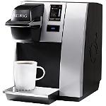K150 & K150P 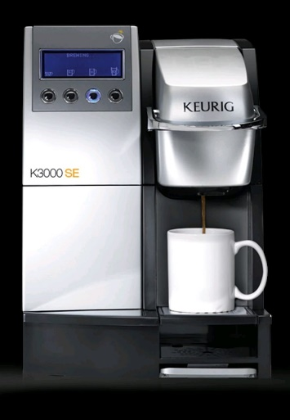 K3000
(Plumbed or Not Plumbed) (Plumbed only)

Traditional Brewers
