

Ordering products with Office Depot will differ from your standard, Ops vendors. Office Depot is setup as a punchout vendor which means rather than Ops hosting a catalog for us, we host our own catalog for our customers on their website. This catalog is still unique to each customer so you will see only the items that have been approved by your management company.
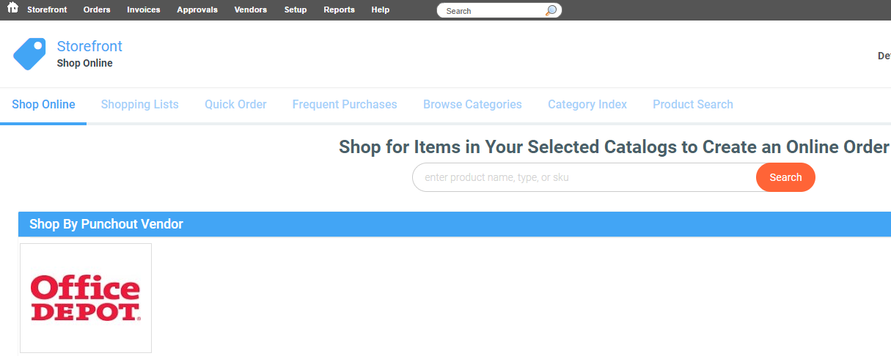To access the punchout catalog for Office Depot you can follow the steps below:
- Click Storefront from the toolbar
- Click on the supplier hosted catalog for Office Depot in the “Shop by Punchout Vendor” section
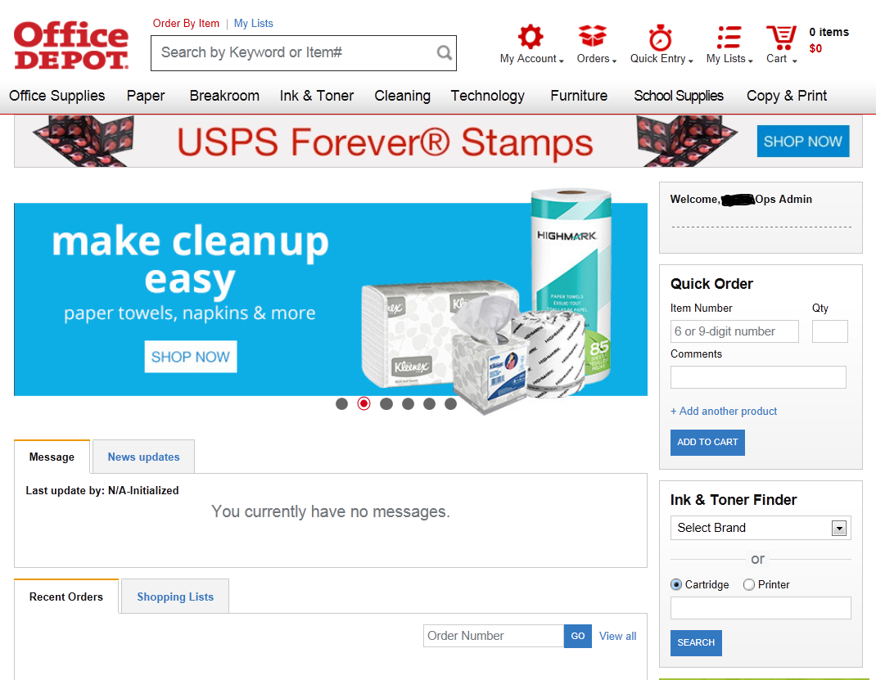
From the home page you can view recent orders, view shopping lists that you have setup for your most commonly purchased items or you can use the tool bar across the top of the page to search the different categories for your needs.
There is also an option on the right hand side to place a quick order. This is useful if you know the sku of the item needed. You can simply add the sku and quantity and add the item to your cart.
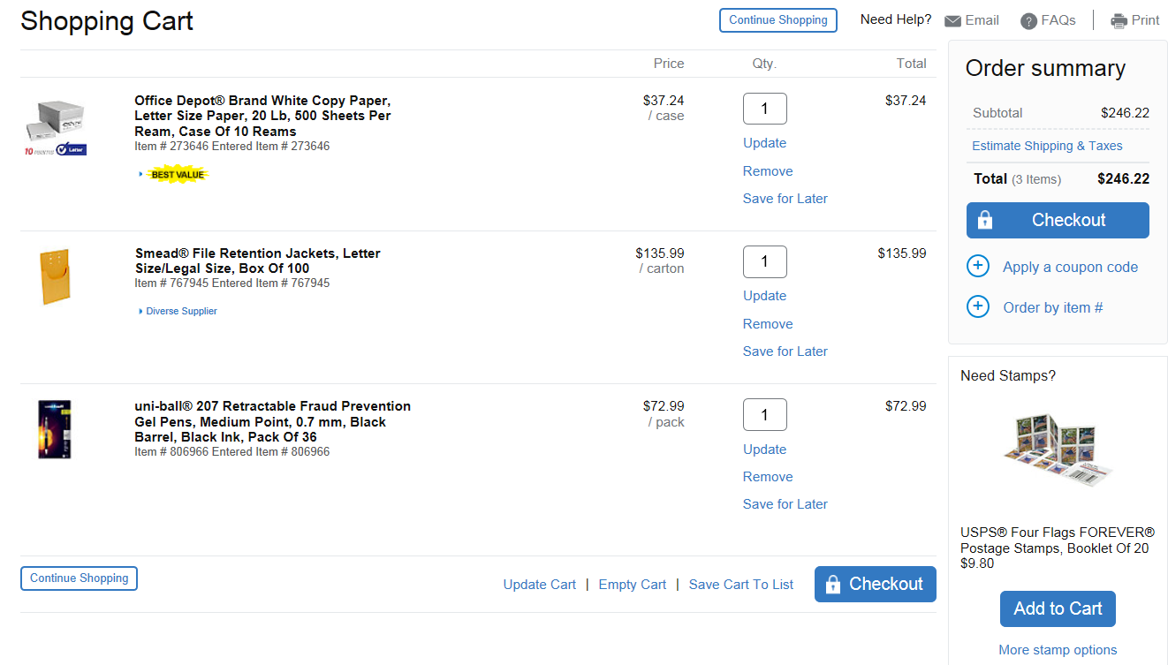
You will shop via the punchout catalog similarly to how you would shop online. Find the items you need, add the quantity and add them to your cart. Once you are ready to check out, simply click “Checkout.”
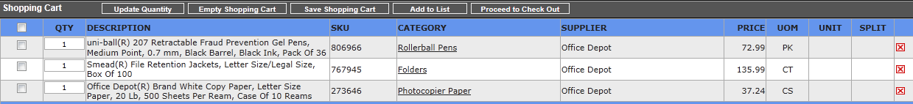
This will put you back into your OpsTechnology account where you can complete the order as usual and electronically send it to Office Depot.

THINGS TO REMEMBER
- IF YOU ARE WORKING ON A SPECIAL PROJECT OR HAVE A BULK PURCHASE, CONTACT YOUR ACCOUNT MANAGER FOR ASSITANCE OR A SPECIAL QUOTE.
- Account Managers: Joey Garrison: joey.garrison@officedepot.com or Patti Huddleston: patricia.huddleston@officedepot.com
- PLACE ORDERS BY 5:00 P.M. LOCAL TIME FOR NEXT DAY DELIVERY in most cases
- ORDER TRACKING – Allows you to view 18 months of your order history

DELIVERY & SHIPPING
Deliveries to all major markets are scheduled for the next business day. Orders must be submitted by 5:00 p.m. local customer time. Please note that items in your order may be delivered from separate warehouses, which may result in multiple boxes/deliveries for one order.

RETURN POLICY AND PROCEDURES
Please, use these guidelines to assist you in handling a return request.
- Returnable items include any products sold by Office Depot.
- Merchandise must be returned within 30 days of the original delivery date
- Items should be in their original packaging.
- Returns must be requested via phone with Customer Service 1-888-777-4044

To ensure accurate credit and pick up, please have the following information available. The information is located on your packing slip, internet (account history) or by calling the Customer Service 1-888-777-4044
- Account number
- Original order number
- Item (SKU) number of product being returned
- Reason for the return
- Contact Information for Customer Service Representative or the driver

RETURN EXCEPTIONS
- Items not in the original packaging.
- Custom or imprinted items (unless produced incorrectly or delivered defective).
- Special order items (unless received in error from the manufacturer).
- Dated items must be returned within 30 days of purchase.

Once your return request is processed, your Customer Service Representative will provide you with a RETURN AUTHORIZATION NUMBER and inform you of the process, which will take place to pick up the item and deliver a new item or process the credit due.

