Field Ecommerce Frequently Asked Questions
Q. What is the Field Ecommerce Team?
A. Five associates, called Ecommerce Consultants, who support the Field Selling Team and customers with various Ecommerce solutions. They are liaisons between Sales, customers and the Integration Team.

Q. Who are the members of the team and what regions do they support?
A. Carrie Russell, Wendy Jenks, Patti Paul, Ryan Libunao & Alex Gibson. Here is a coverage map. Alex Gibson is at HQ working mainly on BSD requests and issues.

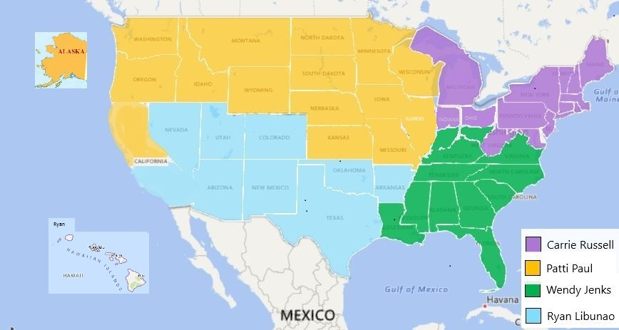

Q. How do the Ecommerce Consultants provide support to Sales and customers?
A. Here are some examples:
- They work closely with their regions to ensure Account Managers know the BSD site and can sell it confidently to their customers.
- They are the “go to” subject matter experts for customers interested in third party integrations, assisting with answering questions and handling discovery for integrations then transitioning the project to the Integration and Implementation Teams. Click here for more information about third party integrations.
- As the Voice of the Customer and Sales, they will be working closely with the Development Team providing valuable feedback related to enhancements and communicating upcoming changes to the field so customers will be prepared when they go live in the system.
- Account Managers and customers can send the Ecommerce Consultants suggestions for system enhancements then the team will work with Development prioritize the requests.
- The Team participates in CEWS training sessions reviewing key subjects related to the BSD website.
- They can assist with consulting on complex web account and user setups.
- When Ecommerce Field Support requests are submitted in Salesforce they are assigned to the Ecommerce Consultant supporting their region.
- They report critical customer issues with the BSD website to the Development Team so they can be fixed.

Q. How do I request assistance from the Field Ecommerce Team?
A. Submit an Ecommerce Field Support request in Salesforce, not an Account Maintenance request. Here are the steps. If you have an account specific request make sure the account number is included in the ticket.

Q. If a customer is ready to integrate with Office Depot and their third party system, what do I do?
A. Submit an Account Maintenance/Implementation Team/Assign Implementation Manager request for an Implementation Manager. Then submit an Ecommerce Field Support request for an Ecommerce Consultant. Provide the technical contact’s information and any other information about the project such as the transactions to be integrated and system the customer will use.

Q. What will the Ecommerce Consultant do for an integration?
A. They will handle the project discovery for the technical aspects for the project then submit a request for an Ecommerce Analyst via a JIRA. The Ecommerce Analyst is the person who works with the customer’s technical team to setup and test the integrated documents.

Q. If I have a customer with an issue on the BSD website who can help me?
A. Contact the EC Support Team either via email at ec.support@officedepot.com or phone 800 269-6888. They should be able to help with most technical questions and issues. You can copy your regional Ecommerce Consultant.

Q. Who can help if my customer using a third party system is having issues with punchout or orders after they have gone live and are placing orders in Production?
A. Email b2bsupport@officedepot.com and make sure the account number and screen shots or a detailed description of the issue is included. You can copy your regional Ecommerce Consultant.

