Salesforce Communities - Layout Options
Internal Use Only

- Message may be removed or one of 4 standard messages may be selected,
See: Exhibit A
- Customer Logo may be inserted. Logo area will be resized to fit: 360 pixels wide by 110 pixels high
- Register - User registration for online ordering. See Exhibit B
- Benefits section may also be blocked.
- Request a separate account. Setup under common Parent. See Exhibit C
- Optional - IMPORTANT DOWNLOADS - Link to Store Purchasing Card and other websites and documents.
- ACCOUNT INFORMATION - Account Representative assigned to the Account. The information is based upon Account Manager’s Salesforce profile.

Areas marked with *are optional may be removed from the page:
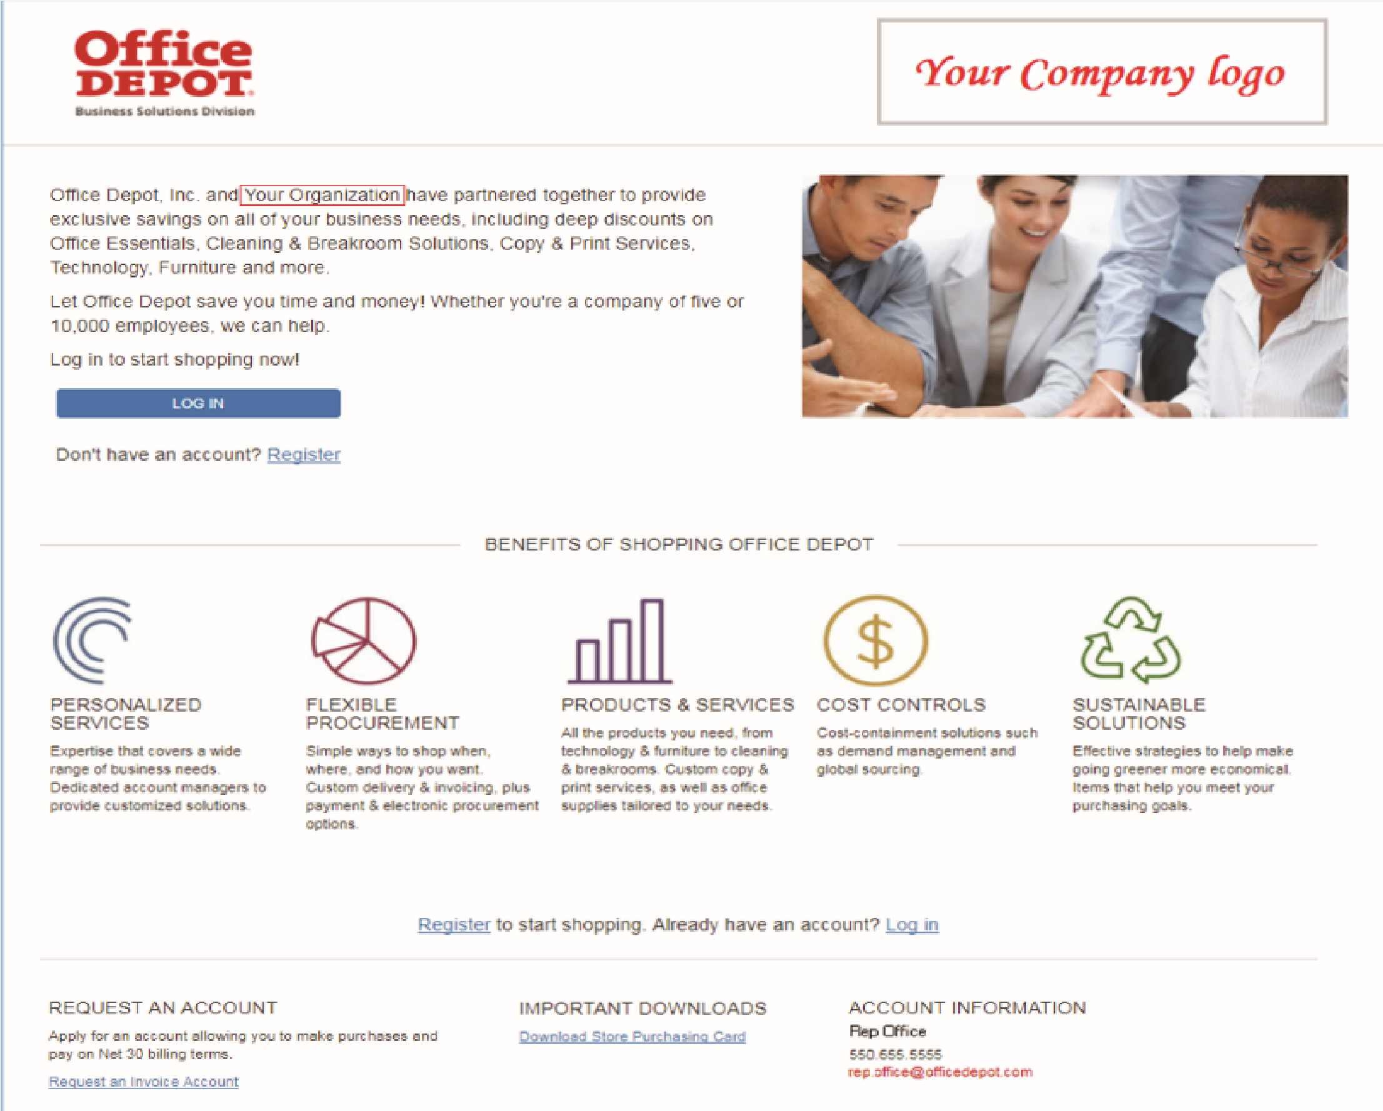
*

B.
*

A.
F.
G.

C.

*

D.

*

*

*

E.

Exhibit in A

Standard Message 1  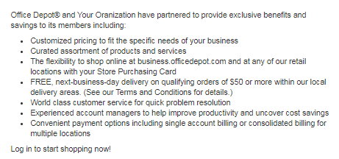  Standard Message 3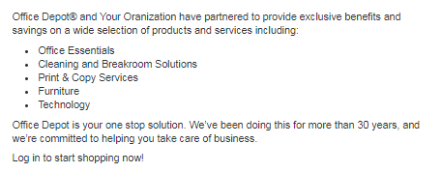 | Standard Message 2  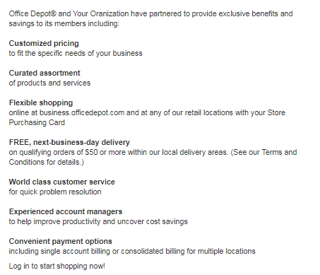  Standard Message 4  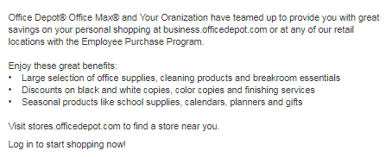

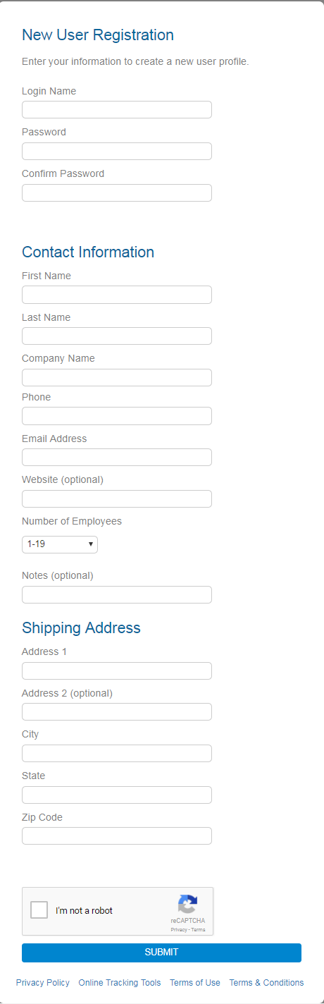
Exhibit in B
The user completes this simple user registration
form,

If Public community, and all information entered is complete and accurate, will result in immediate user setup for online purchase with credit card.

If Private community, all information entered, is held approval queue until Private Community Administrator approves the user setup request.

This is a standard registration form. Areas marked with *are optional may be removed.
*

*

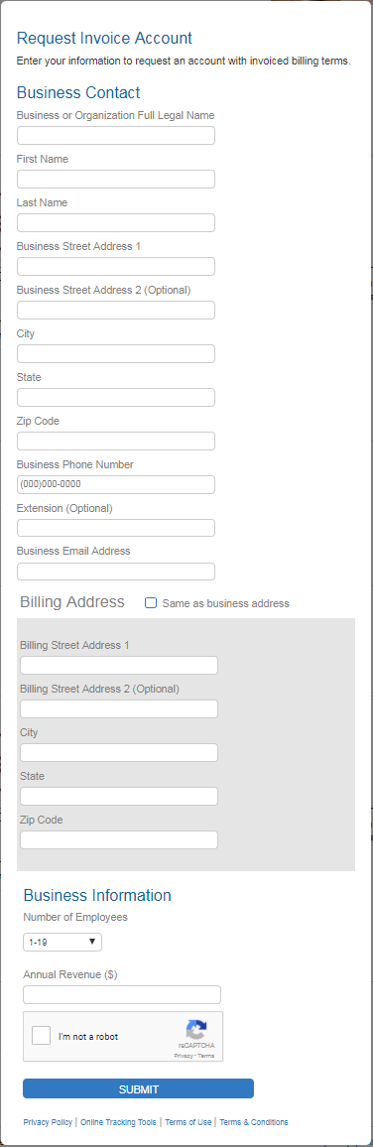
Exhibit in C
This form will be used to collect information required to setup a separate account under the associated Parent.

The information gathered on this form will be held in a salesforce case queue and Office Depot customer service administrative associate will create the account following procedures laid out on the form.

