Office Depot Internet Instructions for Approvers

Placing an Order
- Use browser to access the Internet and type in http://business.officedepot.com
- Type in your Login Name: Email address
- Type in your Password: welcome
- Click on (Note: You may click Keep Me Logged In button as this will bypass the login page in the future, however if you have more than one login please do not click the Keep Me Logged In button as you will not be able to access more than one login.)
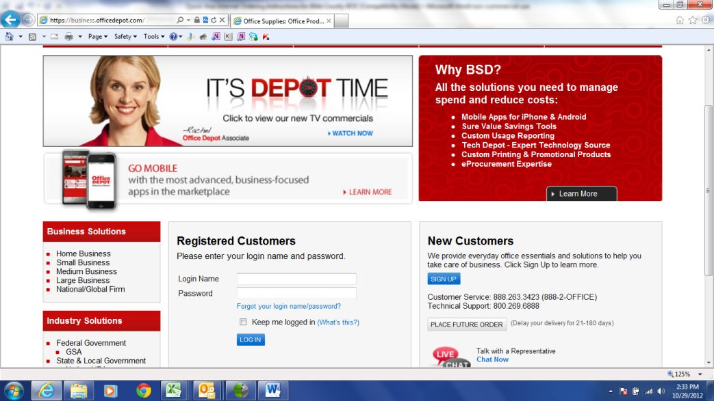

- You will be asked to change your password. Please put welcome as the old password then select a new password and confirm the new password. (must be 6-10 alphanumeric characters)
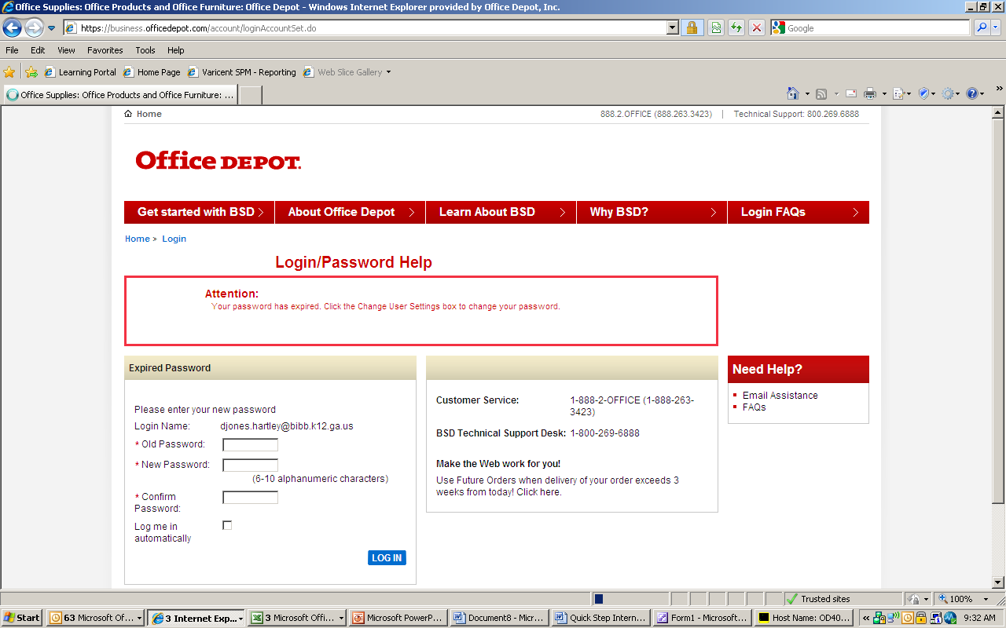

- You will then be asked to Update a Security Question (Please answer the security question so in case you forget your password, you will be able to easily retrieve it by clicking forgot password.)
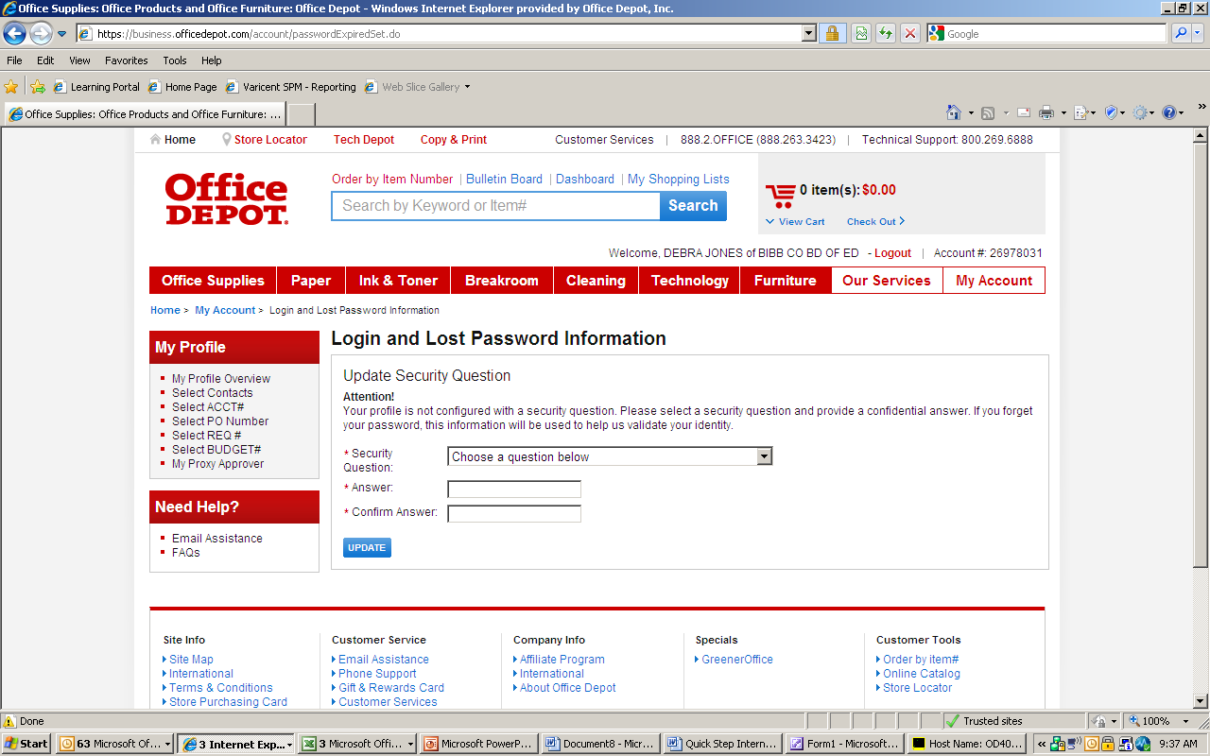
- Put your curser of your mouse over the red and white tab My Account and click Order Tracking.
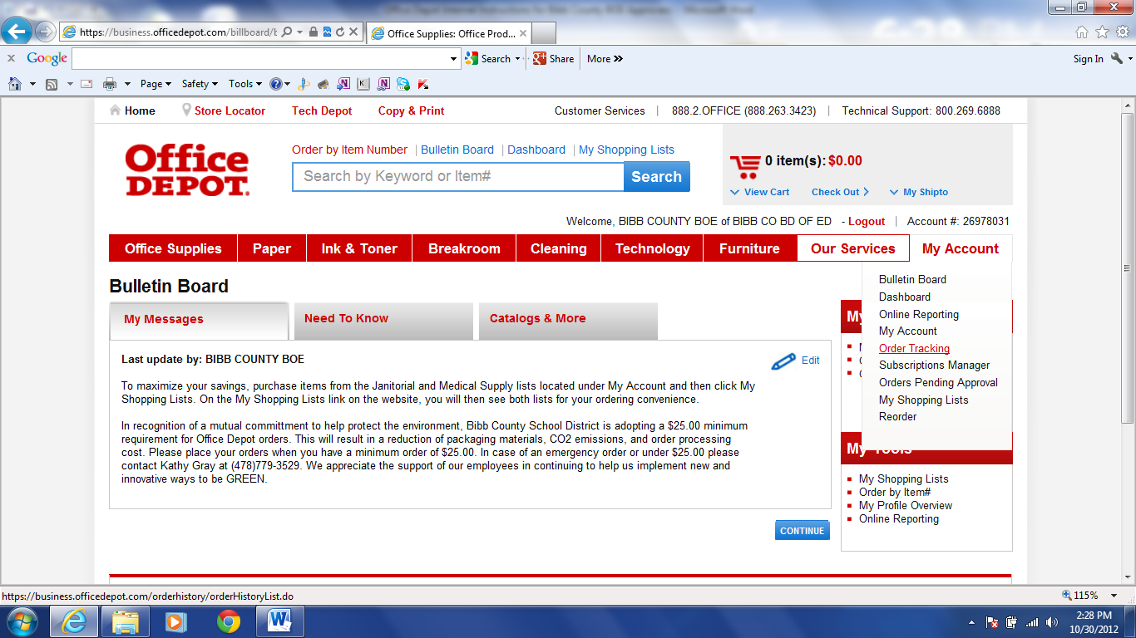
- The screen will automatically display all of your orders on hold under Orders Pending Approval and any orders that have been approved, as well as, credits and returns for your account settings for one month under Processed Orders. Click on the blue order number under Order Number for the order you will need to approve. (NOTE: Your name will be under Approver if you need to approve. You may view up to a year of your orders by Search By, Status, Date Range, Dollar Range, and Approver.) 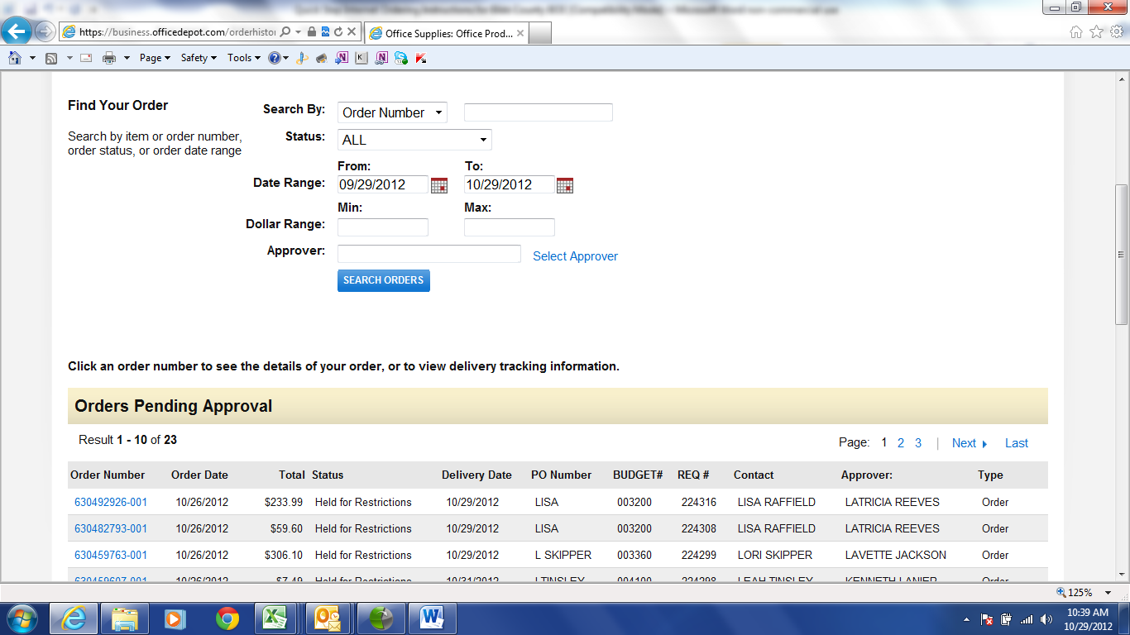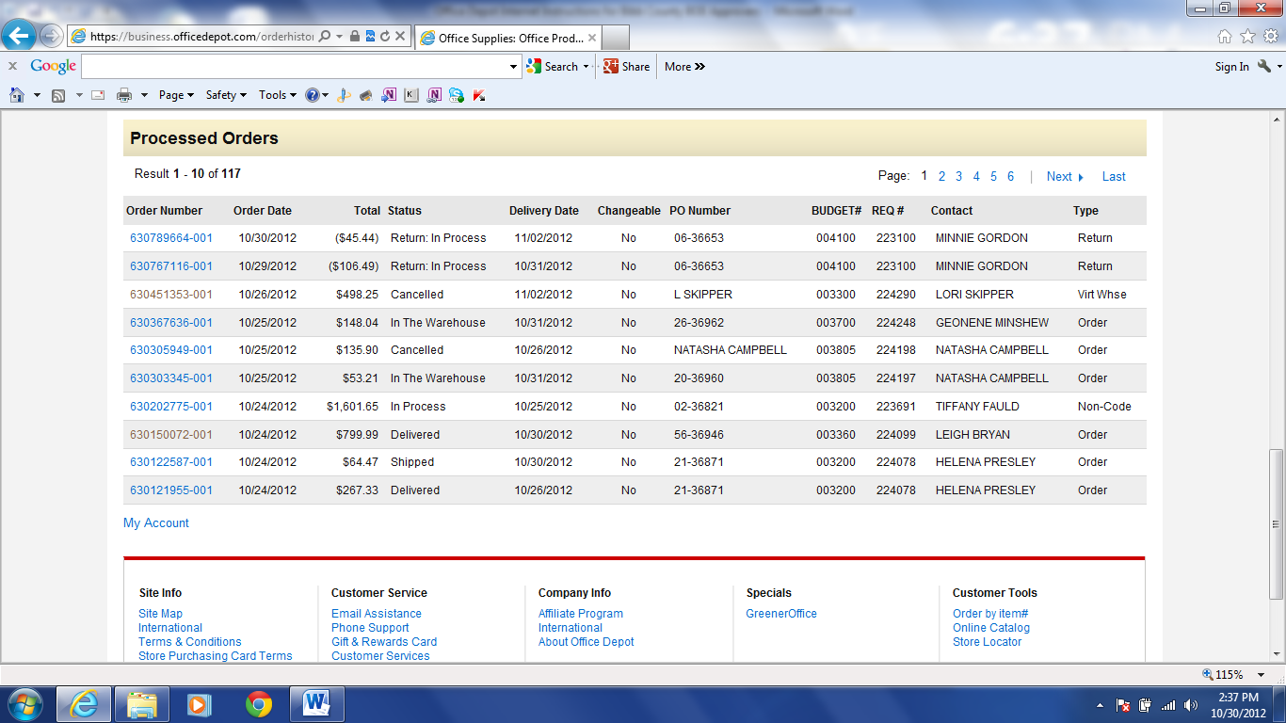
- Scroll down to Workflow Status and you will see the status of who has approved the order (unless you are the first person to approve the order) next to Approved By and who the next person is who needs to approve the order next to Pending Approval By.
Review the merchandise under Order Summary and if you approve the order click the radial button next to Approve and then click the blue GO button. If you disapprove of the order, click the radial button next to Disapprove and add comments of why you are not approving the order. Then click the blue GO button. (Note: You must click the blue GO Button after you approve or disapprove the order. If the order has been disapproved, then the person who created the order will need to modify the order and follow the directions of the comments of why the order was disapproved before resubmitting the order back through the approval process.)
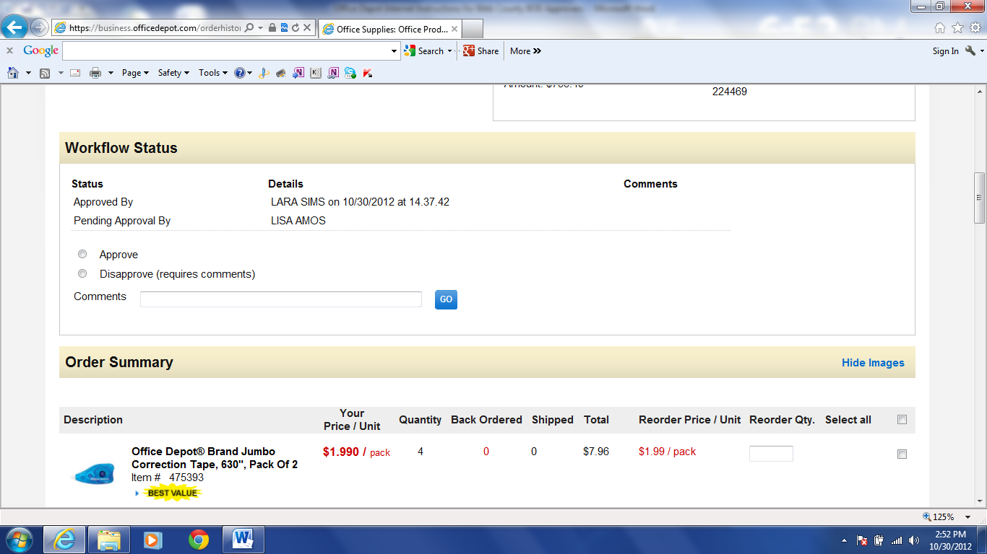
- Once you have approved the order, click back on Order Tracking under the red & white tab My Account to check that the orders you have approved are waiting to be approved by the next approver.

- You will no longer see your name as the approver, but the next person who needs to approve the order under Approver. If there is more than one order, you will need to approve each order. (NOTE: Your name will be under Approver if you still need to approve.)

Online training is available in the Customer Service section of the website or you may call the Internet Help Desk at 800-269-6888 for additional assistance.

