Office Depot Internet Ordering Instructions

Placing an Order
- Use browser to access the Internet and type in http://business.officedepot.com
- Type in your Login Name: Email address
- Type in your Password: welcome
- Click on (Note: you may click Keep Me Logged In button as this will bypass the login page in the future, however if you have more than one login please do not click the Keep Me Logged In button as you will not be able to access more than one login)
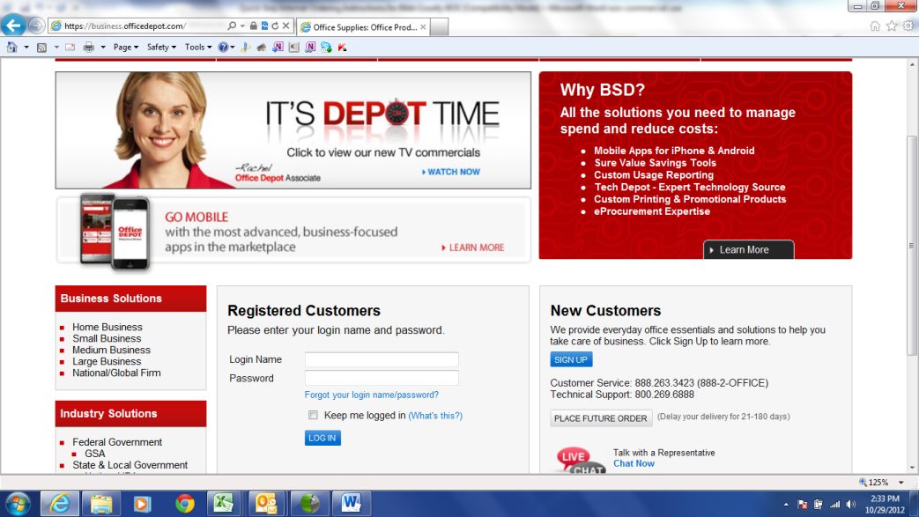

- You will be asked to change your password. Please put welcome as the old password then select a new password and confirm the new password. (must be 6-10 alphanumeric characters)
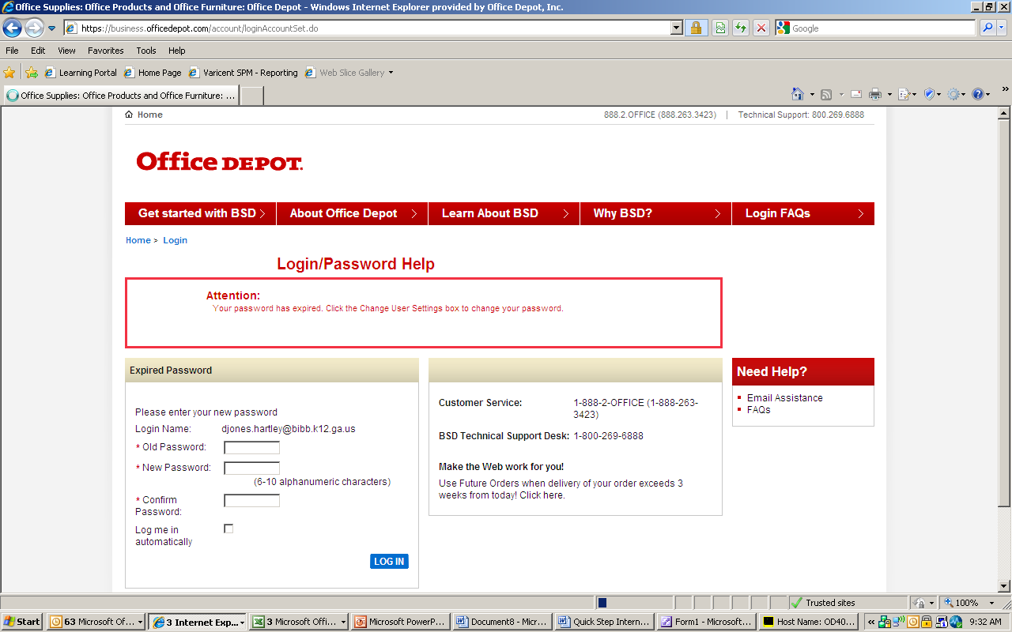

- You will then be asked to Update a Security Question (Please answer the security question so in case you forget your password, you will be able to easily retrieve it by clicking forgot password.)
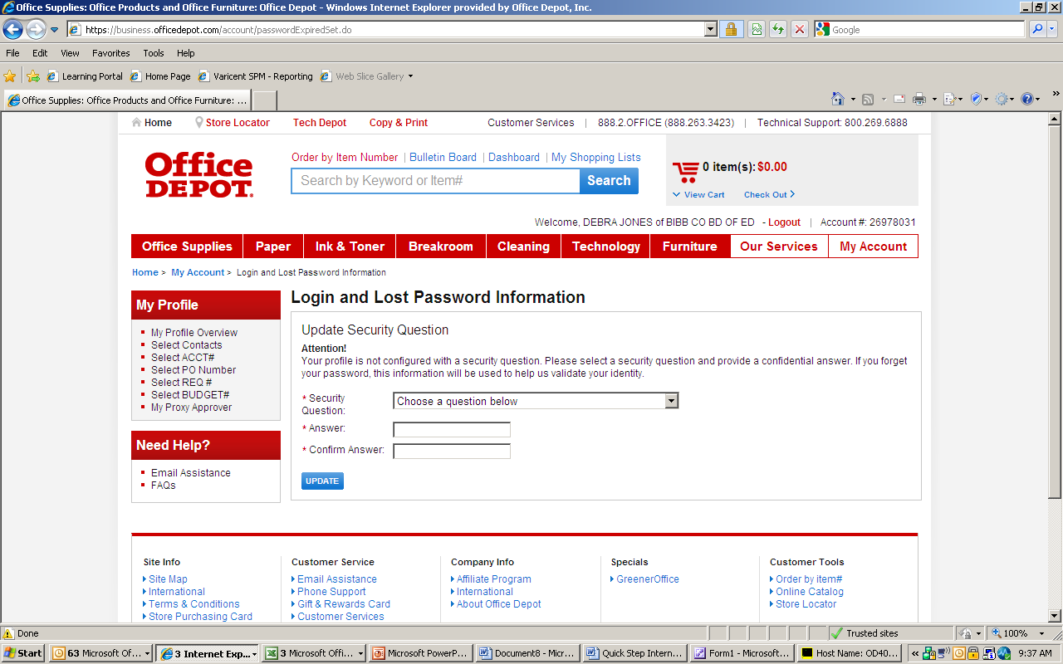

- If you know the item number(s) for the product(s) you wish to order click Order by Item Number above the Search field.
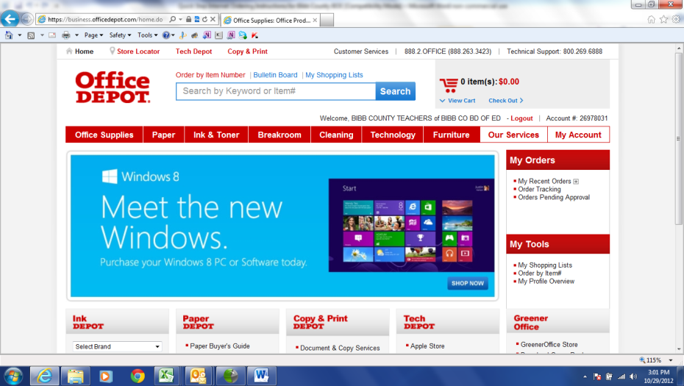

- Check the box Show Images if you want to view the images when you input the items. Type in Office Depot Item #, quantity, and comment, if desired. Then click Add to Cart at the bottom of the page.
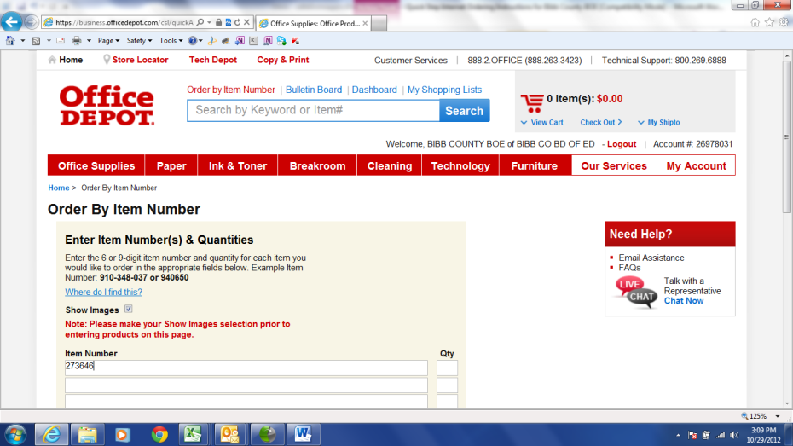

- If you do not know the item number(s) for the product(s) you wish to order, you can:
Search for product using key words or manufacturer part numbers by entering the information in the space provided in the blue toolbar and then clicking Search or pressing enter. You may, also, browse by the Red Tabs at the top of the page (Office Supplies, Paper, Ink & Toner, etc.)
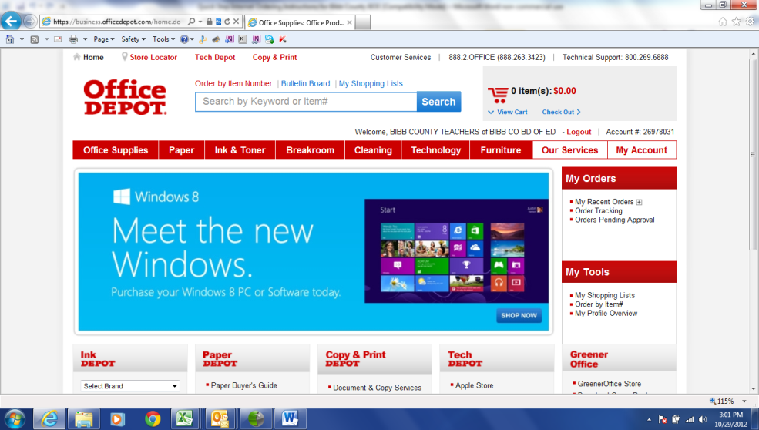
- Put in quantity and click Add to Cart to add your desired product to your shopping cart.
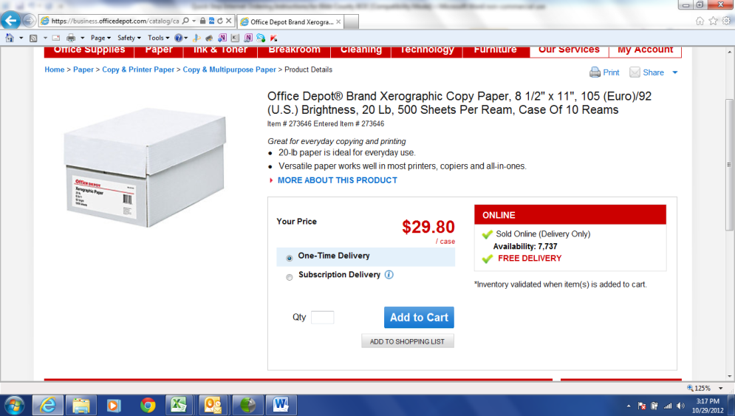
- Select Continue Shopping to continue or Check Out from the shopping cart in the top left if you have finished shopping. (Note: If you do not have your requisition number, you may want to save your items that are in your cart for a later time until you have retrieved one. Go to next step below (Step 12). If you want to check out, skip to step 16.)
. 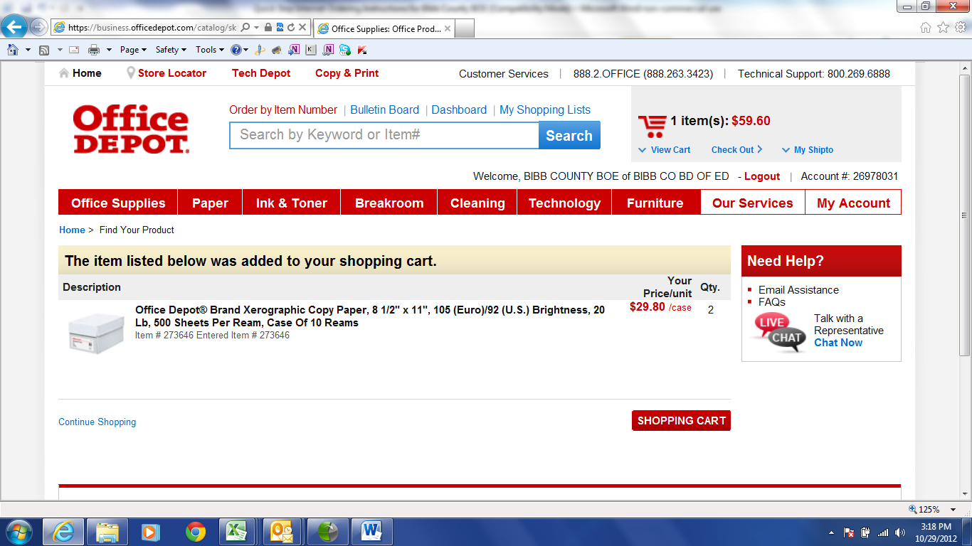
- If you do not have your requisition number, you may want to save your items that are in your cart for a later time until you have retrieved one. Click on View Cart at the top of the page next to Check Out. Then click Save Cart To List at the bottom of the page next to CHECK OUT.
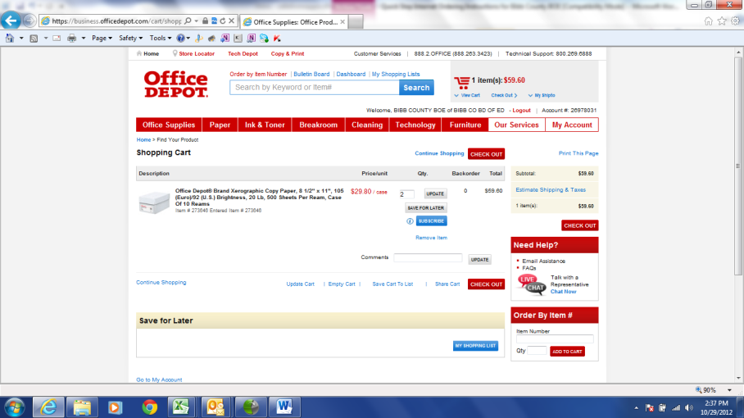

- You will then click Select an Existing List and click the drop down arrow box and choose Save
For Later (NOTE: This will be the name of your list.) Then Click ADD TO LIST
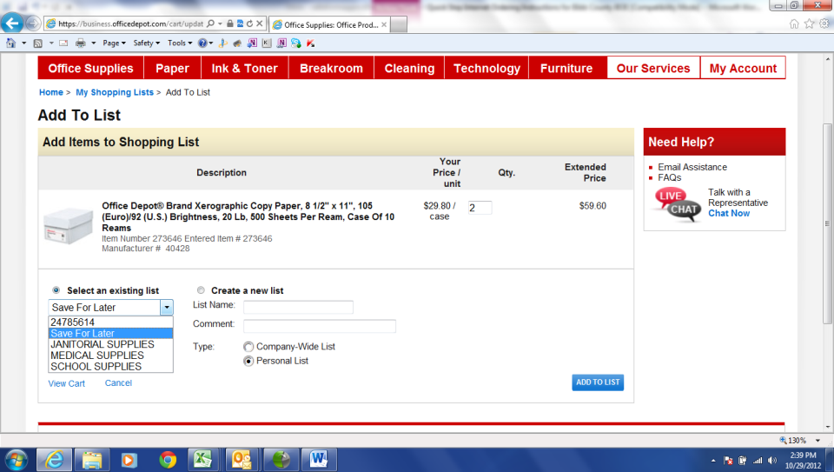
- When you have retrieved a Requisition number, log back in and put your curser of your mouse over the red and white tab My Account and click My Shopping Lists.
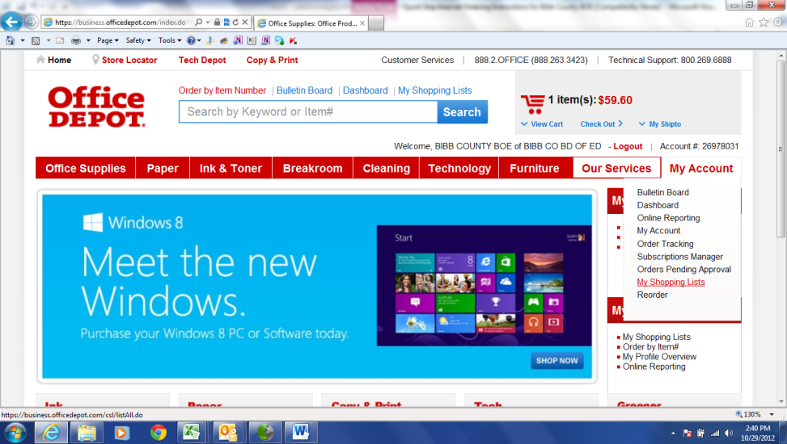
- Scroll to the bottom of the page under Current Lists and click Save For Later List. Select the desired items or Select All to put the desired items in your shopping cart and click ADD TO CART. This will then bring you back to your shopping cart. Click Check Out at the top of the page and follow directions below. 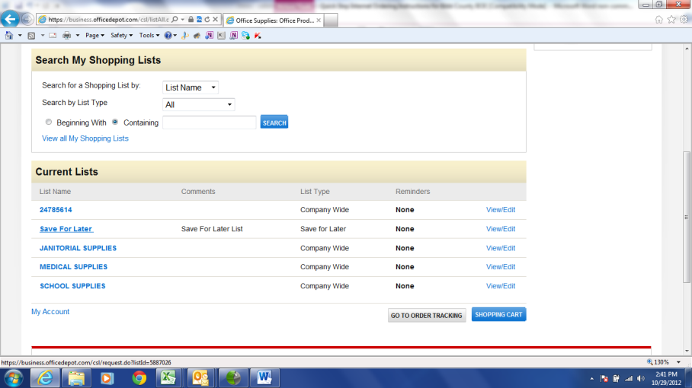
- If you are ready to place your order, click on Check Out at the top of the page under the red shopping cart. You will then see the screen below. If you have the option to select more than one shipping address you will see the blue SELECT button.
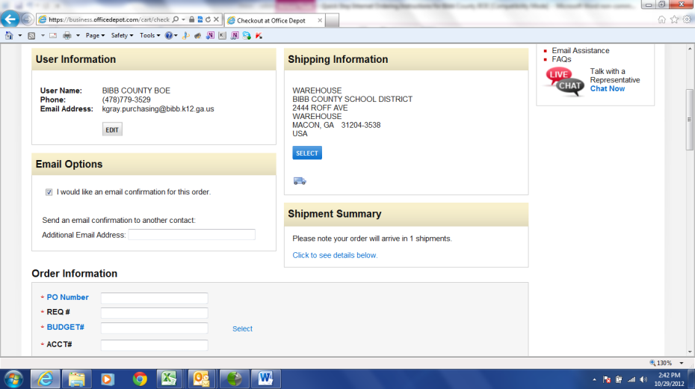
- If you need to change the shipping address click the SELECT button. You will see a list of addresses. Click the radial button under Current next to the desired address you would like the order to be shipped to and then click the SELECT button. This will bring you back to the Check Out page.
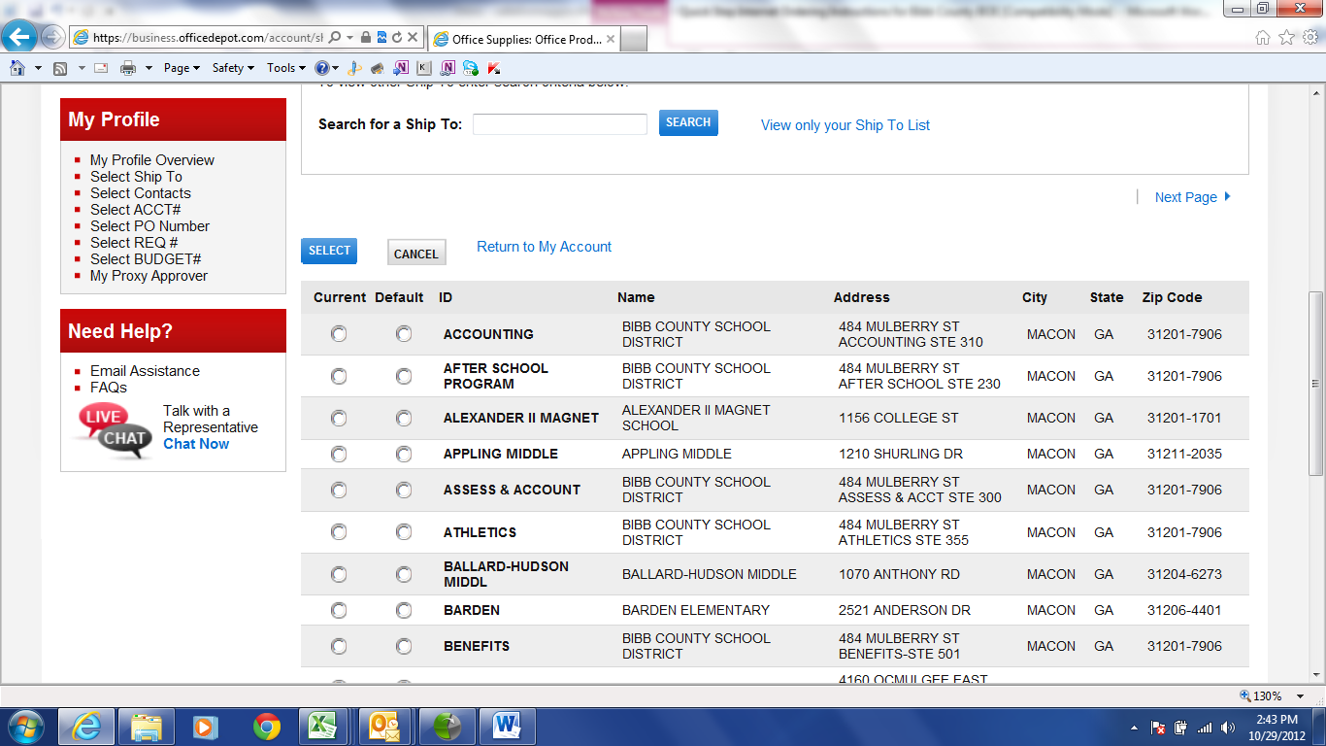

- There are four required fields you must fill out before placing your order:
PO Number: Your full name, REQ #: Your requisition number (ex. 224316), Budget #: This should be your last six digits of your account number (ex. 003200), ACCT #: This should be your account number no dashes or spaces (ex 1003240061000011). (Note: Since you have entered your budget number already you will not need the last six digits of the account number.)
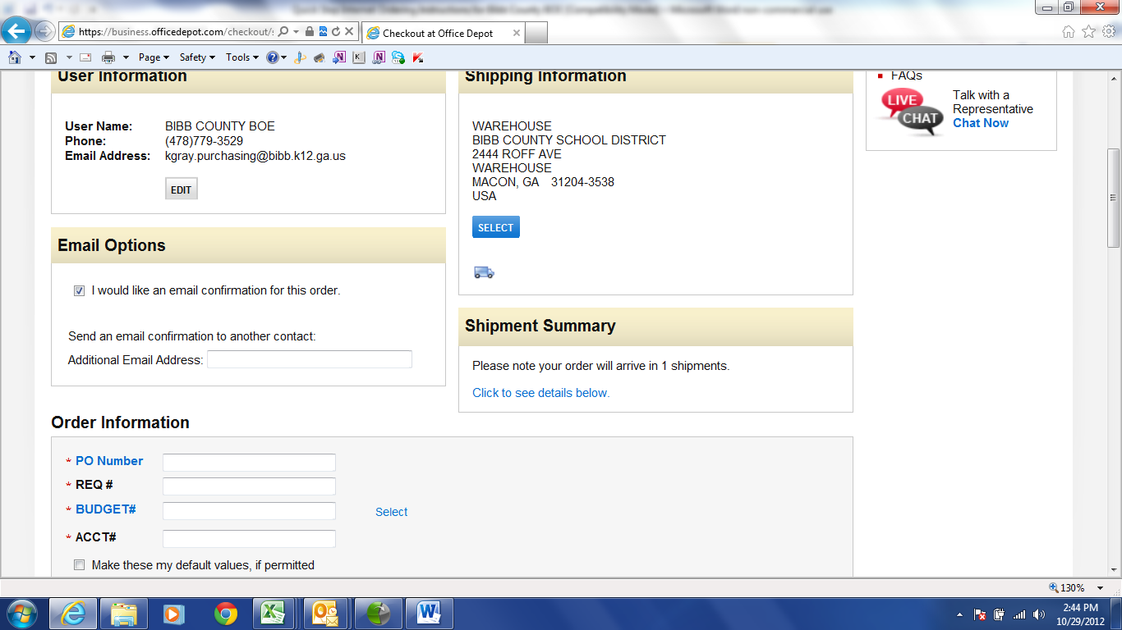

- Changing the Date-On the checkout screen in the middle of the page, you will see Delivery Options.
Under For Standard Delivery, click the dropdown arrow and this is where you can change the delivery date. You will have the option to change the delivery date out to twelve days. NOTE: Right under Delivery Options is the Shopping Cart and then your Estimated Delivery Date. So if the estimated delivery date is not the date you want the merchandise to be delivered, then change the delivery date under For Standard Delivery.
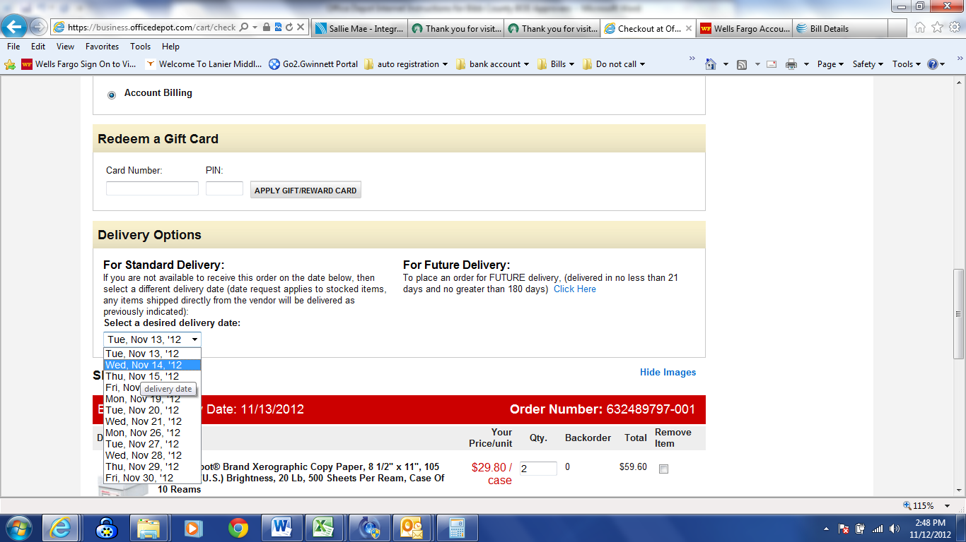

- You now have two options SAVE CART TO LIST or PUT THIS ORDER ON HOLD
  - If you are satisfied with your order, select PUT THIS ORDER ON HOLD.
When placing an order on hold, your inventory will be held for 24 hrs. When you see, “Thank you for your order and your confirmation number”, your order has been successfully completed, but will remain on hold until a designated approver releases the order. (Note: If the order has been disapproved, then the person who created the order will need to modify the order and follow the directions of the comments of why the order was disapproved before resubmitting the order back through the approval process.)
  - If you would like to save the items in a list but not create the order select
SAVE CART TO LIST (NOTE: This is the same as steps 12-15)
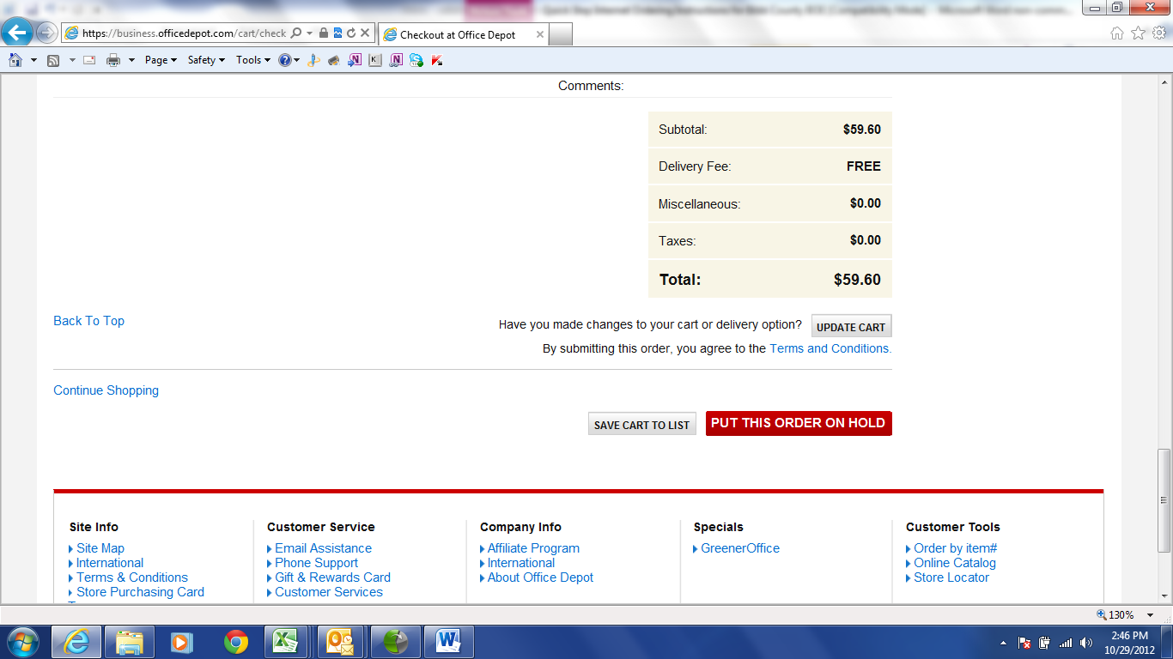
- If you have clicked PUT THIS ORDER ON HOLD, you will see the below confirmation screen.
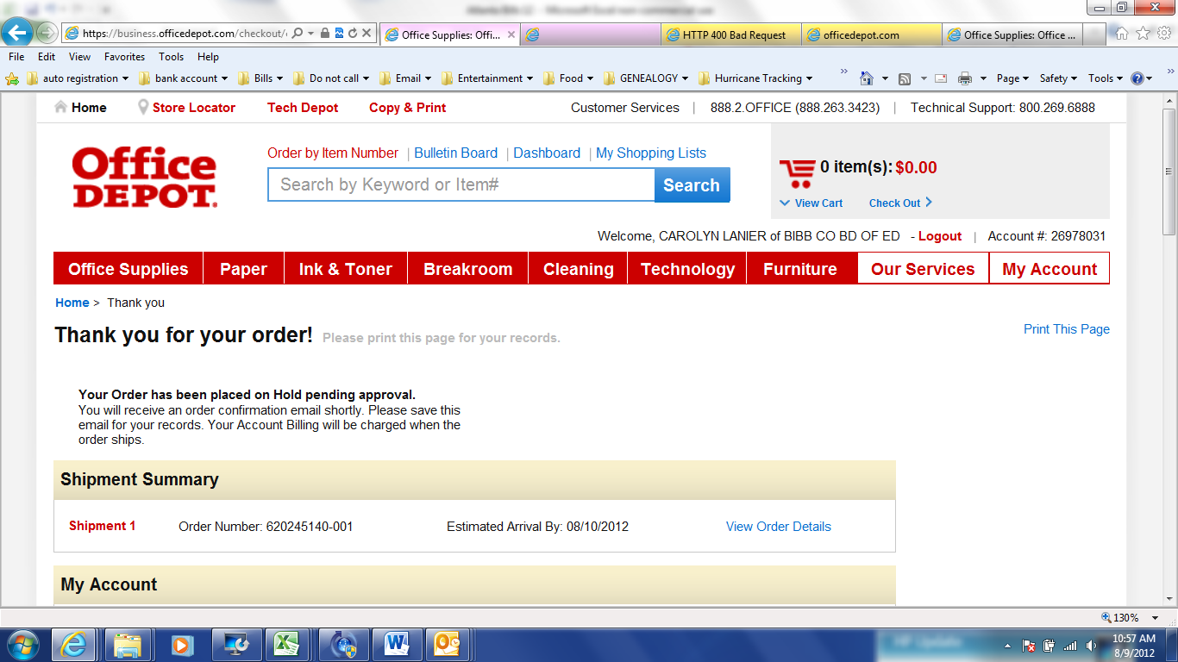
- You may, also, put your curser of your mouse over the red and white tab My Account and click Order Tracking. The screen will automatically display all of your orders on hold and any orders that have been approved, as well as, credits and returns for your account settings for one month. You may view up to a year of your orders by Searching by Order Number, Status, Date Range, Dollar Range, and Approver. (Note: If you have just placed an order, you will automatically see it in Order Tracking with your contact name and who the approver is currently pending to release the order. If you do not see your order here that you have recently placed, then your order has not been placed. You must make sure that you have clicked the place order on hold button to have completed your order.)
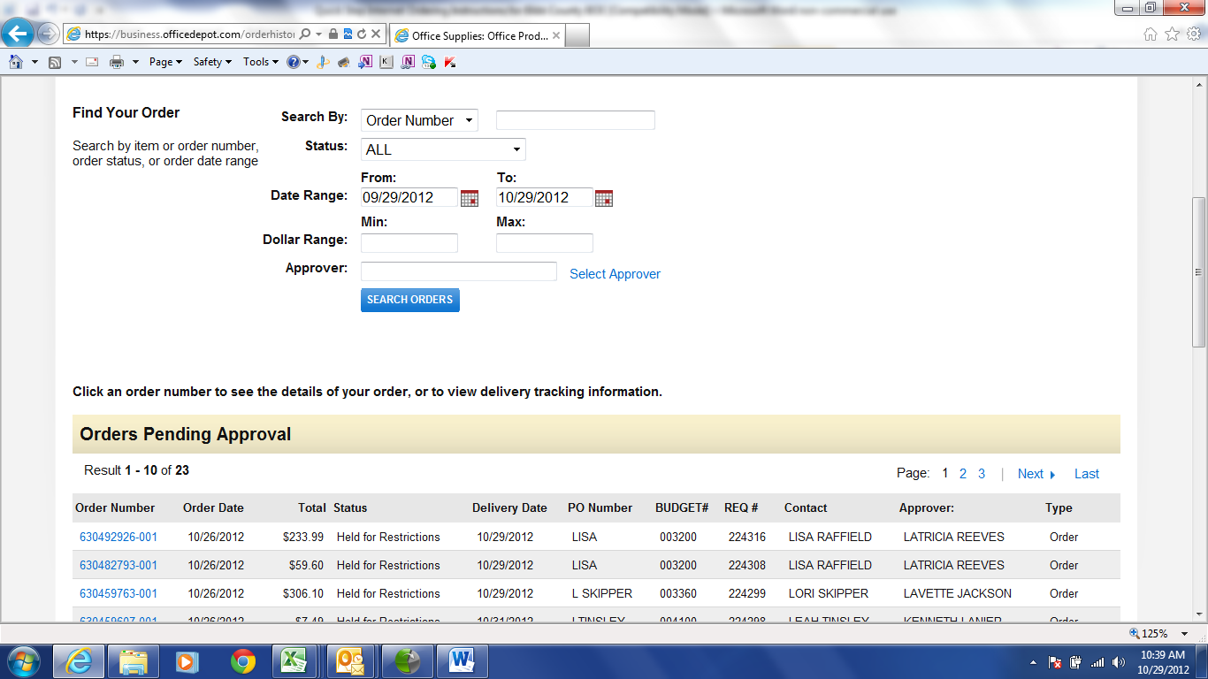
Online training is available in the Customer Service section of the website or you may call the Internet Help Desk at 800-269-6888 for additional assistance.

