Punchout
User Guide

Technical support: 800.269.6888 • Customer Services: 888.263.3423

Home
The landing page includes 2 tiles for messages to keep you informed. Just click Read More to view details.

Shop for products by category.

For Office Depot services such as:

Print and Copy, Coffee Services, PrintIQ, Shredding Services, Tech Services, Water Services, Workplace Interiors.

Shopping Lists and Order Tracking

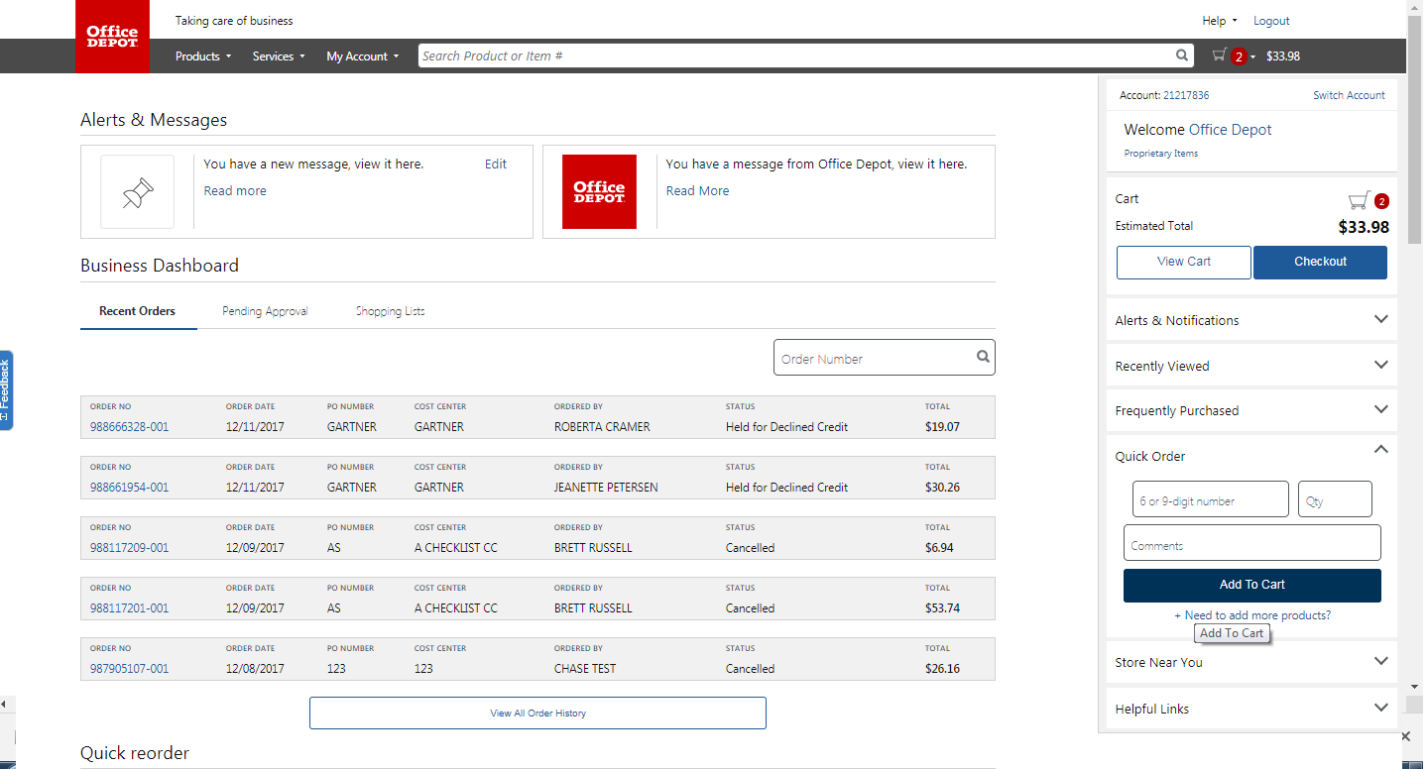
Office Depot Business Solutions Division • Punchout User Guide
Search:
Type in product:
description
Office Depot or manufacturer product codes.
Predictive Search reduces keystrokes.

Enter product and quantity or click
to enter up to 20 items.

Building Your Order

  - Punchout from your procurement system by clicking the Office Depot catalog.

Step 2 Combine any of the following tools to build you order:  - Catalog: Click a category from the Navigation Bar and select the category or sub-category to view products.  - Search: Type item Keyword or Item Number and click Search. A summary of matching categories and the top ranking items will appear. Choose a category or brand, or go directly to an item. Results can be resorted by: Best Value (Contract), Price and Relevance. To filter search results by characteristics such as brand, size, color etc, click the desired characteristic listed on the left-side tool bar.  - Quick Order: Enter the Office Depot, manufacturer, or custom product code numbers, then quantity and click Add to Cart. For multiple items click:  Click the “Show Images” check box to view product images and details. Enter up to 20 items at once. | - Shop from Personal or Company Wide Lists. Click then My Lists. To add an item to your shopping cart: enter the quantity desired, make sure the select box is checked, and then click Add to Cart. Hint: If the shopping list quantities are preset to “0”, simply click “Select all” and populate a quantity only on the desired items.
-  Review your selections, view Office Depot recommended savings opportunities, save items for later in a shopping list, or add to custom shopping lists.

- - The shopping cart items are returned to your procurement system and the Office Depot session ends. *Purchase orders received by 5:00 pm local time will be processed for next available day delivery.

Office Depot Business Solutions Division • Punchout User Guide

Checking Orders
Processing Returns
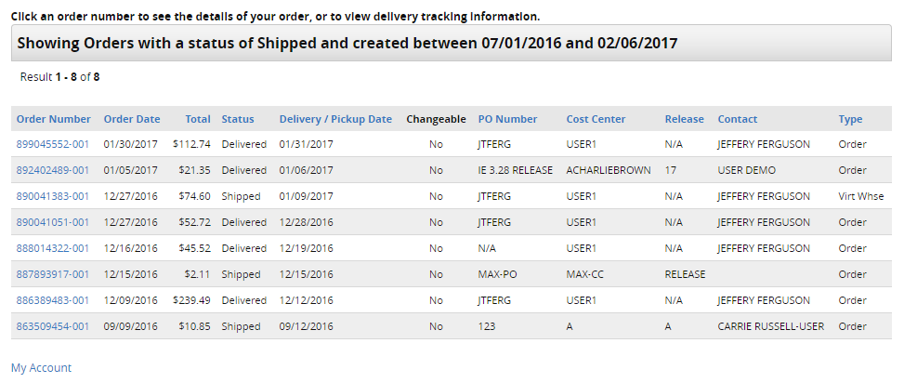
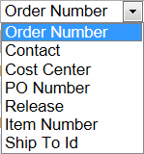
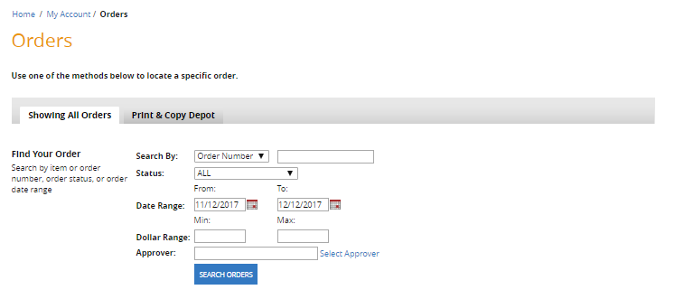
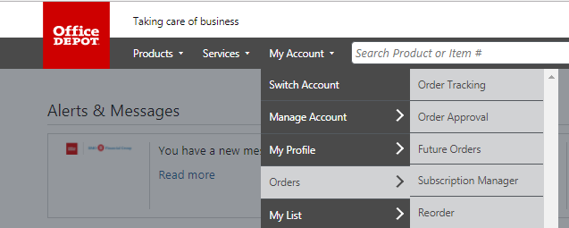
Search results are displayed in descending chronological order.

Click the Order Number to view details of the order.

Under
, select
Orders then
Order Tracking.
Under the Search By drop box select PO Number then in the adjacent field enter your Purchase Order number.

If the order was placed before previous 30 days, adjust date parameters.

Office Depot Business Solutions Division • Punchout User Guide

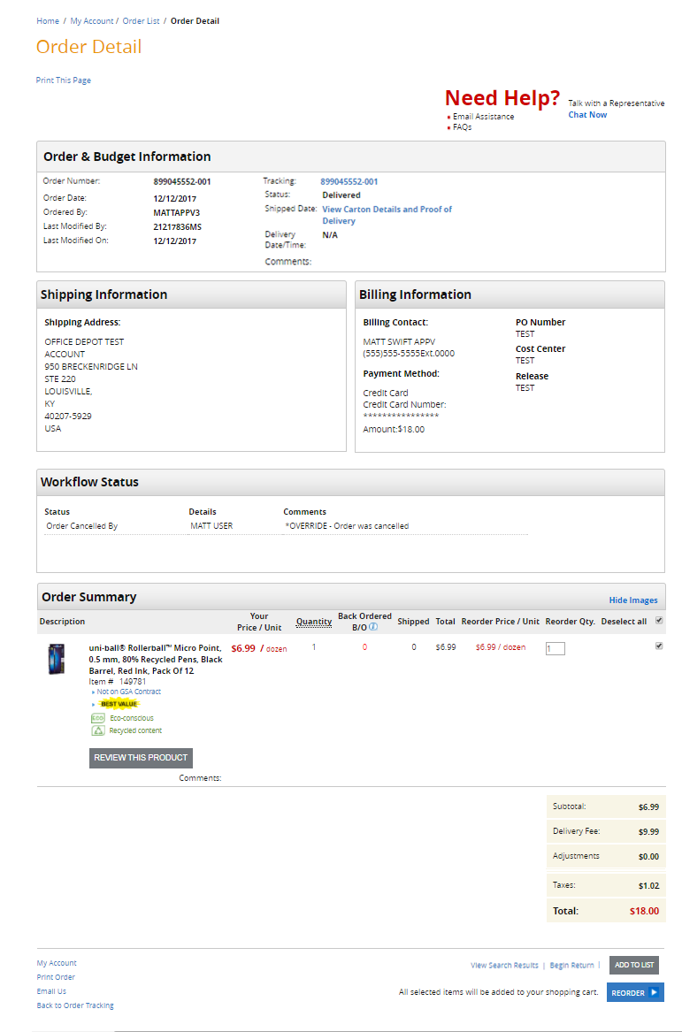
Shows the full detail including:
Order Number
Delivery Status
Tracking information

All details of the order including, Quantity shipped, Product description and links to product detail, item icons such as Contract, Best Value and product restriction status.

Need to request a return?
Click Begin Return and follow the simple step by step instruction for returning your unneeded items.

To place items into a custom shopping lists shopping list.

To create a new order with the same items.

