Submitting a request for Field eCommerce Support for Salesforce Communities
Instruction:
Open Salesforce,
- Select Support,
- Click
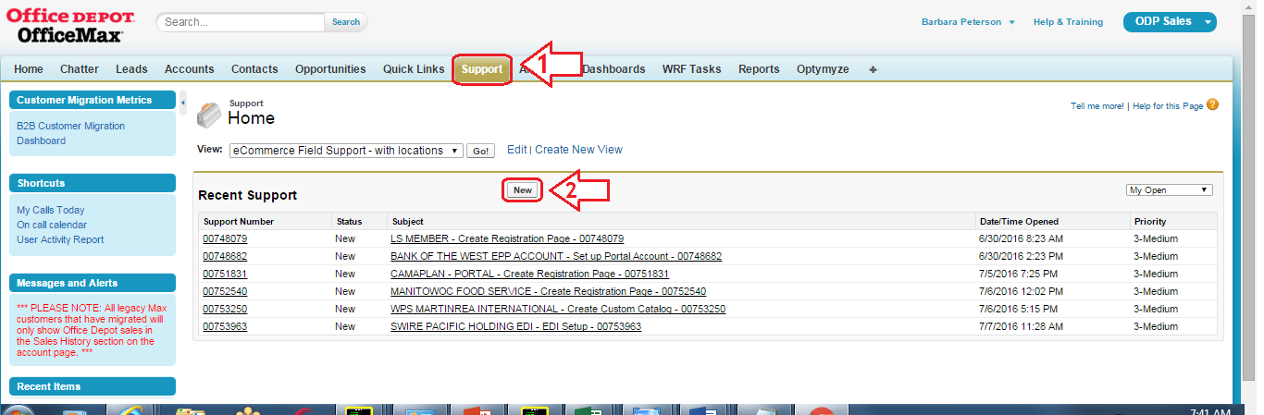
Select Record Type: eCommerce – Field Support then click.
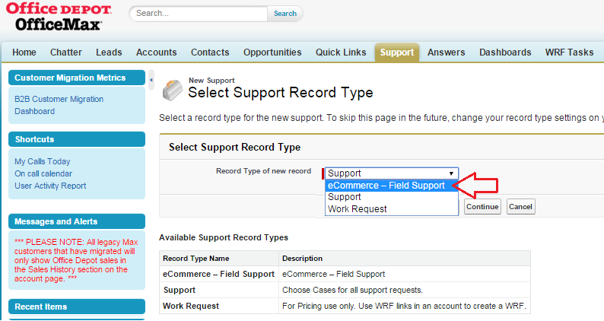

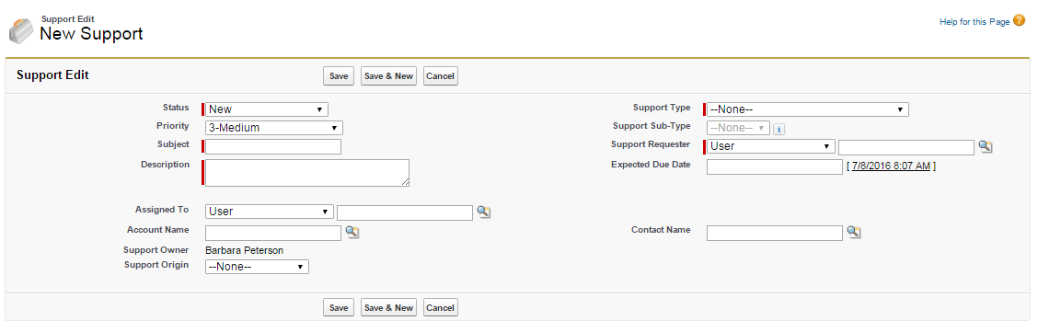
A New Support form will now open. Complete the form with as much detail as possible.
- Enter Brief Subject
- Provide additional information such as:
5.
- User Setup Only
6.
1.
- User + Invoice account setup
3.
2.
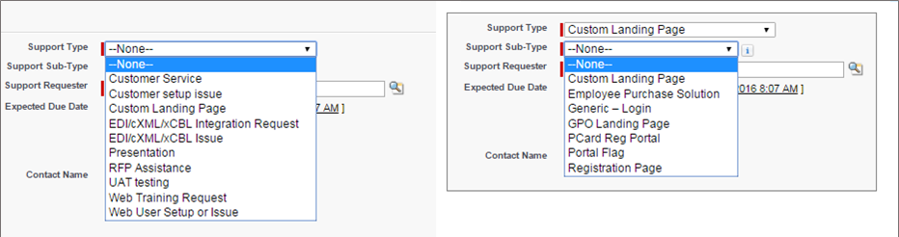
- Leave Assigned to BLANK, Entering a name will cause the setup to be delayed
4.
Leave blank
- Enter Account by using search by name Account Number
7.
- Select Support type: “Custom Landing Page
- Select appropriate SubType
- Click Save or Save & New

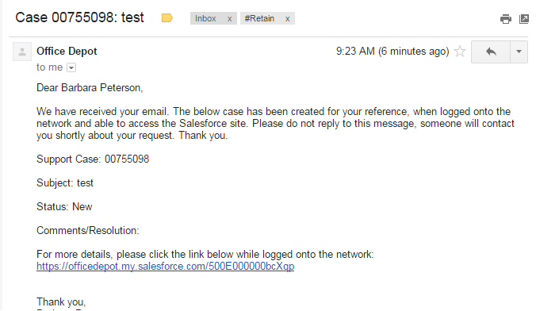
A confirmation email will be sent to your from Office Depot (salesforce@officedepot.com).
The confirmation includes a case # and link.
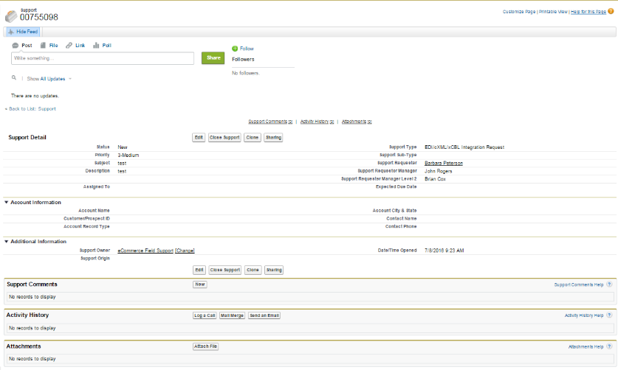
Please use this as reference for reviewing status, adding comments and attachments such as customer logos. Clicking the link will take you directly to the case.

Add attachments or comments as needed.
If you have a customer logo or other documents, you may attach them from this screen. No need to edit the document.

