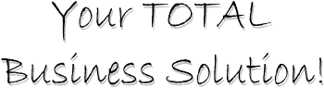
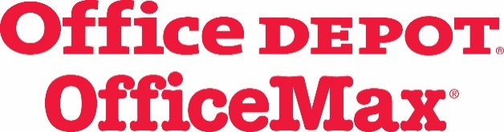
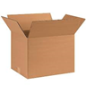

BIZ
BOX
NEW!!
Professional IT Services
Workspace Interiors
Entreprenural Services
- Accounting
- Email Marketing
- Payroll Management
- HR Services
- Search Marketing
- Legal Services
- Logo Design
- Website Creation & Hosting
- Technical Services
- Full Time Support Staff
-

- Desktop & Application
- Asset Lifecycle Management
- POS Technology
- Managed Print Services
- Cloud & Data Center
- Security Solutions
- Service Technicians
- IT Project Management
- Network Solutions
- Enterprise Mobility
- IoT Solutions

- Chairs & Chairmats
- Desks, Credenzas & Hutches
- Vertical & Lateral File Cabinets
- Fireproof Files & Safes
- Reception Desks & Seating
- Sit-Stand Desks
- Training & Meeting Tables
- Magazine Racks
- Awards Cabinets
- Design Services
- Full-Service Installation

Supply Partnership
Facilities solutions
Copy & Print Depot
- Cleaning Supplies
- Chemicals & Degreasers
- Dilution Systems
- Trash Liners & Receptacles
- Coffee, Water & Vending
- Toilet Tissue & Hand Towels
- Soaps & Sanitizers
- Dispensers
- Floor Cleaners & Wax
- Mops & Buckets
- Labeling Compliance

- Custom Stationary
- Stamps & Notaries
- Marketing & Branding Solutions
- Multipart Forms
- Signage & Banners
- Training Manuals
- Company Handbooks
- Logoed Merchandise
- Tradeshow Displays
- Thermographic Labels
- Nameplates & Badges

- Aggressive Pricing Strategies
- Personal Account Management
- Multi-User Web Platform
- Tiered Approvals
- Cost Savings Dashboard
- Online Bill Management
- Quarterly Business Reviews
- National Retail Footprint
- Green Solutions
- Rebates & Transition Bonuses
- Implementation Experts

