

XL PARTS / THE PARTS HOUSE
GETTING STARTED WITH THE OFFICE SUPPLIES & BUSINESS SOLUTIONS PROGRAM IS EASY

Welcome to ODP Business Solutions!

Your ODP Business Solutions account is now available and ready for use. To access our ODP Business Solutions website, click here or copy and paste URL https://www.odpbusiness.com/home.do into your favorite web browser. Please add us as a favorite by bookmarking our webpage in your preferred browser.

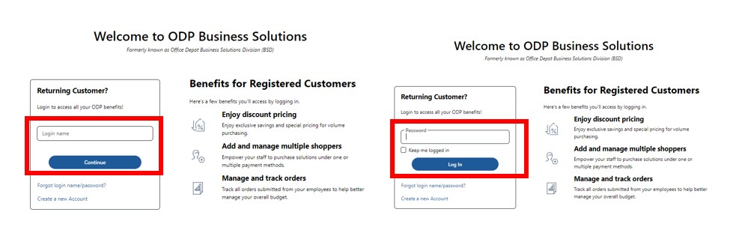
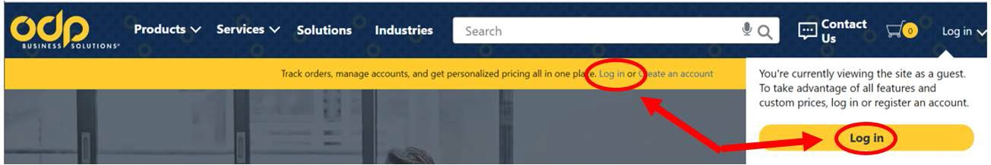

Your Login Name is your Branch Email Address EMAIL ADDRESS
Your Password is: Welcome1 (case sensitive)

Helpful numbers to reference:

- If you should have any navigational questions or need assistance signing on, call our ODP Technical Support Desk at 888-263-3423.
- For inquiries concerning product information, returns or questions concerning your orders, you can contact our ODP Strategic Support Customer Service Desk – StrategicSupport@odpbusiness.com or 800-279-1528.

ODP Business Solutions Confidential

Tips for Navigating the Website

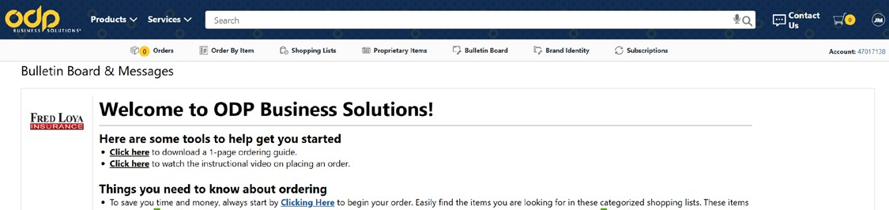



From the Bulletin Board, Click here for the Preferred Shopping Lists.
The prices shown are your companies negotiated prices and can be identified by the Best Value green ribbon icon From the Shopping List, you will select the product category to select Best Value products.
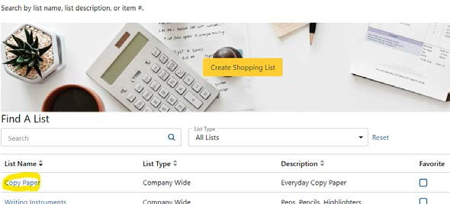

To order an item, simply click on it, update the quantity, and add it to your cart. If you cannot find an item on the website or in the catalog, contact ODP Customer Service for assistance at StrategicSupport@odpbusiness.com

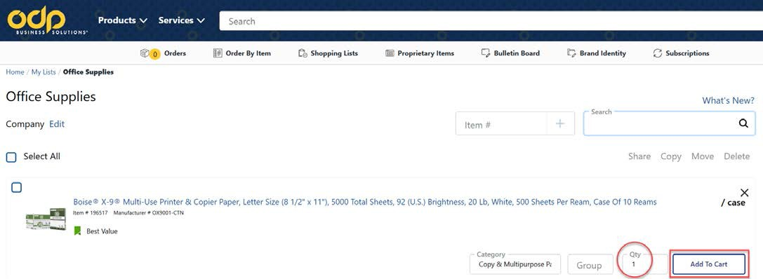

- NOTE: there is a recommended $ 5 0 minimum order thresh old.
- Best Practice is to consolidate orders. order consolidation efforts.)

ODP Business Solutions Confidential

CHECKING OUT
- When finished shopping, click on the ‘View Cart’ link or picture of the shopping cart at the Top Right of your screen.
You will have the opportunity to review your Shopping Cart and make any changes.
- Verify items in your cart, complete any required information, make any necessary changes to your cart then click ‘Update Shopping Cart’.
- Review the items in the cart and when you are ready to proceed with your purchase, click the button.
- By Default, you have a BU # that has been preloaded, please change if you are order for a different BU Number, once submitted order will go to the designated approver for APPROVAL.
- Payment Option:
  - By default, Account Billing is set up.
- When your order has been submitted, the Order Confirmation page will appear. This confirms that your order has been successfully submitted to the ODP system. Your order can be tracked by using the order
number displayed on that page or simply by going to the “Orders” on the navigation bar at the top of the page.

DELIVERY & SHIPPING

- Deliveries to all major markets are normally scheduled for the next business day. Orders must be submitted by and/or approved (if applicable) by 3:00 p.m. local time.

ORDER TRACKING & RETURNS

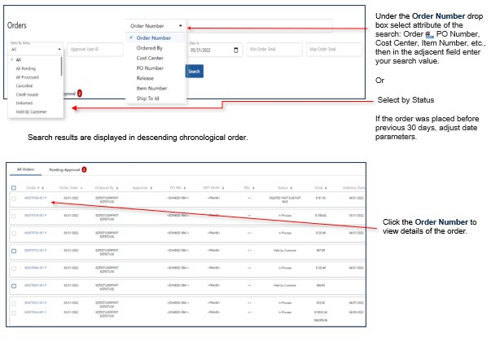

ODP Business Solutions Confidential

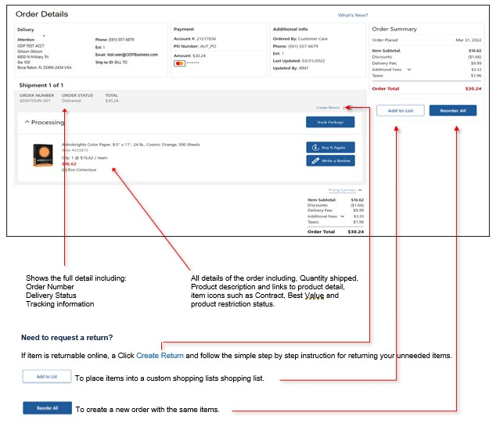

- Review the information for the return and click “Submit Return” at which point you will get a return authorization number for the return.

- You may include instructions for an ODP or UPS driver.

- Your return pickup will be scheduled to coincide with your next delivery, or within 5 days if no orders are scheduled.

- You may return most items in their original packaging within 30 days (most technology items within 14 days). All returns must be in their original packaging.

- You may submit only one online return request per order. Please contact ODP Strategic Support if you need to return an additional item from the same order. Please send email to StrategicSupport@odpbusiness.com Please include the order number, the item number and the qty of that item you are requesting to return.

For inquiries concerning product information, returns or questions concerning your orders, please contact our ODP Strategic Support Customer Service Team

StrategicSupport@odpbusiness.com or 800-279-1528.

Business Development
KEN Rose
ken.rose@odpbusiness.com

