

Office Depot Business Solutions Division

Smart Guide for WPX Energy

Technical support: 800.269.6888 • National Customer Service Desk: 888.263.3423
User Login
In the internet browser address bar, type https://business.officedepot.com.

Enter you user Name/ID

Enter Password

Click Log in

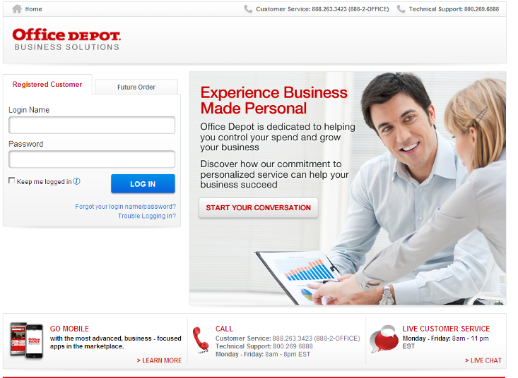
“Automatic Login”
Check this box to by-pass the login page and connect to your account without rekeying credentials.

Lost Login / Password assistance

Home
The landing page includes a bulletin board to keep you informed. From this page all shopping features may be launched.

Office Depot Business Solutions Division • Quick Smart Guide for Users

My Account
To view Account Profile, On line Reporting, Dashboard features

Orders
View order tracking, Orders waiting for approval, Future Order
Recent orders

Quick Entry:
Add a single item to order or shopping cart with fewer clicks.

My Lists
Shopping Lists, manage lists and quick view default shopping lists

 Shopping Cart: value, details and current shipping address

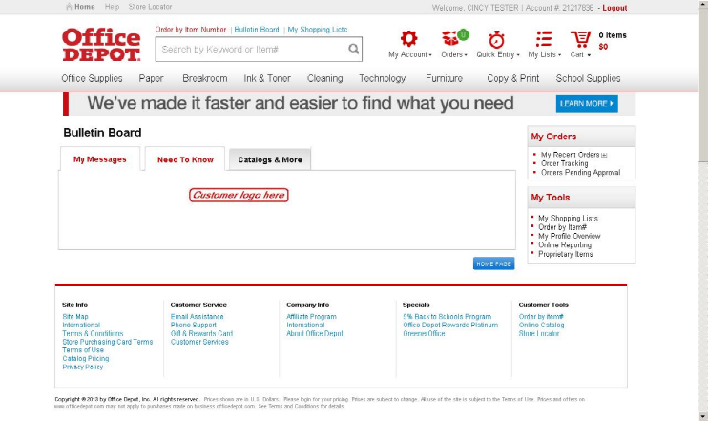
Help
Live Chat, customer service links, User Guide and online Demos

Store Locator

Order by Item #
Key in up to 20 product #s for simultaneous entry into shopping cart.

Search:
Type in product description: Office Depot or manufacturer product codes. Predictive search reduces keystrokes

Click on Product Category to
view product groupings.
Ink & Toner Find refills and supplies for your business machines.

Building Your Order

  - Logon on to https://business.officedepot.com using the unique user id and password provided by your Office Depot representative

Step 2 Combine any of the following tools to build you order:  - Catalog: Click a category from the Product Navigation Bar and select the category or sub-category to view products.  - Search: type item Keyword or Item Number and click Search. A summary of matching categories and the top ranking items will appear. Choose a category or brand, or go directly to an item. Results can be resorted by: Best Value (Contract), Price and relevance. To filter search results by characteristics such as brand, size, color etc, click the desired characteristic listed on the left-side tool bar.  - Order by Item #: Enter the Office Depot, manufacturer, or custom product code numbers, then quantity and click  Click the “Show Images” check box to view product images and details. Enter up to 20 items at once.  - . | - Quick Entry: Add a single item to order by entering Office Depot part # manufacturer# , or custom product code numbers, quantity then  - My Lists. Select Default or any Add preselected lists. To add an item to your shopping cart: enter the quantity desired, make sure the select box is checked, and then click Add to Cart. Hint: If the shopping list quantities are preset to “0”, simply click “Select all” and populate a quantity only on the desired items.
- ** Shopping Cart to review your selections, view Office Depot recommended savings opportunities, share your cart with another user, save items for later, or add to custom shopping lists.

- eckout - Review selected items and shipping address and accounting field requirements; modify as needed. If the order is released by 5:00 it will be processed for next available day delivery

Office Depot Business Solutions Division • Quick Smart Guide for Users

My Shopping List

My Shopping Lists enable you to view and purchase multiple products in one place with no searching. They're great for quickly reordering items you purchase frequently.

Who Can Use Them?
Anyone with an account can use them. You must be fully logged in with your login name and password to use your shopping lists.

How To Use Them?
To Create Your First List
- Click "My Shopping Lists" on the left navigation bar. You will come to the "My Shopping Lists Information" page (i.e. This page).
- Click the "Create New List" button at the top of this page. This will guide you to a page to name your list.
- Enter a name and comment and click the "Create New List" button. (Note: Comments are optional and for your use only.)
- That's it - you've created your first list.
Note: You may create as many lists as you like by repeating the steps above.

To Add Products to a List
- Ensure you are logged in.
- As you search and browse for products, simply click the "Add to Shopping List" button to add that item to a list.
- You can select an existing list or create a new list.
- Select the "Add to List" button.

To Shop with a List
- Ensure you are logged in.
- Select "Shopping Lists" in the "My Account" section.
- Select the desired list.
- Enter the quantities as desired.
- Make sure the checkbox is checked next to the item(s) you want to purchase.
- Click "Add to Cart".
- You will receive confirmation that items were added to your cart (Note: If an item is out of stock, you will be given the option to backorder it or choose another item).
- Click "Checkout" to finish ordering.

To View, Edit, or Delete a Previously Created List
- Go to the Shopping Lists page.
- Select the desired list.
- To edit the list name or comment, simply enter your changes and click "Update".
- To remove items from the list, click "Remove".
- If you change any quantities, you must click "Update" to save the changes.
- To delete the list, click "Delete List".

To Sort a List
- Items on Custom Shopping lists are sorted in ascending order by the value in the 'Category' field.
- When items are added to a list, this field is automatically populated with the item's default category (i.e. 'Copy & Multipurpose Paper'). However, super users have the ability to change the default category on 'Company Wide' lists and all users can change the category on their personal lists.
- Items within the same category are sorted in ascending order by item number.
- The 'Group' field can be used to change the sorting on items within the same 'Category'. For example, if three items are in the 'General use Binders' category in ascending order by item number, the Group field can be used to change the sequence of the three items by entering a '1' in the item that should appear first, a '2' for the item that should be second and a '3' for the item that should be third.

Tips, Tricks, & Shortcuts
- To avoid typing your username and password next time, check Autologin on the account setup page.
- To prevent items on your list from being added to your cart, enter zero in the quantity before clicking "Add to Cart".
- You can also uncheck the checkbox next to an item and click "Add to Cart" to prevent it from being added to the shopping cart.

