

Office Depot Welcome Packet

Transition to business.officedepot.com
January 2016

Dear MISBO Members,

Office Depot is pleased to continue our partnership as your office products provider. Backed by customer focused sales resources and delivery centers throughout North America, we will partner with MISBO schools to ensure a smooth transition to the Office Depot platform. By providing an array of smart solutions tailored to your specific needs, our dedicated team of professionals will help you take care of business more productively.

We look forward to enhancing the customer experience in the months and years ahead!

Andrew Klingman
District Sales Manager
T: 678-350-3506
E: andrew.kli@gman@officedepot.com

Jodie Satterfield
K12 Service Consultant
T: 678-522-7801
E: jodie.satterfield@officedepot.com

Account Information:

Your Office Depot Account #: Will be provided in your welcome packet and/or by your account manager. If you are unable to locate or unsure if you have any account please reach out to Jodie Satterfield.
Web address: business.officedepot.com – Orders may be placed via the web only.

Your Office Depot Representatives are Jodie Satterfield, and Andrew Klingman. Customer Service should be your first point of contact. After contacting customer service, for special pricing, order inquiries, or questions, please contact a member of your account management team. We are all here to help!

Ordering Method:

To access your contract pricing:

Log in Name: Same as previous Office Max ID*
Temporary Password: Same as previous Office Max password*
*Account management team will notify end users with exceptions.

Customer Service Desk:

1-800-521-3939 – Monday through Friday, 8AM-8PM
- Product or pricing questions
- Returns / Exchanges (new orders must be processed through web)

You can connect immediately with a customer service representative, Monday–Friday 8:00 A.M. to 11:00 P.M. (EST), using our Live Chat functionality (or by calling us toll-free at 800.521.3939 Monday-Friday 8:00 A.M. to 8:00 P.M). For technical support, our E-Commerce Support Desk is available via phone at 800.269.6888 or by e-mail at ecsupport@officedepot.com.

On-line Tutorials:
To review how to navigate through the Office Depot website please click on the Customer Services link located at the bottom of the screen. The User Guide and Web Demonstrations can be accessed via the General Help section, under Helpful Links, on the left side of the Customer Services page.

You can also access by going to https://business.officedepot.com/speciallinks/us/bsd/docs/customerservice/onlinetraining/userguide.pdf

Order Confirmations:
For every order placed, you will receive an email confirmation that details your transaction and product status of the items you ordered. You can track you order at any time online or by calling customer service.

Deliveries:
Most deliveries to will be made the next business day. These orders must be processed before the assigned deadline, as follows:

ORDERS PLACED BY 5:00PM YOUR LOCAL TIME, FOR IN-STOCK ITEMS, WILL BE SCHEDULED FOR NEXT BUSINESS DAY DELIVERY.

There are occasions where an item is shipping from an alternate source (not stocked) and may deliver within a few business days. Any extended shipping or backorders will be noted on your order confirmations.

Freight:
Orders will be delivered free of charge. Please consolidate your orders where possible. Ordering in bulk is a simple way to reduce costs, waste, fuel and greenhouse gases. You will save on paper, staff time and logistical costs while also reducing the product packaging waste & carbon dioxide emissions associated with delivery of your office supplies.

Upon Receipt of Your Order:
Verify that all items on the packing slip listed as shipped are in your order. Any shortages or incorrect items should be reported to the Office Depot Customer Service Desk within 10 days of delivery. Items on back order will be noted on the packing slip.

Return Procedures:

Returns via Phone:
Step 1: Call the Office Depot Customer Service team and provide the invoice number and 6-digit Office Depot product/SKU number and/or the manufacturer’s part number of the product being returned and credited.
Step 2: Provide a brief description of the reason for the return/credit (i.e. ordered in error, damaged/defective, etc.).
Step 3: Place the merchandise in your standard delivery area for pick-up.

Web Return Orders:
Step 1: Click on “Order Tracking” located in ‘My Account’ in the top navigation bar.
Step 2: Locate the sales order number that you need to place a return on. Once the order detail appears, click ‘Submit Return’.
Step 3: Fill in the return quantity, select the reason for the return and enter any special instructions and click ‘Continue’.

A confirmation number for your return will appear. Please print this page and/or write this number down and keep for your records.

Please visit our Customer Service page on business.officedepot.com for complete details on our Return Policy.

Quick Step Internet Ordering Instructions

Placing an Order
- Use browser to access the Internet and type in http://business.officedepot.com
- Type in your Login Name and Password
- Click on
- Please click the items link from the bulletin board to access your core items. We have categorized your core items for convenience. Please shop your core items first.
- If you know the item number(s) for the product(s) you wish to order select:

- Type in Office Depot Item #, quantity, and comment, if desired
- If you do not know the item number(s) for the product(s) you wish to order, you can:
  - Search for product using key words or manufacturer part numbers by entering the information in the space provided in the gray toolbar and then clicking Go 

Placing an Order
- Use browser to access the Internet and type in http://business.officedepot.com
- Type in your Login Name and Password
- Click on
- Please click the items link from the bulletin board to access your core items. We have categorized your core items for convenience. Please shop your core items first.
- If you know the item number(s) for the product(s) you wish to order select:
- Type in Office Depot Item #, quantity, and comment, if desired
- If you do not know the item number(s) for the product(s) you wish to order, you can:
  - Search for product using key words or manufacturer part numbers by entering the information in the space provided in the gray toolbar and then clicking Go
  - Shop using our online catalog. Simply click on in the upper left hand corner or  in the grey toolbar and you will be directed to category listings of the catalog
- Select to add your desired product to your shopping cart
- Select to continue or from the shopping cart in the top left if you have finished shopping
- If you selected then click on to add more items
- If you selected verify items in your cart and complete any required information
- Please confirm your shipping information is correct.

Placing an Order
- You now have three options, 
  - If you are satisfied with your order, select to complete the process
  - If you would like to save the items in your cart and purchase at a later date, select . (When placing an order on hold, your inventory will be held for 48 hrs. You must release your order within the 48 hour time-frame, via order tracking, or the system will auto-cancel your order and place the live inventory back into stock)
  - If you would like to save the items in a list but not create the order select
- When selecting the ‘place order option’, when you see “Thank you for your order,” and your number, your order has been successfully completed.
Online training is available in the Customer Service section or call the Internet Help Desk 800-269-6888

Custom Shopping Lists:

For your convenience, online shopping lists have been created containing your core items, separated by categories. You can access these lists by clicking on the link we created & added to your customized bulletin board. You may also access these lists by clicking on the ‘My Shopping Lists link’ at the top of the page, or by hovering over the ‘My Lists Bubble’ at the top of the page on the right hand side. You can pull items from the list to add to your order as well as create your own personal lists of products you order.

To Create Your First List
- Click on at the top of the page. You will come to the information page.
- Click the button at the top of this page.
- Enter a name and comment and click the SAVE button. (Note: Comments are optional and for your use only.)
- That's it - you've created your first list.
Note: You may create as many lists as you like by repeating the steps above.

To Add Products to a List
- Ensure you are logged in.
- As you search and browse for products, simply click the button to add that item to a list.
- You can select an existing list or create a new list.
- Select the button.

To Shop with a List
- Ensure you are logged in.
- Select at the top of the page.
- Select the desired list.
- Enter the quantities as desired.
- Make sure the checkbox is checked next to the item(s) you want to purchase.
- Click .
- You will receive confirmation that items were added to your cart (Note: If an item is out-of-stock, you will be given the option to backorder it or choose another item).
- Click to finish ordering.
To View, Edit, or Delete a Previously Created List
- Select at the top of the page.
- Select the desired list.
- To edit the list name or comment, simply enter your changes and click .
- To remove items from the list, click .

To View, Edit, or Delete a Previously Created List
- If you change any quantities, you must click to save the changes.
- To delete the list, click (at the bottom of your page).
Tips
- To prevent items on your list from being added to your cart, enter zero in the quantity before clicking .
- You can also uncheck the checkbox next to an item and click to prevent it from being added to the shopping cart.
SEARCHING FOR ITEMS:
Enter your keywords in the search parameters box to search for items (you may enter up to 5 descriptive words). Once search your results appear, you may click on “Sort By” and select “Best Value”. You can simply add the quantity of the item you wish to order & click on ‘Add to Cart’ to add the item to your cart. If you have created a shopping list, you can also click ‘Add to Shopping List’ to add the item to your list.
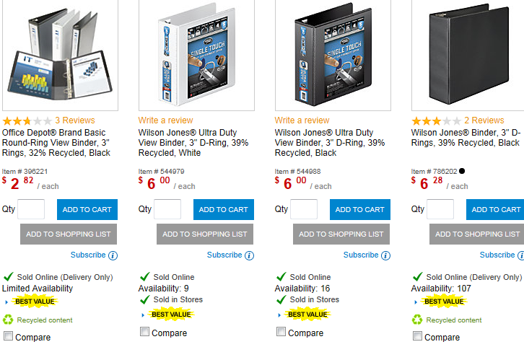

ORDER BY ITEM NUMBER:
With Order by Item Number, you can quickly enter up to twenty items directly to the Shopping Cart or a Shopping List by entering the item numbers & quantities. To display the Order by Item # page, select ‘Order by Item #’ on the left navigation bar. To begin adding items to the Shopping Cart:
- Type the item number in the ‘Item #’ field. Item numbers include Office Depot SKU numbers, manufacturer numbers, and customer-specific codes.
- Type in the quantity desired in the ‘Qty’ field.
  - Note: If you leave any of the quantity boxes blank, the items will be added to your Shopping Cart with a quantity of 1.
- When finished, select ‘Add to Cart’ (or ‘Add to List’) located at the bottom of the page.
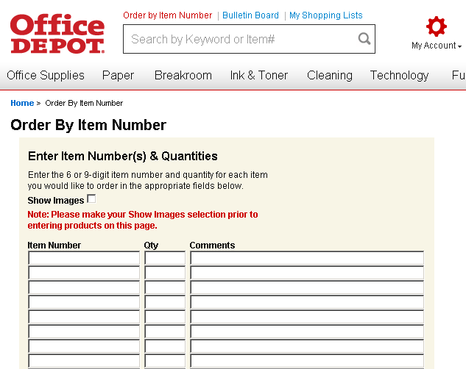

Frequently Asked Questions:

I have forgotten my password for ordering on the Office Depot website. What should I do?

Simply go to our website (business.officedepot.com) and click on the ‘Forgot your login name/password?’ link. You will be prompted to enter your login name and respond to your pre-determined security question. You will then be asked to update your profile with a new password. If you do not remember your login name, call our HELP DESK at 1-800-269-6888 any time between the hours of 7:00 AM - 9:00 PM Eastern Standard Time and they will be glad to help you. Have your account number ready when you call
Your Account # Schools – 90375646 Central Office - 70981523

Help, I’m on the Office Depot website and forgot how to create a Custom Shopping List. What do I do?

Click on ‘My Shopping Lists’: You can create a new list there or open the “How to use and create lists” guide. This will guide you through each of our online tools step-by-step.

We just received our order and I thought I ordered 12 pens, but instead received 12 boxes of them.
What do I do?

Our product return policy and procedures are designed to help our customers make returns and exchanges quickly and efficiently. You can place your return online. Simply go to the Order Tracking and History feature under ‘My Account’, select Order Tracking and History, locate your order, click on the order then go to the bottom right hand corner of the page and select Begin Return. You may also refer to our website for our complete Return Policy and for instructions on how to process such requests.

I need additional copies of the catalog for my office. How do I request them?

Many offices like to keep several catalogs on hand so that they can be used by several different people. Our catalogs are offered to our customers free of charge. You can request a catalog with your next online
or phone order. Simply add Sku # 559619 for the General catalog and Sku # 559772 for the School Solutions supplement to your cart when you place your next order.

I’ve looked all through the catalog and can’t find the item I really need. Does this mean Office Depot doesn’t have it?

Not at all, Office Depot offers over 15,000, items but we also have access to a large assortment of additional products that are made available through various third-party sources. Please call your field account representative or customer service representative for assistance in ordering the product you need.

It’s early in the morning and I just realized that I need to add something to an existing order. My order usually arrives around noon. Can I call to add this item to today’s order?

Our orders are packaged at night so that delivery trucks can be loaded early in the morning before embarking on their routes. Our delivery trucks usually leave our distribution centers well before 8:00 AM, so unfortunately it would not be possible to update this existing order. We instead encourage you to use the Office Depot Store Purchasing Card or contact your field account representative to place an order for pick-up at a local retail store near you. Please contact your field account representative and/or ask how to link your p-card to access discounts in our stores.

THINGS TO REMEMBER

- YOUR OFFICE DEPOT ACCOUNT NUMBER CAN BE FOUND ONLINE OR BY CONTACTING YOUR LOCAL ACCOUNT MANAGER OR JODIE SATTERFIELD
- REAL TIME INVENTORY SHOWN ONLINE
- YOU SEE YOUR ACTUAL CONTRACT PRICE FOR EVERY ITEM.
- ORDERS PLACED BY 5:00PM YOUR LOCAL TIME, FOR IN-STOCK ITEMS, WILL BE SCHEDULED FOR NEXT BUSINESS DAY DELIVERY.
- ORDER TRACKING – Allows you to view 12 months of your order history. To track an order, view the order detail and/or make changes to the order. You can simply click on “Order Tracking” located with the ‘Order’ header at the top right hand corner of your screen.
- ONLINE TRAINING – Click on Customer Services Link (located bottom of screen) for Online Training.
- ONLINE RETURNS –Go to ‘ORDER TRACKING’, click on the Blue underlined order number. Click on the SUBMIT RETURN button (located at bottom of page) to return items for credit only.
- CUSTOMER SERVICE DESK – 1-888-521-3939, 8:00 AM to 8:00 PM EST, Monday – Friday.
- INTERNET HELP DESK (assistance with website, forgotten password)– 1-800-269-6888 Hours:
7 AM to 9:00 PM EST, Monday – Friday. Or via email: ecsupport@officedepot.com.

Andrew Klingman
District Sales Manager
T: 678-350-3506
E: andrew.klingman@officedepot.com

Jodie Satterfield
K12 Service Consultant
T: 678-522-7801
E: jodie.satterfield@officedepot.com

THANK YOU FOR PARTNERING WITH OFFICE DEPOT!

