Office Depot Overview (https://business.officedepot.com)
Stores are only to order “Best Value” items. As long as your store is ordering “Best Value” items and you are under your monthly budget (budgets are based on total account dollars, new store budgets are set to $250), your order will automatically be approved without being routed through your DM and in most cases will be received the next business day. If you order a restricted item or go over budget, your order will be routed to your District Manager, then to Morgan Mannion in the TitleMax warehouse.
Corporate Operations encourage stores to order for the entire month when ordering office supplies. This will ensure that your order meets the $50 free shipping threshold and will also cut back on the number of order approvals that will be generated. If you have a situation where your store needs to order less than $50 worth of supplies, please contact your District Manager to make the order, but it is preferred that you order additional items that you will be able to use in the future.
Accessing “Best Value” items
When you log into the Office Depot website, you will be taken to the Bulletin Board. Here are some pointers to help you navigate this page. Accessing “best value” items through shopping lists can be done 1 of 2 ways.
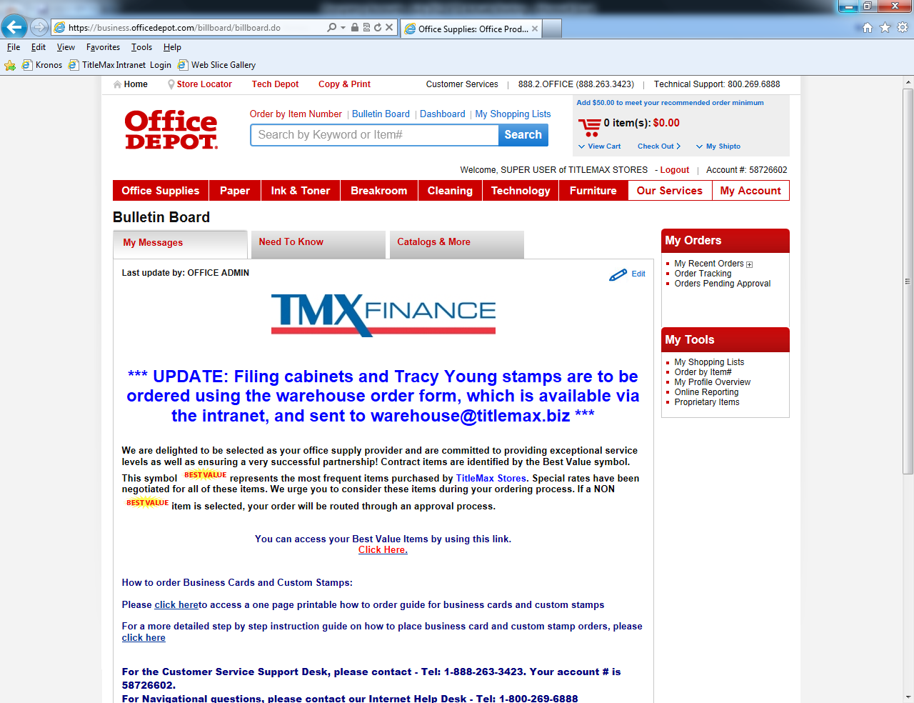
Ordering Business Cards and Custom Stamps
A one page summary guide and detailed instructions on how to order business cards and custom stamps are available by clicking the associated links. Please note that Tracy Young Stamps must be ordered via the warehouse@titlemax.biz.
Orders Pending Approval & Order Tracking
For updates on whose approval an order is awaiting, click here. For updates on already placed orders (including whose approval the order is pending, if it has been shipped from Office Depot warehouse, or whether it has been delivered), click here.
My Shopping List
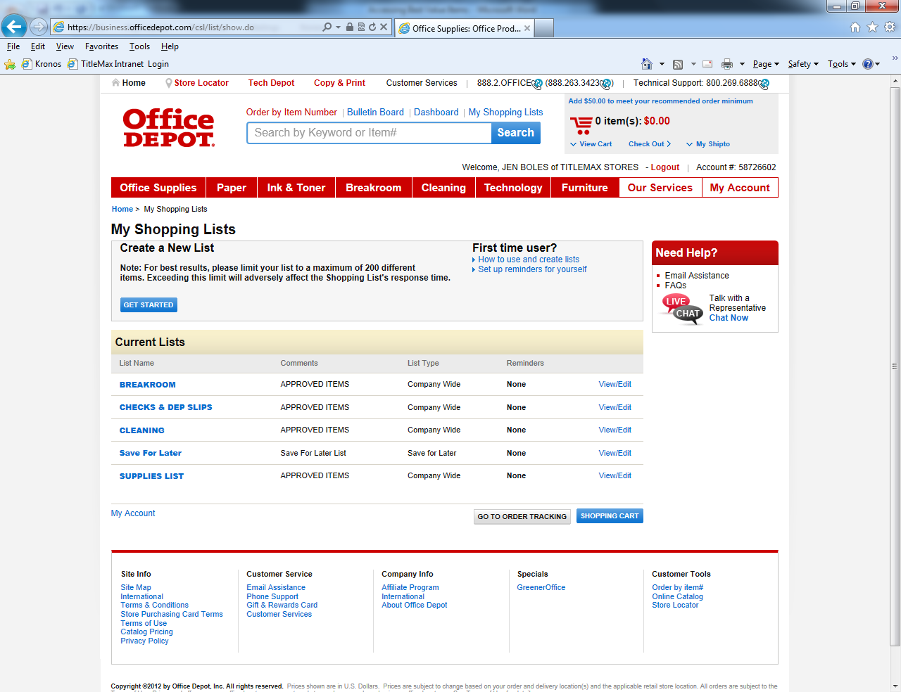

All items you may need are broken down into 4 Categories. DVPs and RMs combed through the list of office supplies to create a succinct list of what a store will need. If there is anything not on the shopping list that you consider a business necessity, contact your District Manager who will fill out a form asking the Warehouse to add the item.
Special Note to New Stores
You will have received everything you need for your first 30 days when you open, except for business cards, a stamp with your stores address, and deposit slips. To order business cards and custom stamps, follow links on bulletin board page outlined on page one of this document.
Office Depot Contact
Davie Hobbs
Territory Development Manager
Office Depot Business Solutions Division
Office: (317) 379-8783
davie.hobbs@officedepot.com

