Office Depot Internet Ordering Instructions

Placing an Order
- Use browser to access the Internet and type in http://business.officedepot.com
- Type in your Login Name: Email address
- Type in your Password: welcome
- Click on (Note: you may click Keep Me Logged In button as this will bypass the login page in the future, however if you have more than one login please do not click the Keep Me Logged In button as you will not be able to access more than one login)
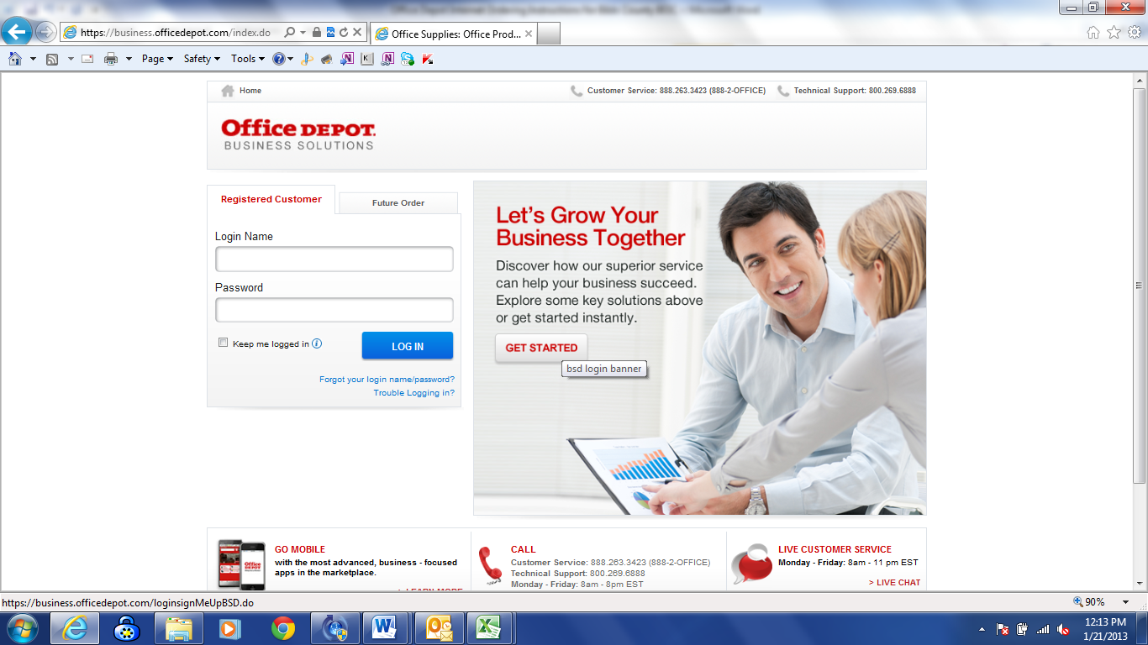

- You will be asked to change your password. Please put welcome as the old password then select a new password and confirm the new password. (must be 6-10 alphanumeric characters)
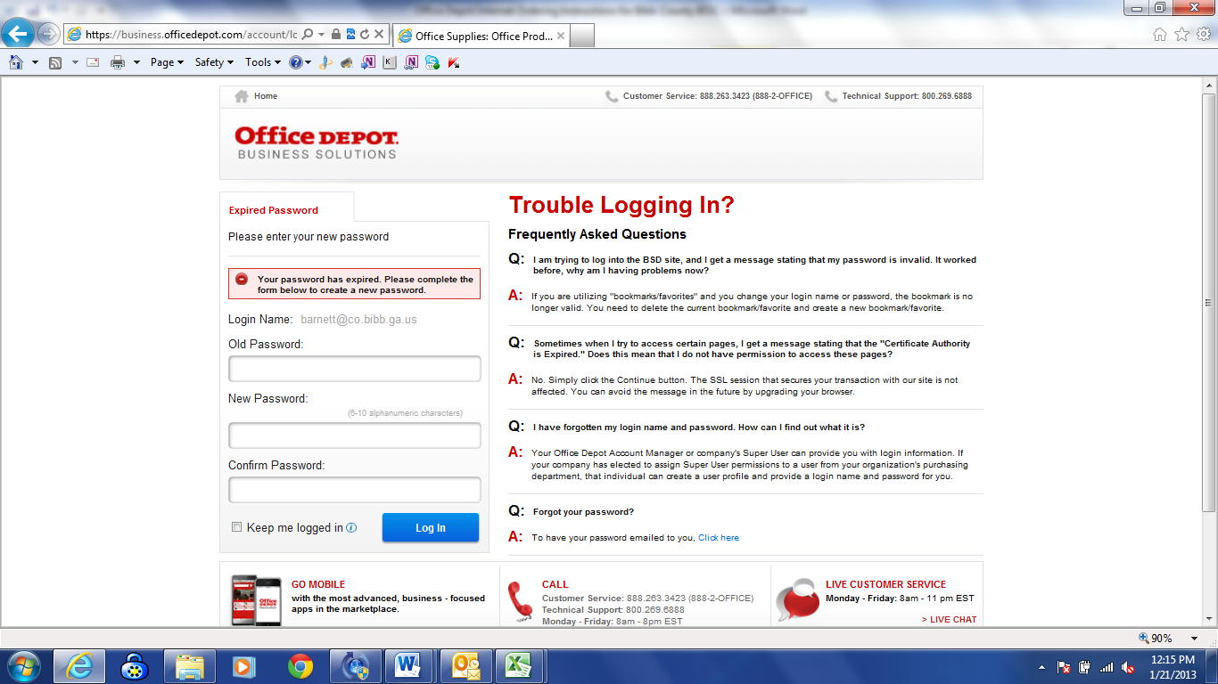

- You will then be asked to Update a Security Question (Please answer the security question so in case you forget your password, you will be able to easily retrieve it by clicking forgot password.)

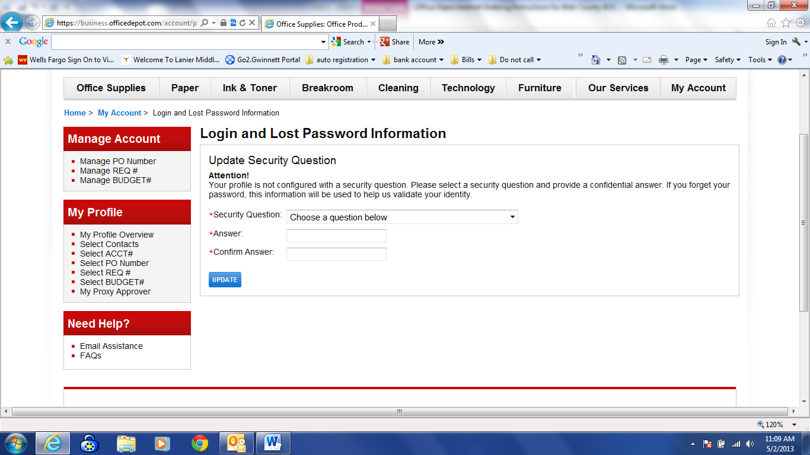

- If you know the item number(s) for the product(s) you wish to order click Order by Item Number above the Search field.
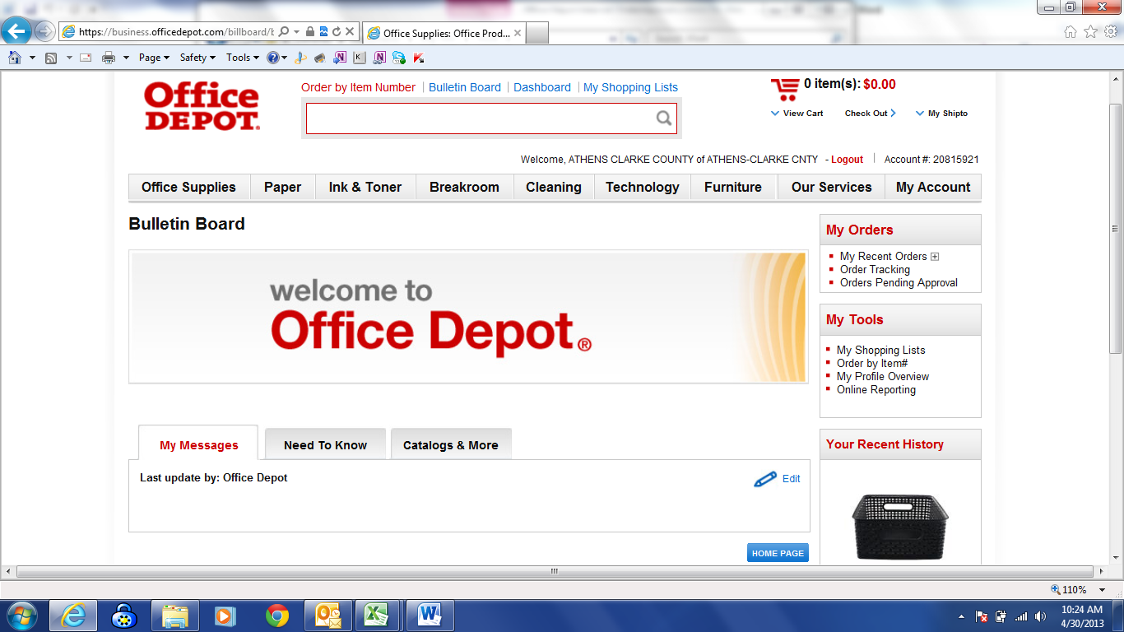

- Check the box Show Images if you want to view the images when you input the items. Type in Office Depot Item #, quantity, and comment, if desired. Then click Add to Cart at the bottom of the page.
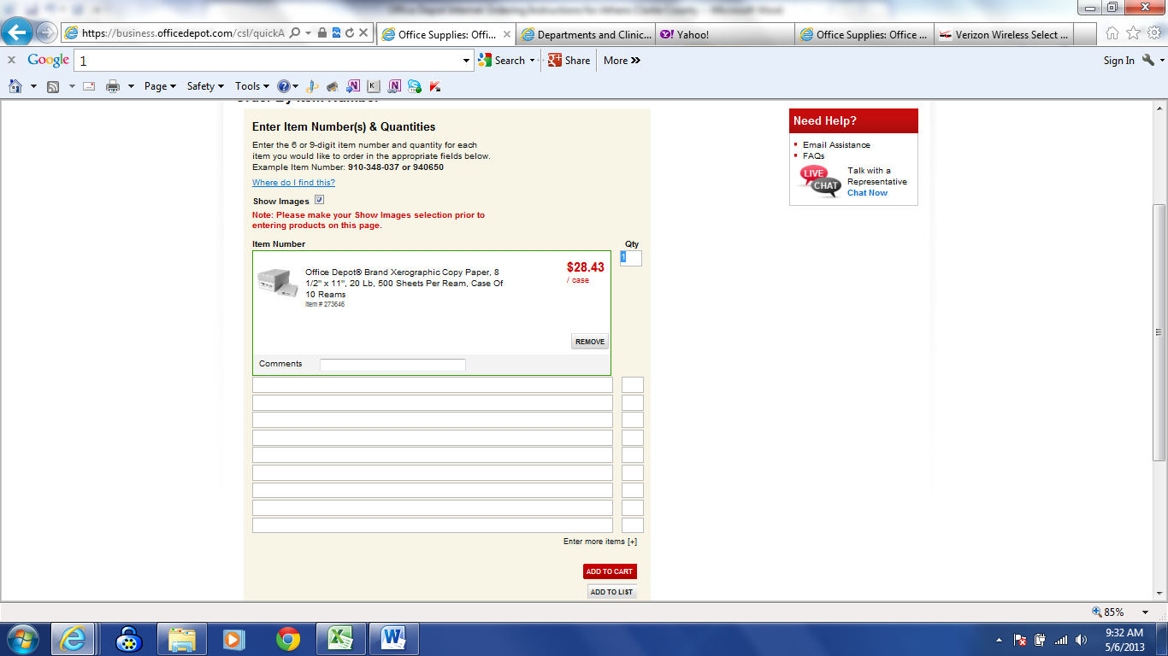
- If you do not know the item number(s) for the product(s) you wish to order, you can:
Search for product using key words or manufacturer part numbers by entering the information in the space provided in the Search by Keyword or Item# toolbar and then clicking the Magnifying Glass/Search button or pressing enter. You may, also, browse by the Grey Tabs at the top of the page (Office Supplies, Paper, Ink & Toner, etc.)
v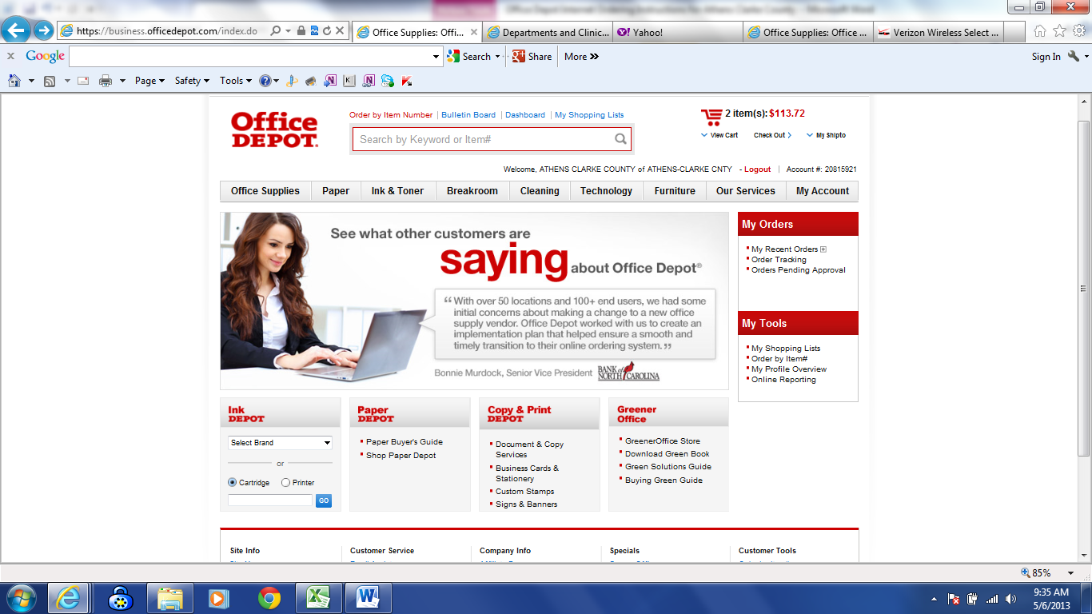
- Put in quantity and click Add to Cart to add your desired product to your shopping cart.
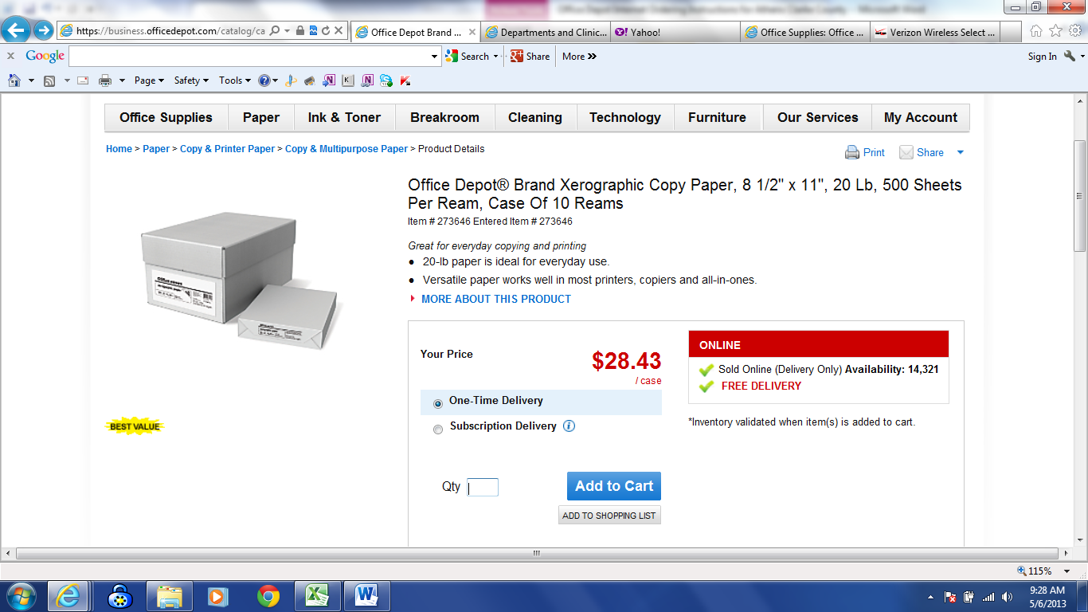
- Select Continue Shopping to continue or Check Out from the shopping cart in the top right if you have finished shopping. 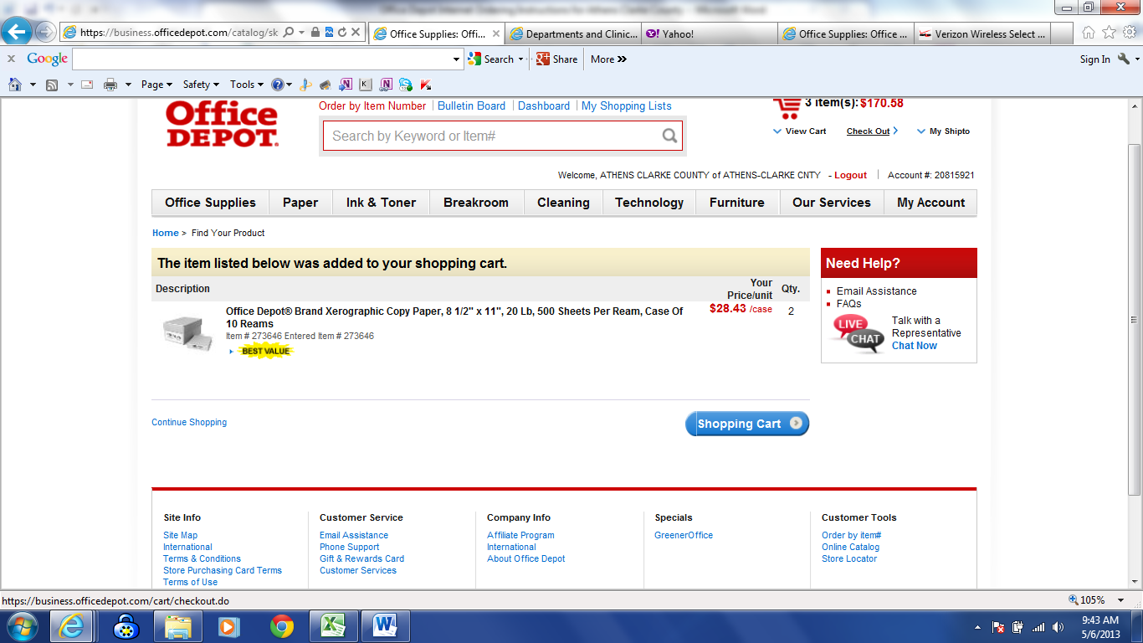

- If you are ready to place your order, you will then see the Check Out screen below. If you have the option to select more than one shipping address you will see the blue SELECT button in Shipping Information field. NOTE: If you don’t need to change the shipping address, please skip to step 14.
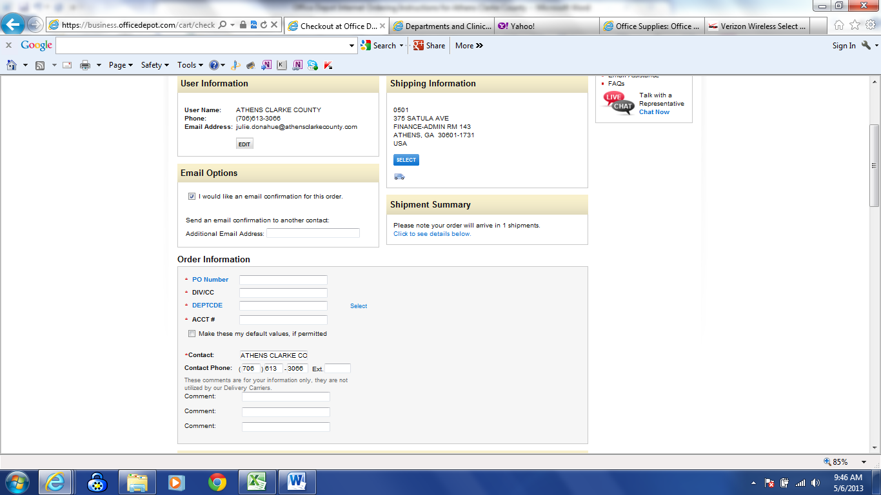

- If you need to change the shipping address, click the SELECT button. You will see a list of addresses designated for your login. Click the blue select button under Current next to the desired address you would like the order to be shipped. You will then be brought back to the Check Out page.
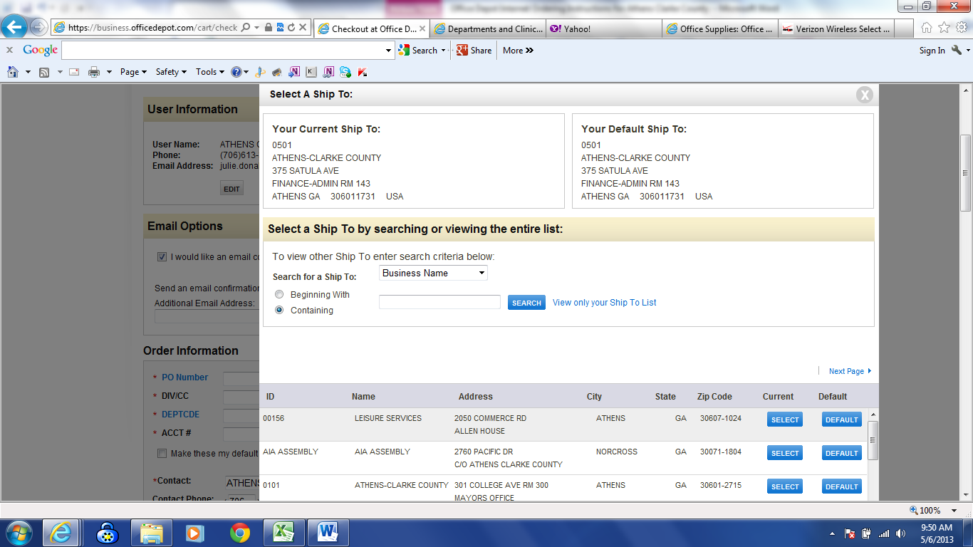

- There are four required fields you must fill out before placing your order:
PO Number: Your full name
DIV/CC: Your Division or Cost Center code
DEPTCDE: Your department code (ex. 07 is Tax Commisioners Office) NOTE: If you only order for one dept, then the dept code will be defaulted in the field for you. If you have other departments you order for, you will have a select button. You may click select and a list of dept codes that are designated for your login to choose from. Click the blue Select button next to the dept code you would like to order for. You will then be brought back to the Check Out page.
Acct #: Your account number Note: This is not the Office Depot account number
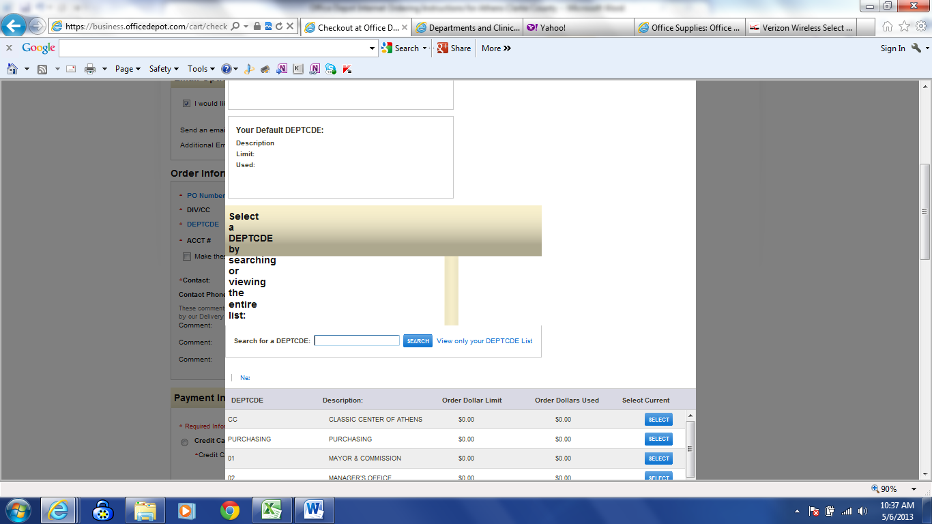

- Changing the Date-On the checkout screen in the middle of the page, you will see Delivery Options.
Under For Standard Delivery, click the dropdown arrow and this is where you can change the delivery date. You will have the option to change the delivery date out to twelve days. NOTE: Right under Delivery Options is your Estimated Delivery Date and the Shopping Cart. So if the estimated delivery date is not the date you want the merchandise to be delivered, then change the delivery date under For Standard Delivery. Please don’t use For Future Delivery.
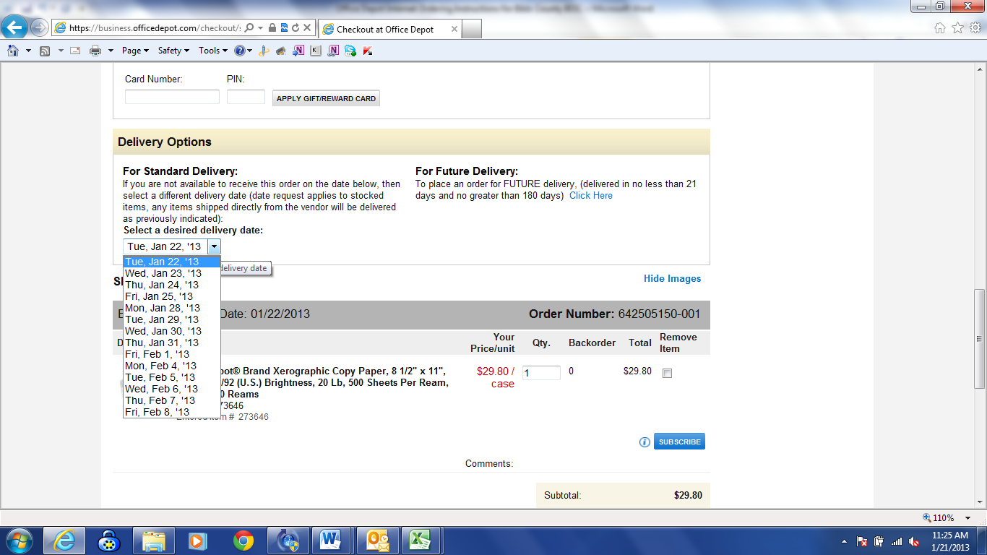

- You now have two options SAVE CART TO LIST or PUT THIS ORDER ON HOLD
  - If you are satisfied with your order, select PUT THIS ORDER ON HOLD.
When placing an order on hold, your inventory will be held for 24 hrs. When you see, “Thank you for your order and your confirmation number”, your order has been successfully completed, but will remain on hold until a designated approver releases the order.
  - If you would like to save the items in a list and not place the order on hold yet, select
SAVE CART TO LIST
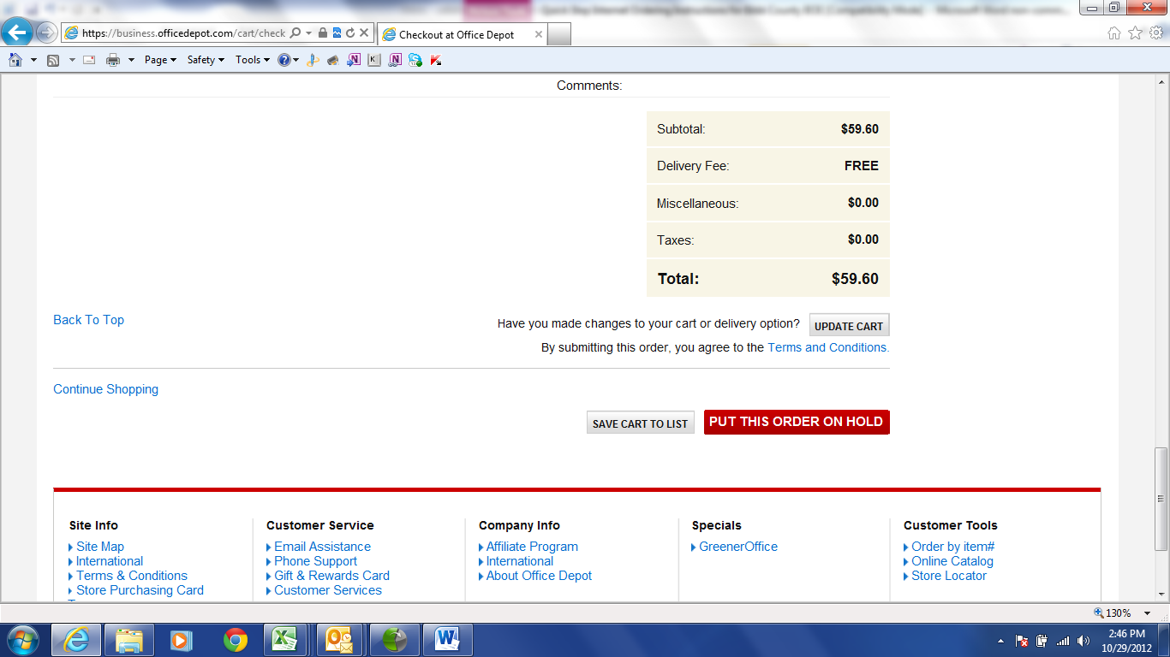

- You may, also, put your curser of your mouse over the tab My Account and click Order Tracking. The screen will automatically display all of your orders on hold and any orders that have been approved, as well as, credits and returns for your account settings for one month. You may view up to a year of your orders by Searching by Order Number, Status, Date Range, Dollar Range, and Approver. (Note: If you have just placed an order, you will automatically see it in Order Tracking with your contact name and who the approver is currently pending to release the order. If you do not see your order here that you have recently placed, then your order has not been placed. You must make sure that you have clicked the place order on hold button to have completed your order.)
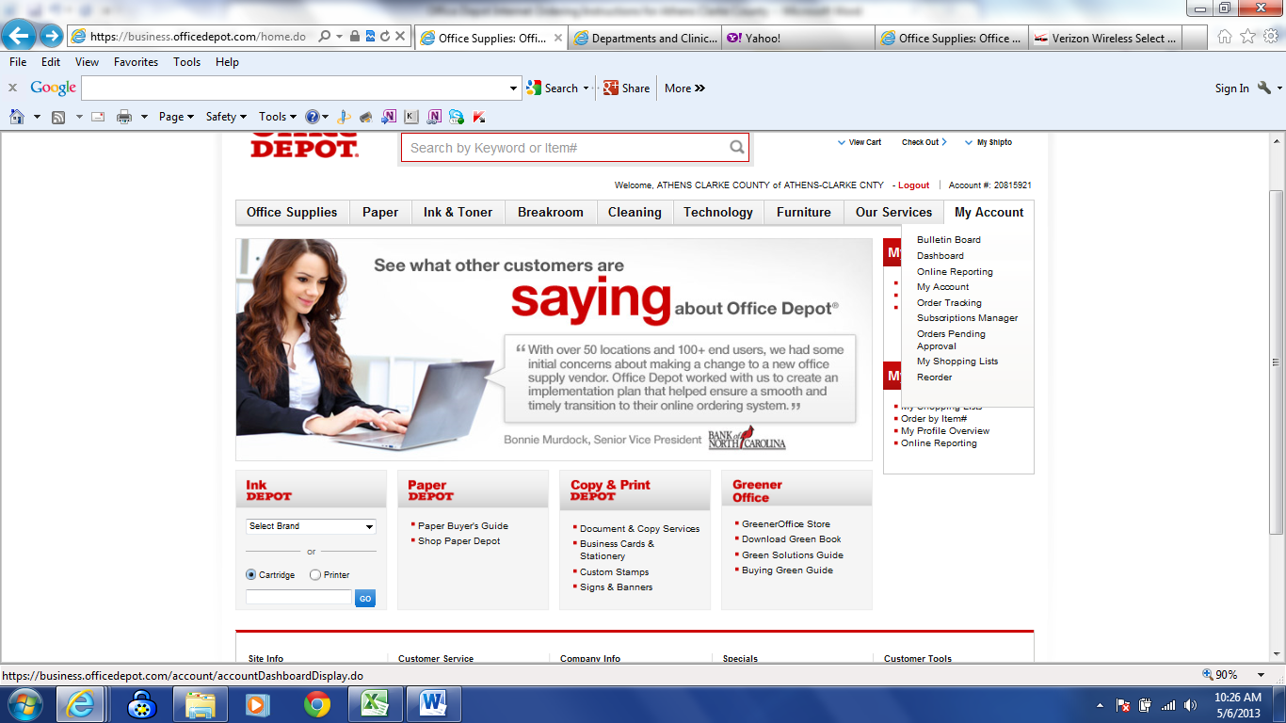
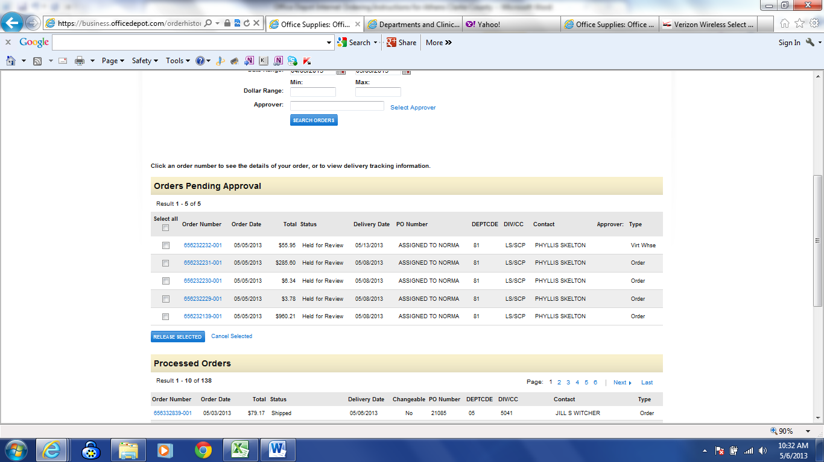

Online training is available in the Customer Service section of the website or you may call the Internet Help Desk at 800-269-6888 or sandy.saltaformaggio@officedepot.com or 678-983-6355 for additional assistance.

