

Office Supply Program for Russell Investments

Thank you for this exciting opportunity to partner with Russell. Office Depot is your global office products provider that has developed and built the most comprehensive office products and supply solution in the industry. Our national program will provide Russell with the most advanced ordering solutions and lowest overall price solution, all backed by our outstanding customer service.

Included in this “Welcome Tutorial” :

- Important login information for first time visitors

- Contact Information
- Quick step online ordering steps
- How to locate online training guides
- Order Size Discounts
- Product Returns/Credits
- Reporting Capabilities
- Frequently Asked Questions

Office Depot Contact Information:

Russell Account Number # 47668577
Online Ordering Web address: https://business.officedepot.com
Customer Service: 1-888-777-4044
Available: 5:00am to 5:00pm PST

Office Depot Account Manager Rayna Whitright
253-872-1619 Office

Rayna.whitright@officedepot.com

Russell Contact Information Ed Sharp, Corporate Services
206-505-2707 Office
esharp@russell.com
Ordering Method – Internet Order:

FOR YOUR FIRST LOGIN SESSION PLEASE FOLLOW THESE 4 STEPS

1) Go to  https://business.officedepot.com

Login Name: your Russell email address (i.e. jsmith@russell.com)
Initial Password: welcome

2) You will be prompted to choose a new password and answer a security question.
Passwords must be at least six alphanumeric characters. Click update.

3) You will be asked to set up your profile with your phone number and ship to address.

4) Go directly to the ‘BULLETIN BOARD’ page to start shopping.

If you are a new office product user or unable to login with the password provided above, please register at the following link: https://odams.officedepot.com/registrations/russell_invest_reg.php

Quick Step Internet Ordering Instructions, after initial profile/password set up:

Placing an Order

- Select: My Shopping Lists (upper right hand corner or under My Account)
- Select the desired list. Check the box of the item needed & desired quantity. Scroll to the bottom of the list.
- Select:
- Select if you are not through or if you are done.
- If you selected simply go back to the My Shopping Lists and continue your selections.
- If you selected next click on then validate and complete any required information (including cost centers and GL code).
- Review your order and select to complete the process.
- When you see Thank you for ordering with Office Depot Business Services Division your order has been successfully completed.
- You will receive a confirming email with your order number.
represents Russell’s contracted items – If you search, ALWAYS look for these items.
represents items from Minority businesses
Items not on approved shopping lists will show icons, those items are available via special request for valid business purposes only.

Online Training:

Training and customer support information is available online, under Our Services/Customer Services located in the red bar going across the top of the page. Here you will find many useful topics to help make your shopping experience at Office Depot as easy as possible. Once you have logged in, you can click on the links on the LEFT HAND SIDE for help in several areas.

Please feel free to contact Rayna Whitright regarding any questions or concerns you may have. Office Depot can offer any level of training you request, individual or group. Call today if you would like to receive a training session. Rayna.Whitright@officedepot.com or direct at 253.872.1619.

Order Size Discounts:
Many of our customers have come to understand their cost of placing small orders. We encourage you to consolidate orders whenever possible. These discounts are not an incentive to spend more, but to order less often. To help you plan ahead, our system allows for you to indefinitely hold items in your cart until you are ready to order. Consolidating orders will also help to reduce packaging.

$125.00 order – 1.5 % discount taken at check out
$175.00 order – 2.5 % discount taken at check out
$250.00 order – 3.5 % discount taken at check out

We highly recommend working within your location or department and choosing one day a week or month to place your orders to reduce the number of times the delivery trucks are traveling to your location.

Backorders:
All catalog items are in stock, diminishing the chance of backorders. In-stock backorders are automatically filled from automatic replenishment of inventory and a re-order is not necessary. Your packing slip will identify backordered items. The Internet ordering system notifies you immediately of any possible low-stock condition. Customer service can update you on the status of a backorder at any time or you may track your order online under the My Account/Order Tracking Link.

Product Returns:

Return Policy:
If you are dissatisfied for any reason, you will receive full credit provided that general supply items are returned in the original packaging, within 30 days. Returns are performed on your next outgoing delivery. To enable us to re-sell the merchandise, please do not write on the packaging or the product that is being returned.

- Online Returns; if your order was placed via our website:

- Click on My Account/Order Tracking from the top of the screen.
- Find the sales order number you need to place a return on an click the link.
- Once the order detail appears, scroll to the bottom of the screen and click on .
- Follow the prompts to return the items.
- A confirmation number will appear on the screen for your return.
- Place the returning merchandise in your standard outgoing delivery area.

b) Phone or Fax Returns; if your order was placed via phone or fax:
- Call Customer Service, give them the invoice number and 6-digit Office Depot SKU number (or manufacturer’s part number) of the product being returned and credited.
- Give a brief description of the reason for the return/credit, Office Depot will assign a Return Authorization Number and inform you of the process to return the item.
- Place the returning merchandise in your standard outgoing delivery area.

Reporting

Online Reporting – All Russell Associates have access to review reporting online. This will allow you to you’re your own usage for your department online and print reports when needed. To utilize this feature click “Online Reporting” from the navigation bar and then click the “continue” button.

Click on the “Reports” tab to create usage reports. This screen shows all the locations listed in your Internet profile. To create a report, select all or select only the locations that you would like included in your report.

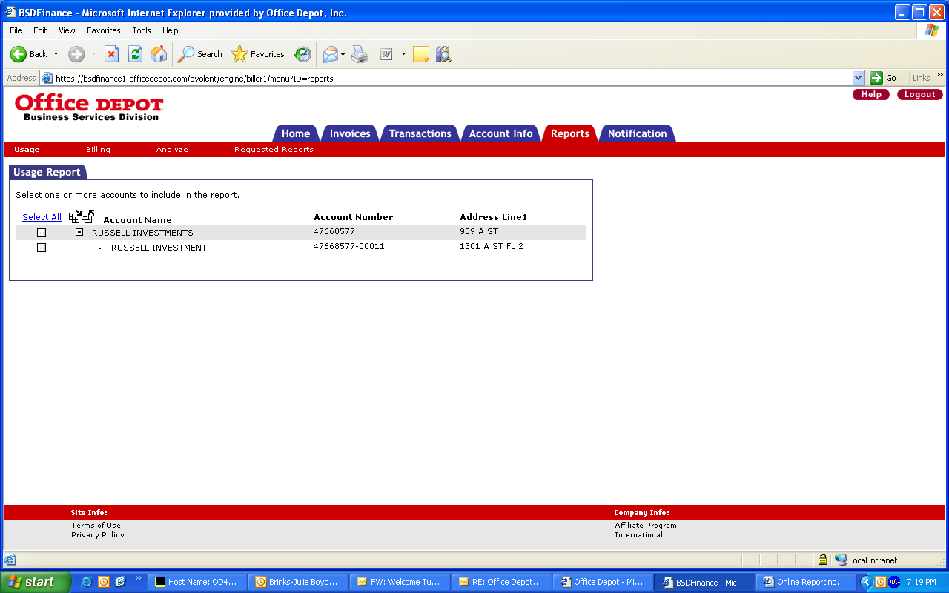

Select your report criteria. Once you have customized your report, click “Submit” and the report will download into the “Requested Reports” tab. It may take 3-5 minutes for the report to fully download. You’ll know the report is ready when it can be clicked on to be viewed in an excel format.

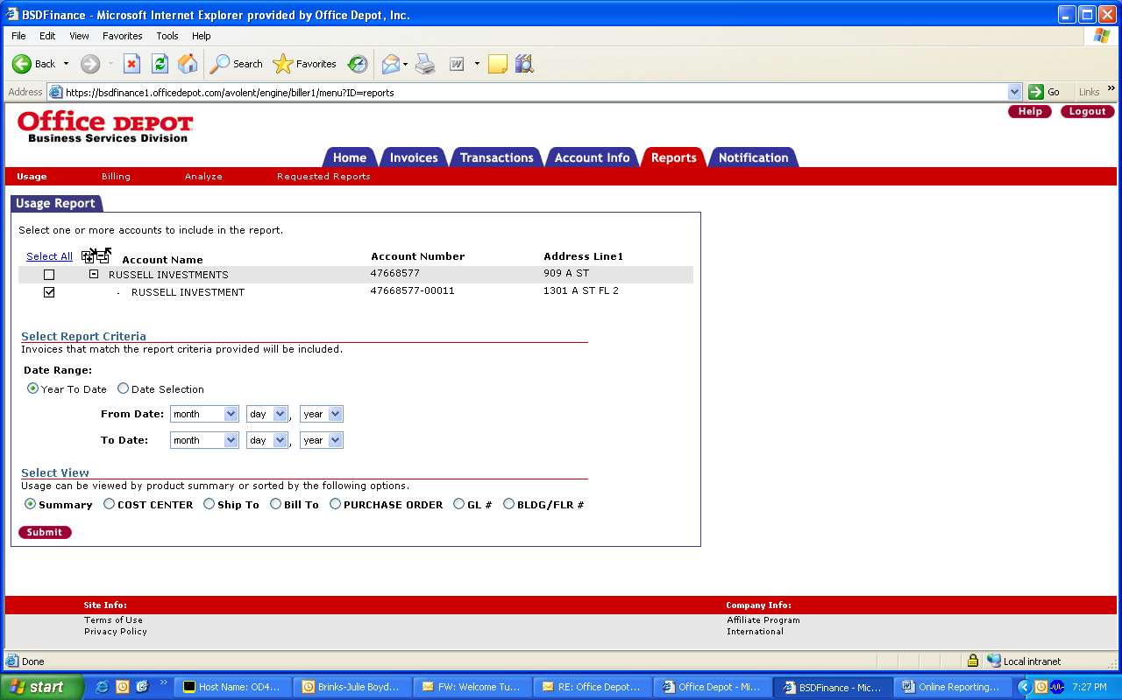

This screen shows the usage report in an Excel format.

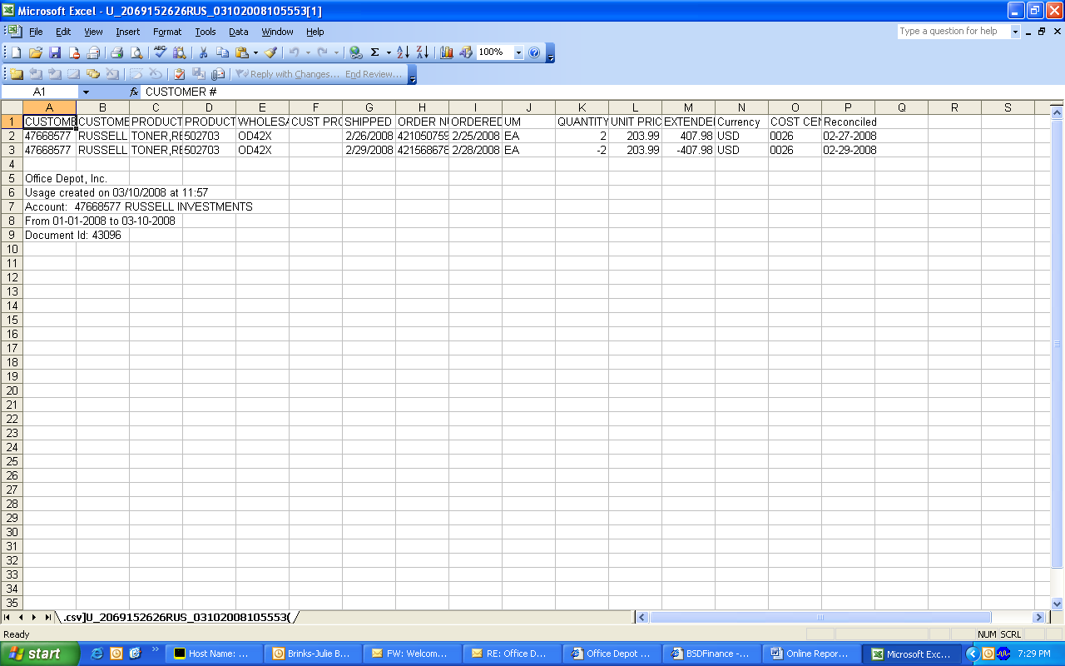

Frequently Asked Questions

- We just received our order and I thought I ordered 12 pens, but received 12 BOXES, what do I do?

Remember our Return Policy, every item in the catalog is assigned a unit of measure (each, dozen, box, pack, set, etc.) to assist you when placing your order. Simply return what you won’t use.

- I’m in the Office Depot Internet Site and forgot how to set up a Custom Shopping List, what do I do?

Click on the ONLINE TRAINING button to go through each step of the set up for this or almost any other procedure on the Office Depot Internet Site.

- I need additional copies of the catalog, how do I get additional copies for my office?

Try using the online catalog first, although many offices like to keep several hardcopy catalogs on hand. The catalogues are free of charge. If you would like a hardcopy catalog you can request a catalog with your next supply order. Russell utilizes the “Solutions Big Book” catalog, item # 696-588.

- With so many passwords I have to remember, I forgot which one I use for Office Depot online ordering. How can I find out my password?

Just go to our website (https://business.officedepot.com) and click on “Forgot Your password?”. Type in your login name, select the security question you picked when you logged on for the first time, answer the question and you will be logged in. The website will then ask you to update your profile with a new password. If you do not remember your log in name, call Office Depot at 800.269.6888 any time between the hours of 7:00 AM - 9:00 PM EST and they will be glad to help you. Have your account number ready before you call. Your Russell Account number is # 47668577.

- I can’t find the product I’m looking for online or in the catalog, so how can I make a Special Order?

Contact Customer Service or your Account Manager. We have access to many other products through various sources.

Customer Service: 1-888-777-4044

Account Manager: Rayna Whitright
Phone: 253-872-1619 Office
Email: Rayna.Whitright@officedepot.com

- My initial “welcome” password is not letting me log on. What do I do?

If you are a new office product user or unable to login with the password provided above, please register at the following link: https://odams.officedepot.com/registrations/russell_invest_reg.php

