Check Order status or submit return requests. Select 
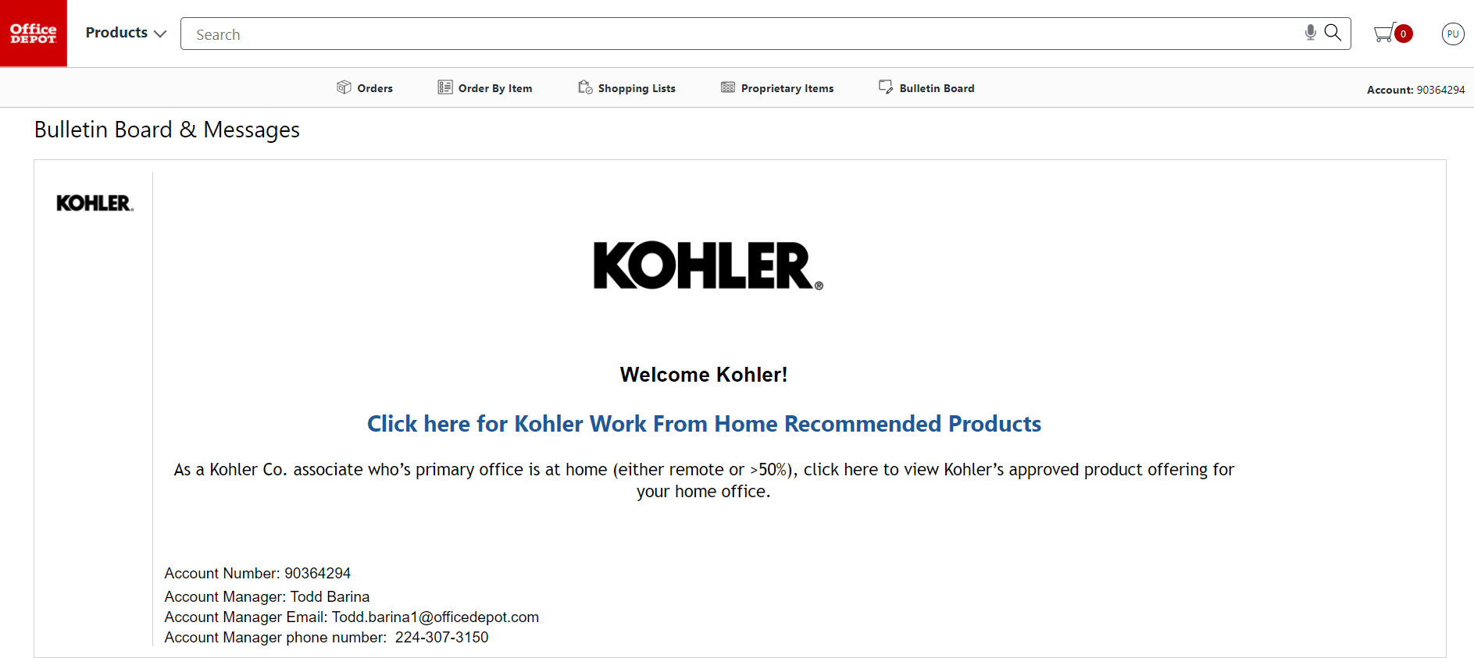
Order Tracking Screen will display all orders regardless of status, Descending Chronological order, grouping related purchase orders. The default Search definition is Order Number. Click the drop down to select another search definition.
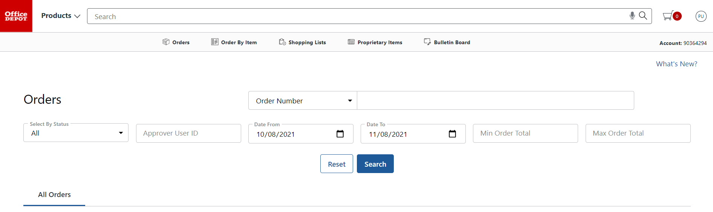
In this example, Selecting Search by #1 “PO Number” Then #2 enter the purchase order # in the search parameter
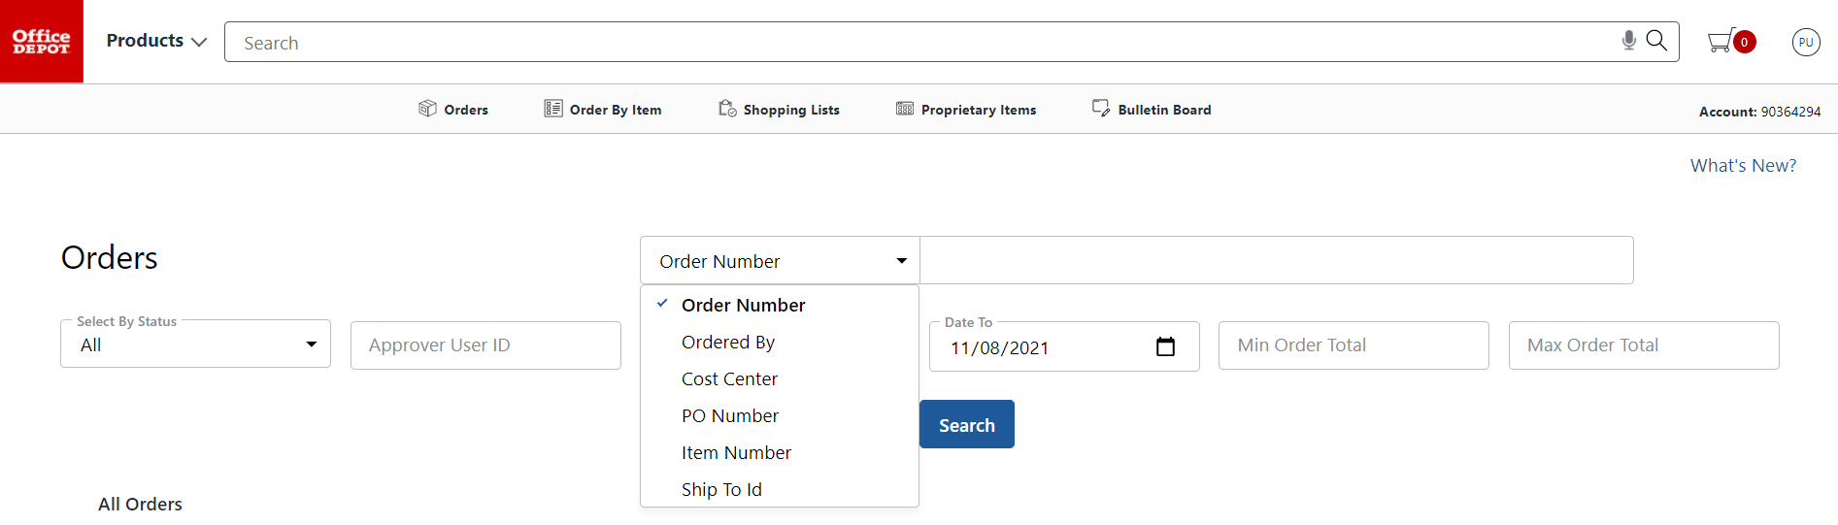
1
3300705944

2
Click the Order number to view order details and tracking information.
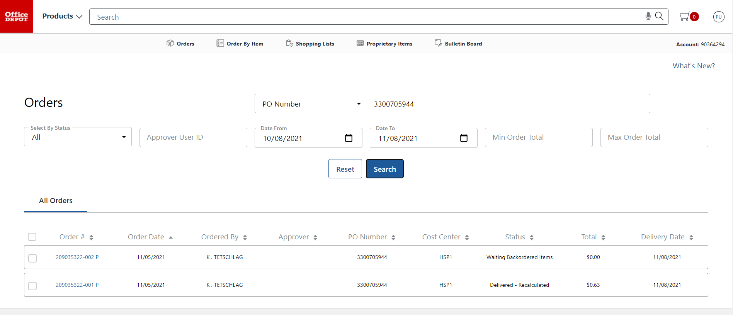

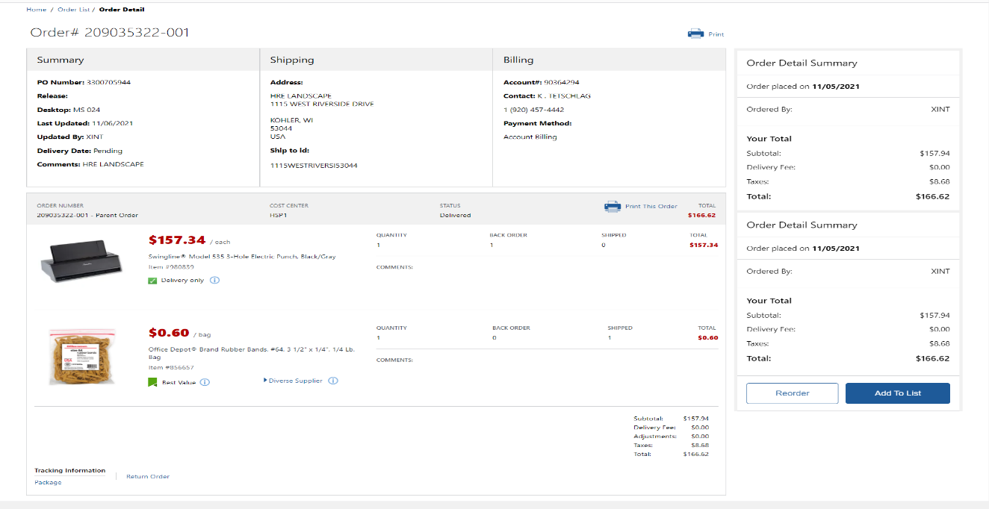
1
2

- Tracking information – Package Delivery Details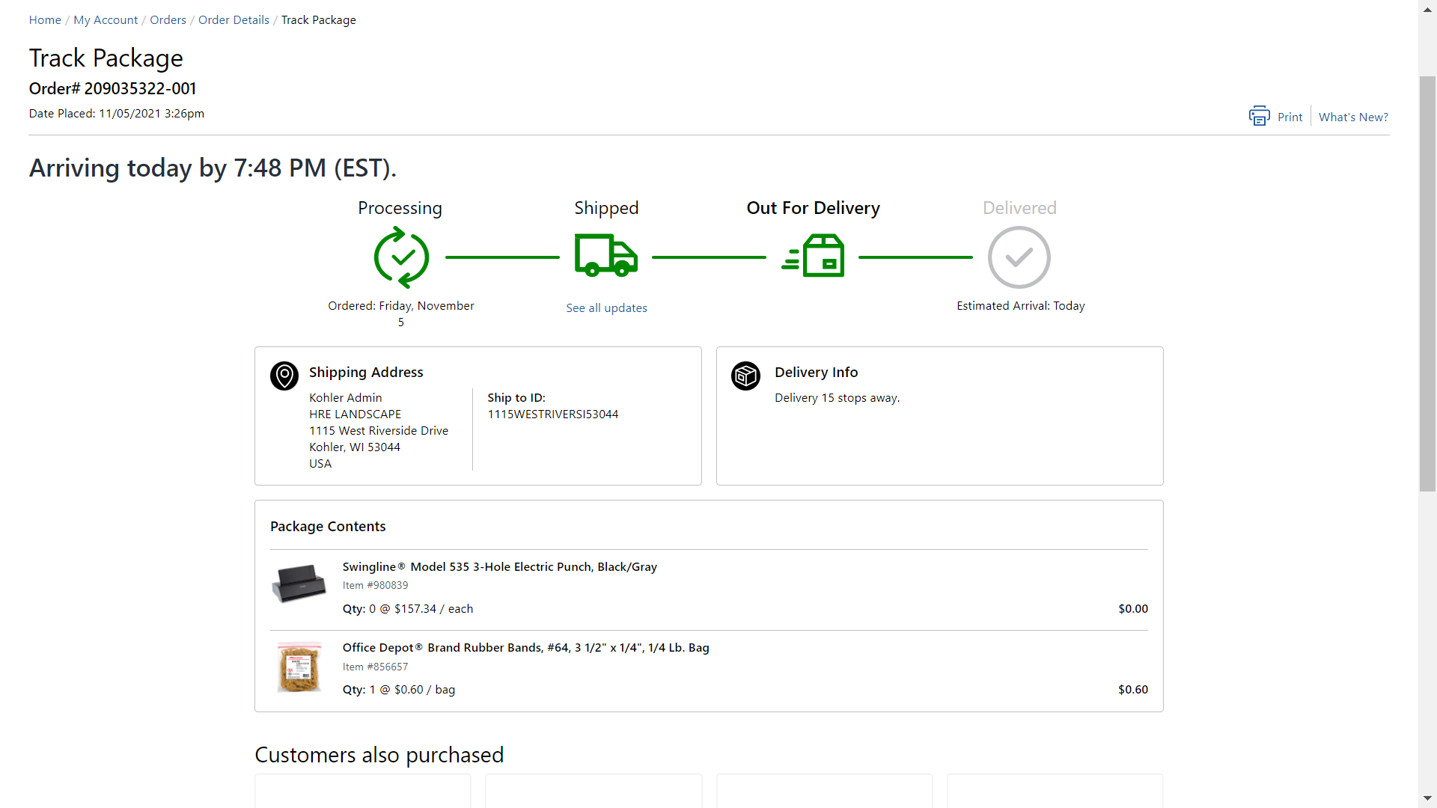
2. Submitting a return request.  Indicates that an item on the order may not be return eligible
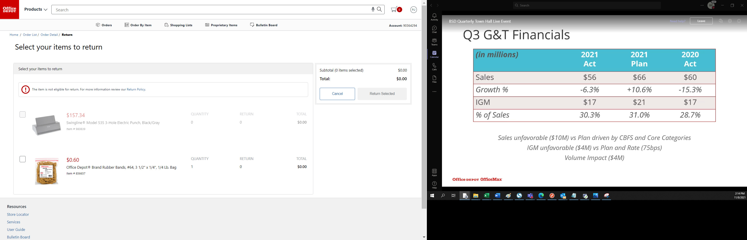
Click the check box on the item returned, indicate the quantity to be returned and select a reason for return from the drop-box. Follow the prompts provided to complete your return request.
