


New Program at a glance!

Partnership has its rewards
Succeeding in business is about building smart partnerships. That’s why we created the Office Depot State Farm program that allows all State Farm Agent locations to buy under the same umbrella as State Farm. This partnership opens up competitive volume pricing, dedicated customer service, and *free next day delivery to all within the program. *Some exclusions do apply.

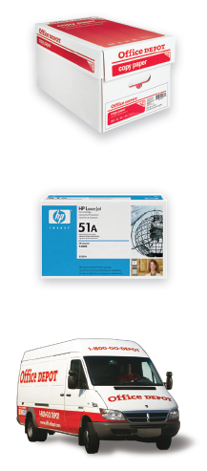
- Easy Registration!
  - ONLINE ORDERS: Click on the ‘ONLINE REGISTRATION BUTTON” on the landing page to create your custom login name and password.
  - RETAIL STORE PURCHASES: Click on the “STORE PURCHASING CARD” button to receive your printable card. You can take this into any store and they will laminate the card portion for FREE.
- Order Tracking and History: See all your orders in one place and view tracking information.
- Custom Shopping Lists: Create your own custom shopping lists to easily order the things you buy frequently.
- State Farm Negotiated Volume Pricing!
- Office Depot Business App: Order on the go wherever business takes you, with our simple-to-use business-focused app designed for tablets, iPhone® and Android™ phones
- NO Order Minimums!
- FREE Next Day Delivery on all orders. Place your office supply order online or via phone by 5:00 pm your time (in most locations) and get it delivered the next business-day, FREE! (Some furniture, technology and special order items do not quality).
- Best Value Icon: Indicates Core List items that are specially priced for your account.

Customer Service: 888-777-4044
Please provide customer service with the Agent account number 90448599 when calling for support.

