

Punchout User Guide

Customer Services: 888.263.3423

Home
The landing page includes two tiles for messages to keep you informed. Just click Read More to view details.

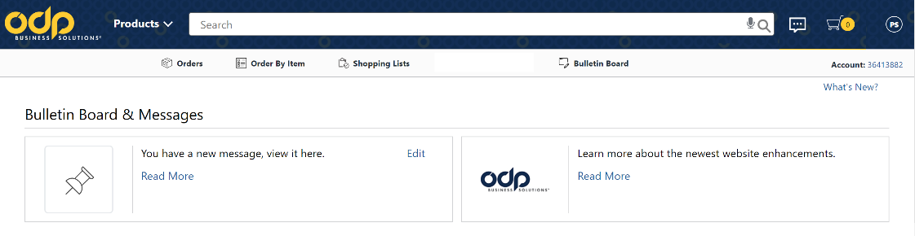

Search:
Type in product:
description
ODP or manufacturer product codes.
Predictive Search reduces keystrokes.

 Customer Service information / Website support.

 Link to shopping cart / quick view cart qty.

Shop for products by category.

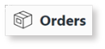
Order lookup / tracking.

Input item # to quickly add to cart.

View company or personal shopping lists.

Punchout User Guide

Building Your Order

  - Punchout from your procurement system by clicking the ODP Business Solutions catalog.

Step 2 Combine any of the following tools to build you order:  - Catalog: Click a category from the Navigation Bar and select the category or sub-category to view products.  - Search: Type item Keyword or Item Number and click Search. A summary of matching categories and the top-ranking items will appear. Choose a category or brand or go directly to an item. Results can be resorted by: Best Value (Contract), Price and Relevance. To filter search results by characteristics such as brand, size, color etc., click the desired characteristic listed on the left-side tool bar.  - Order by Item #: Enter the Office Depot, manufacturer, or custom product code numbers, then quantity and click Add to Cart. For multiple items click: | - Shop from Personal or Company Wide Lists.  Click then My Lists. To add an item to your shopping cart: enter the quantity desired, make sure the select box is checked, and then click Add to Cart.  Hint: If the shopping list quantities are preset to “0”, simply click “Select all” and populate a quantity only on the desired items.
-  Review your selections, view ODP recommended savings opportunities, save items for later in a shopping list, or add to custom shopping lists.

Step 4  The shopping cart contents are passed to your eProcure application and the ODP session ends. *Purchase orders received by 3:30 pm local time are processed for next available day delivery.

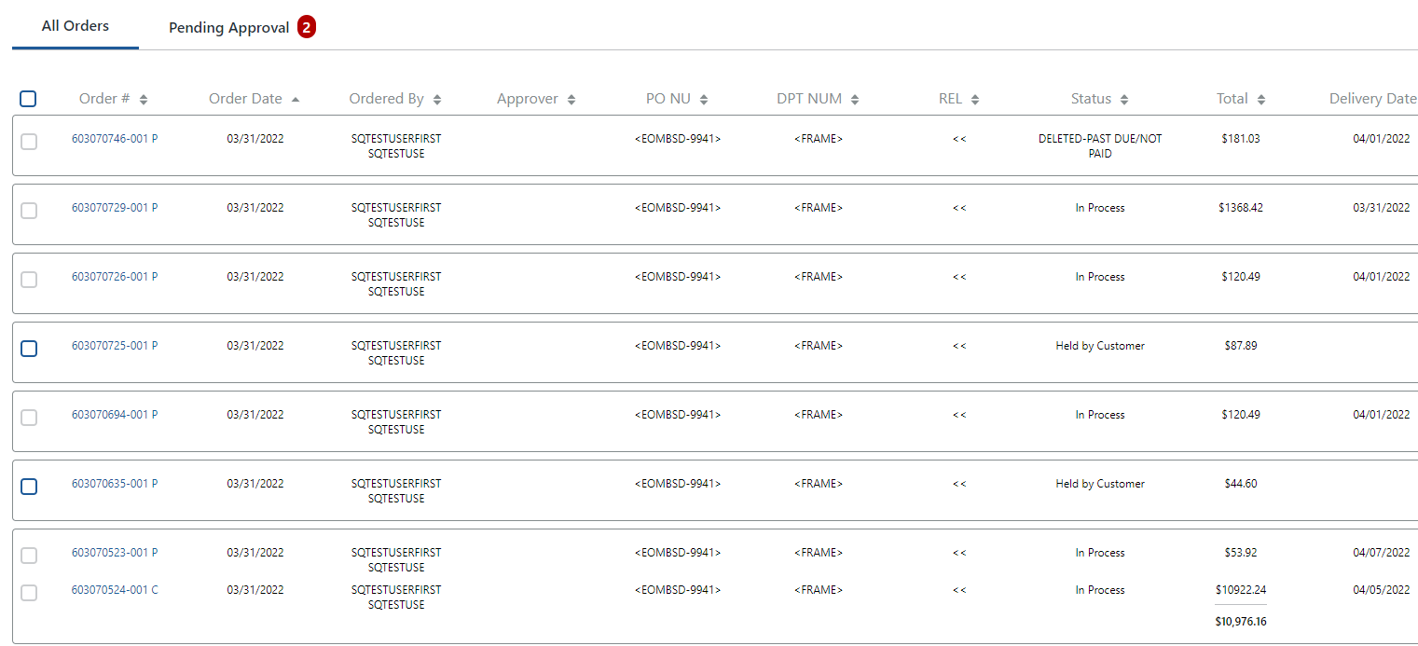
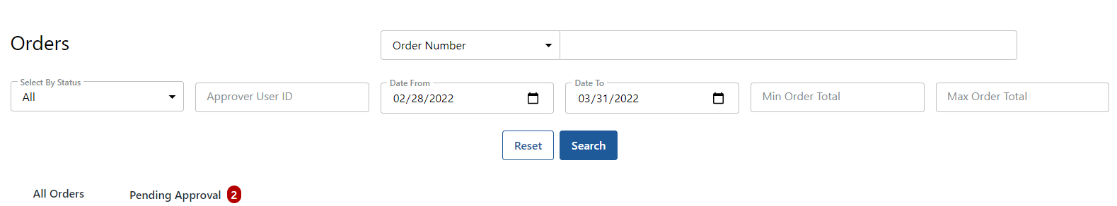
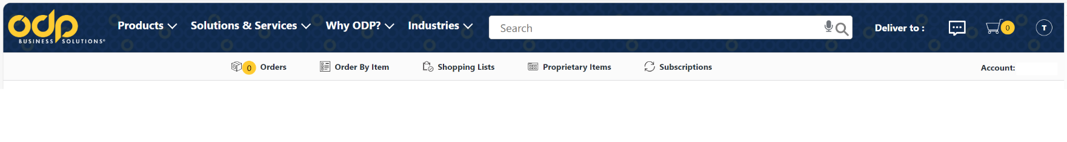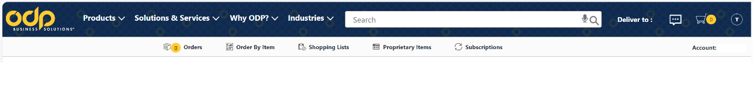
Search results appear in descending chronological order.

Click the Order Number to view details of the order.

(continued next page)

Under the Order Number drop box select PO Number Order Number, then in the adjacent field enter your Purchase Order number or the shipping order # passed in the email confirmation or on the packing list of your delivered order.

If the order more than 30 days prior, adjust date parameters.

Along the toolbar below the blue band,
Click

Punchout User Guide

Checking Orders and
Processing Returns

Punchout User Guide

Checking Orders

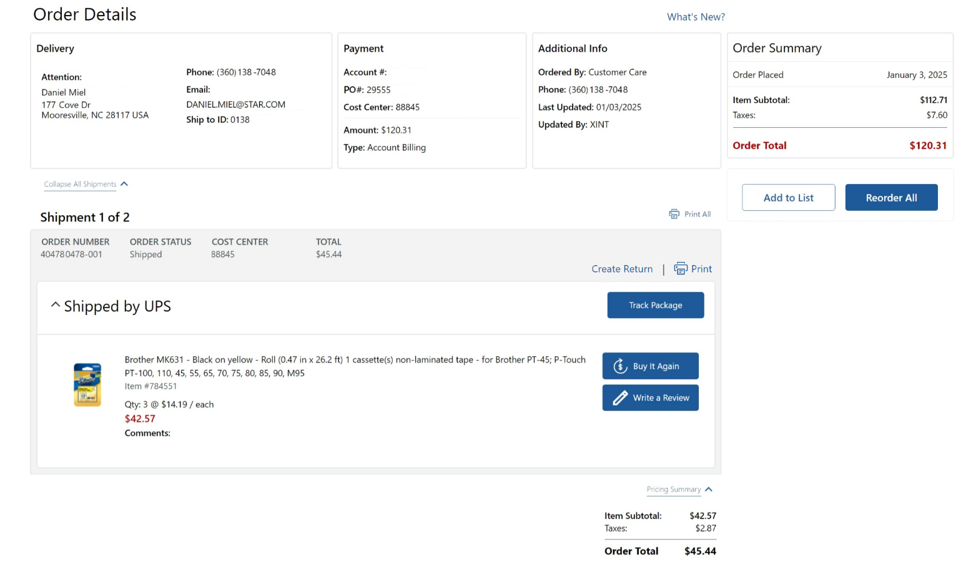
Shows the full detail including:  Order Number, Delivery Status, PO # and other accounting data, Contact name and email, Order status,  Order details, including, quantity shipped, product description and links to product detail, item icons such as Contract, Best Value, and product restriction indicators | Need to request a return? Please contact customer service by phone, online chat, or email.   Up to the minute tracking of your package delivery journey (aka: “WISO”).

Click 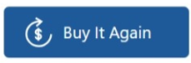 or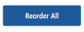 , to create a new shopping cart with the same item(s).

